

TRIRIGA Building Information Models (BIM) User’s Guide

For TRIRIGA Platform 3.8.0,

BIM Connector 3.8.0.0

Technical Contact: Doug Wood [doug.wood@wipro.com](mailto:doug.wood@wipro.com)

Marketing Contact Paul Lacey [placey@us.ibm.com](mailto:placey@us.ibm.com)





**© Copyright International Business Machines Corporation 2020.**

US Government Users Restricted Rights – Use, duplication or disclosure restricted by GSA ADP Schedule Contract with IBM Corp.

Contents

List of Figures vii

1 Overview 10

1.1 What’s New in 3.7.0.1 10

1.2 Utilizing Building Information Modeling (BIM) models with TRIRIGA 10

1.3 Supported Software 10

1.4 Features 11

2 BIM Connector for Revit 11

2.1.1 Model Configuration Ribbon 14

2.2 Connect 15

2.2.1 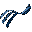 Log In 15

2.2.2  Servers 18

2.2.3  Log Out 22

2.3 Set Up 22

2.3.1  Project Settings 22

2.3.2  Populate Parameters 25

2.3.3 ,  Space Use Class 27

2.3.4  Areas from Rooms 30

2.3.5  Map Areas to Rooms 34

2.3.6 Validate 36

2.3.7  Parameter Mapping 39

2.4 Integrate 42

2.4.1  Publish Status 44

2.4.2  Upgrade 45

2.4.3  Verify Server 46

2.4.4  Building 47

2.4.5  Levels 50

2.4.6  Rooms 53

2.4.7  Spaces 56

2.4.8  Areas 59

2.4.9  Families 64

2.4.10  Assets 67

2.4.11 Detach 71

2.4.12 Sync 72

2.4.13 Publish Floor Plans 76

2.4.14 Publish Model 77

2.5 TRIRIGA Data 77

2.5.1  Property Panel 78

2.5.2 Open Building 80

2.5.3 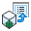 Open Selection 80

2.5.4 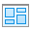 Launch Portal 80

2.6 Help 80

2.6.1 Info 80

3 Autodesk Forge Model Administration 80

3.1 Setting up the Forge Service 81

3.1.1 Register with Autodesk Forge and Create an application 81

3.1.2 Entering Forge Credentials into TRIRIGA 84

3.1.3 Configure TRIRIGA for access to Forge Management tool 85

3.1.4 Autodesk SSL Certificate 86

3.2 Exporting Navisworks Models 90

3.2.1 Exporting the model 90

3.2.2 Enhancing the model 91

3.3 Importing models into the Forge Service 92

3.3.1 Managing Model Storage 92

3.3.2 Managing Model Files 95

3.3.3 Upload Model 96

3.3.4 Associating Translated Models with Buildings 100

3.3.5 Previewing Models in the Viewer 102

4 Using the Autodesk Forge Viewer 103

4.1 TRIRIGA context 103

4.2 Viewer Navigation 103

4.2.1 Viewer Toolbar 103

4.2.2 Model Tree 105

4.3 Sections 106

4.4 Saved views 107

4.5 Markup 110

5 Best Practices 113

6 Troubleshooting 114

6.1 Forge Viewer 114

6.2 BIM Model Management Tool 115

6.3 BIM Connector for Revit 115

6.4 Known Limitations 117

7 Appendix: Configuring to BIM Connector 118

7.1 Configuring Property Panel and Parameter Map Display 118

7.2 Changing Supported Asset Types 119

7.3 Adding additional Revit Categories to Family and Asset integration 123

8 Appendix: REST API support 124

List of Figures

Figure 1 - BIM Connector for Revit Toolbar 12

Figure 2 - Filter 13

Figure 3 - Login Form 16

Figure 3 - Login Form with SSO Web Browser 17

Figure 3 – Network Proxy Login 18

Figure 4 - Server Definition List 19

Figure 5 - Server Definition Form 19

Figure 6 - Server Definition Form with SSO Enabled 20

Figure 7 - Platform OAuth Login Configuration 21

Figure 8 - Project Configuration Form 23

Figure 9 - Parameter value creation rule form 24

Figure 10 - Populate Parameters Form 26

Figure 11 - Space Use Classification Form 29

Figure 12 Areas from Rooms form 33

*Figure 13 - Link Areas to Rooms Form* 35

Figure 14 – Validate Property Sheet 37

Figure 15 - Parameter Map Form 40

Figure 16 – View Unmatched Map Entries Button 41

Figure 17 – Unmatched Entries Form 42

Figure 18 - View Errors Button 42

Figure 19 - Integration Error Form 43

Figure 20 - Confirmation Form 43

Figure 21 Publish Status Monitor 45

Figure 22 - Sync Upgrade Form 46

Figure 23 - Verify Server Form 47

Figure 24 - Building Integration Form 49

Figure 25 - Levels Integration Form 51

Figure 26 - Rooms Integration Form 54

Figure 27 - Space Integration Form 57

Figure 28 - Areas Integration From – Rooms Tab 61

Figure 28 - Areas Integration From – Area Tab 61

Figure 29 - Families Integration Form 65

Figure 30 - Asset Integration Form 69

Figure 31- Detach Form 71

Figure 32 - Synchronize with TRIRIGA Form 72

Figure 33 - Synchronizing mapped parameters 75

Figure 34 - Publish Floorplan Form 76

Figure 35 - Publish Model Form 77

Figure 36 - Property Panel 79

*Figure 37 - Element Not Integrated* 79

Figure 38 - Property Panel Error 79

Figure 39 - Model Integration Process 81

Figure 40 – Create an Autodesk® Forge application 82

Figure 41 – Forge application definitions 83

Figure 42 – Forge application credentials 84

Figure 43 – Configure Forge Credentials in TRIRIGA 85

Figure 44 – TRIRIGA BIM User Security Group. 86

Figure 45 - Model Upload 96

Figure 46 - Translated Viewable (bubble) Details 99

Figure 47 - Building to Model Link 101

Figure 48 - Building to Model Link Details 102

Figure 49 - Forge Viewer Toolbar 104

Figure 50 - TRIRIGA Extension to the Forge Viewer Toolbar 104

Figure 51- Forge Viewer Model Tree 106

Figure 52 - Forge Viewer Section Tool 107

Figure 53 - Saved View Dialog 108

Figure 54 - Apply View Dialog 108

Figure 55 - Manage Forge Views Popup 109

Figure 56 - Forge Viewer Markup Toolbar 110

Figure 57 - Save Markup Dialog 112

Figure 58- Display Markup Dialog 113

**Executive Summary**

The IBM TRIRIGA Application Platform 3.8.0 provides integration with Building Information Models (BIM) to enable initialization of facilities data at building hand-over, and to support facilities management operations. There are two primary integration points for BIM data:

* **The BIM Connector for Revit**: This provides initial population of TRIRIGA facility data from Revit authored models and provides ongoing synchronization of data between TRIRIGA and Revit models during operations.
* **The Autodesk Forge viewer**: This provide in context 3D visualization of BIM data from TRIRIGA applications.

**BIM Connector for Revit**

The Connector for BIM creates TRIRIGA building, floor, spaces, and asset records from Revit models, including linked models. It synchronizes key attributes over the life of the building. It can publish floor plans for use in the TRIRIGA floorplan viewer.

**Forge Viewer**

The Forge viewer is integrated into the Locate and Work Task applications providing in context 3D visualization of spaces and asset, access to model properties, and model markup.

**BIM Model Management**

All the interaction with the Autodesk Forge service required to manage the models used by the Forge viewer can be performed from within TRIRIGA using an intuitive graphic interface.

**Change History**

#### Version 2.6.0

#### Version 3.6.0

#### Version 3.7.0

#### Version 3.7.0.1

# Overview

## What’s New in 3.8.0.0

* Access to Single Sign-on enabled TRIRIGA servers from the BIM Connector. See section 2.2.2 Servers.
* Login support for some Firewall and network boundary services
* The Validate tool now tests if the Revit Area Type is set, and for un-placed/un-bounded Rooms.
* Enhancements to the Areas from Rooms tool so it can be used to create Ares for Rooms added over the life of the building
* Improved Space Use Class processing
* Enhancement to the Area tool to allow Spaces to be create for Areas no contained in a Room such as those in a Shaft.
* Additional data in the Info Screen
* Rework of error reporting in the integration tools
* Many small usability enhancements.

## Utilizing Building Information Modeling (BIM) models with TRIRIGA

Building Information Models are an industry representation of a building that are used during the design and build phases of building construction. The data model provides the information in its attributes to describe (in detail) the infrastructure of a building. The use of data models is becoming more frequently used by contractors and is part of the turnover of a building to the owner. A model that is provided at turnover is generally referred to as the “as built” state of the building.

Building owners who are commissioning a building into production need the information in this model to perform facilities management. The process of loading this information into your maintenance products, such as TRIRIGA, is costly, time consuming, and may introduce errors. The TRIRIGA BIM support allows you to load data from a Revit® model into TRIRIGA to begin the process of maintaining the building. This state is referred to by “as maintained”.

When the data is imported, TRIRIGA provides 3D visualization of the full building model in context with the imported data. This improves the efficiency of the maintenance, work planning, and execution process. Finally, changes made during operations may be synchronized with the model.

## Supported Software

TRIRIGA Platform 3.6.0.5

TRIRIGA Application 10.6.0

TRIRIGA BIM Connector for Revit 3.8.0.0

Autodesk Revit 2018, 2019, 2020, 2021

**Autodesk Forge Viewer:** The Autodesk Forge Viewer is a cloud-based Viewer. To use it in TRIRIGA, a subscription from Autodesk is required. The Forge Viewer requires a browser that supports WebGL.

## Features

The Forge Viewer integration provides visualization of Building Information Model (BIM) data in the context of the TRIRIGA Assets, Locations, and Work Tasks applications. In this context, it provides the following features:

**BIM Connector for Revit**

The BIM Connector for Revit is used to integrate BIM models authored in Revit with TRIRIGA. It can create new TRIRIGA records from model elements, or link model elements to existing TRIRIGA records. Once linked, a limited set of values can be synchronized between TRIRIGA and the model.

Floorplans can be published from Revit directly into TRIRIGA, for use in the TRIRIGA floorplan viewer. Rooms in the floorplan are automatically linked to TRIRIGA spaces created from or linked to Revit rooms.

The Revit model can be published to the Forge service either directly from Revit or indirectly through Navisworks. This enables the model to be viewed in the Forge viewer

**Forge Viewer**

The Forge viewer is embedded in Locate and Work Task applications.

TRIRIGA Space and Building Equipment records created from or linked to Revit elements can be selected in the Forge viewer. And the full set of model properties are available in the viewer

* Full 3D navigation
* Basic search
* Model properties
* Model tree
* Sectioning of a model
* Model walk through
* Save and restore views
* Markup

**BIM Model Management Tool**

A UI for administering the Autodesk Forge service as used by TRIRIGA including:

* Managing storage containers (Autodesk Forge Buckets)
* Uploading models to the Autodesk Forge service
* Translating models into viewable formats
* Associated models with TRIRIGA building records
* Manage saved views

# BIM Connector for Revit

The BIM Connector for Revit is a Revit add-on that is accessed from within Revit. It adds a ribbon to Revit with the TRIRIGA integration functions.



Figure 1 - BIM Connector for Revit Toolbar

The standard workflow is from left to right across the ribbon. Items on the ribbon are context aware and are only enable when the operation they start is legal. They are affected by:

* Whether or not the connector is logged into TRIRIGA
* If prerequisite steps have been completed
* If an integration operation is in progress
* If a required element type is present in the model

#### Shared Parameters

The BIM Connector for Revit adds several Shared Parameters to the Revit Elements that can be integrated with TRIRIGA. The values in these parameters are used for the initial creation of TRIRIGA records from Revit Elements, then can later be updated to reflect changes made to the linked TRIRIGA records. The parameters visible to users include:

All Elements

* IBM.Name
* IBM.Description
* IBM.isTRIRIGA (read-only)

Project Information

* IBM.DXF.Template
* IBM.ModelName
* IBM.ModelDescription
* IBM.BuildingName
* IBM.BuildingDescription
* IBM.TRIRIGA.Version
* IBM.TRIRIGA.Server.URL

Level

* IBM.Level

Rooms, Areas and Spaces

* IBM.UseClassification
* IBM.UseClassification.Name

Components

* IBM.BarCode

Tools described below are provided to manage the values of all these properties. They may also be edited individually from the appropriate element property sheet or schedule. In addition, there are several hidden parameters that do not appear on the property sheets but can be added to schedules. These should not be edited by modelers.

#### Filtering lists

Most lists and trees can be filtered to help find the desired value. This is indicated by a filter entry field above the list or tree.



Figure 2 - Filter

To filter a list:

* Enter text in the filter field.
* Press Enter to apply the filter or wait a few seconds and it is applied automatically. Any entry that contains the filter text is displayed (substring match).
* To clear the filter and restore the full list, click the clear button to the right of the filter field or just delete the filter text.
* If the list being filtered is a tree, then parent nodes of any child that matches the filter are also displayed even if they do not match the filter.
* Any currently selected items are displayed even if they don’t match the filter

#### Trees:

Most trees have buttons to expand and collapse all nodes of the tree.

#### Displaying Elements in the Model

Many of the tables that display Revit elements allow an element to be displayed and selected in the model. Double-click a table row or a tree node. If selection is supported this starts the normal element selection process.

#### Integration Process

The process of creating TRIRIGA records happens in two stages:

1. The Revit data is copied to the TRIRIGA server and stored in staging tables which are found in the triBIM module. Staging records are updated or created as necessary.
2. Publish workflows are run on the staging table records which create or update the application objects. The workflow may also update the staging records from the application records and these updates may flow back to the Revit model.

The connector runs a background process that monitors the progress of the workflows, and retrieves any errors for display in Revit.

The connector stores a globally unique identifier (GUID) in each model file when it is integrated. This links the model to the TRIRIGA building record. Both staging and application records that are created from or linked to Revit elements are tagged with the linked Revit element unique ID. This is used both to link the Revit element and the TRIRIGA record, and to associate TRIRIGA records with graphic elements in the Forge viewer.

#### TRIRIGA Server Configuration

The Connector communicates with the TRIRIGA server using the Open Services for Lifecycle Collaboration (OSLC) protocol. Before the OSLC protocol can be used, it must be configured on the TRIRIGA platform. This can be done either by directly editing the TRIRIGAWEB.properties in the Platform config directory or through the TRIRIGA admin console.

To directly edit the TRIRIGAWEB.properties:

* Locate the file TRIRIGAWEB.properties in the Platform config directory
* Open it with a text editor sunch as Notepad
* Search for OSLC_BASE_URI
* Set the value to the URL that will be used to access OSLC endpoints. This is typically the base TRIRIGA URL = “/oslc”
* The : character must be escaped. Below is an example URL

OSLC_BASE_URI=http\://tririga.mydomain.com\:9080/prod/oslc/

To edit using the TRIRIGA admin console:

* From the left menu select



* At the top, select Edit for TRIRIGA WEB.
* 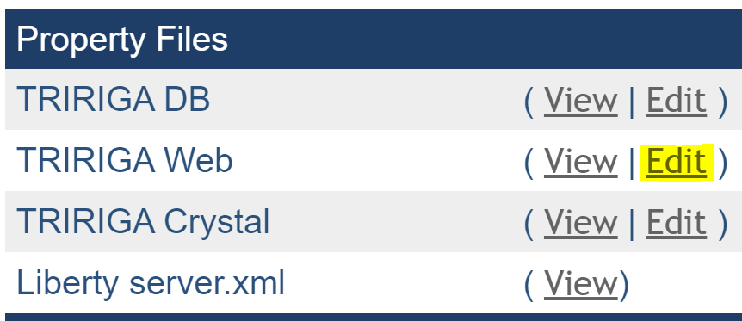
* Scroll down to OSLC_BASE_URI. Properties are in alphabetic order.
* Set the value to the URL that will be used to access OSLC endpoints. This is typically the base TRIRIGA URL = “/oslc”. A sample is below:

OSLC_BASE_URI=http://tririga.mydomain.com:9080/prod/oslc/

* Save your edit.

For both methods, the server must be restarted for your changes to take effect.

As of the 3.8.0.0 Platform, If the TRIRIGAWEB.properties OSLC_BASE_URI value is blank or the default, it is automatically configured based on the login URL. This fails if the address seen by the server is different from the login URL used by the server. Such as when the server is behind a firewall that performs Network Address Translation (NAT). In these cases, the URL must be manually configures as described above.

### Model Configuration Ribbon

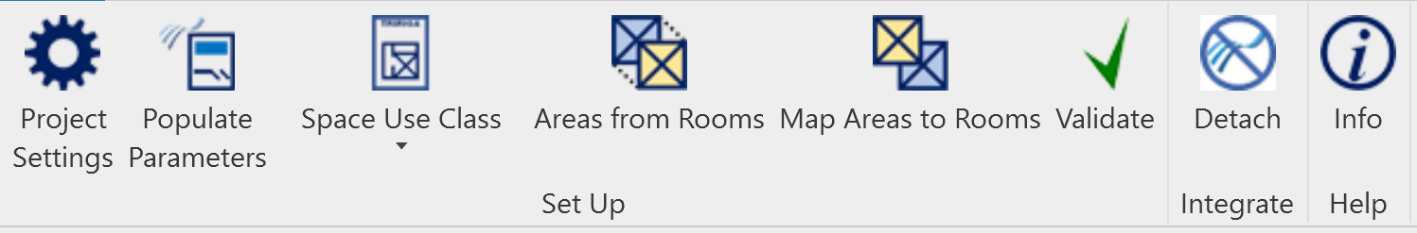

The connector can be configured with a reduced ribbon intended to support the model configuration workflow. That is, the steps required by a design or engineering agency to prepare a model for hand-over. The ribbon only has tools that can be used without access to a TRIRIGA server. In addition, on the settings form, the Load From TRIRIGA and Save to TRIRIGA options are hidden.

To enable the reduced ribbon: Edit the TRIRIGA_AR.properties file and set the option

Profile=NOLOGIN

## Connect

The Connect section manages the connection to TRIRIGA servers.

### Log In

The connector requires at least one pre-defined server configuration before a user can log into TRIRIGA. If none exists, an empty one is created called “environment”. It must be populated with a server configuration.

The fields on the login screen and it behave varies depending on the authentication protocol specified in the server definitions. For Basic, Digest, and NTLM, a user name and password is all that is required. 3rd party Single Sign-on solutions typically require some form of browser based interaction with the user.

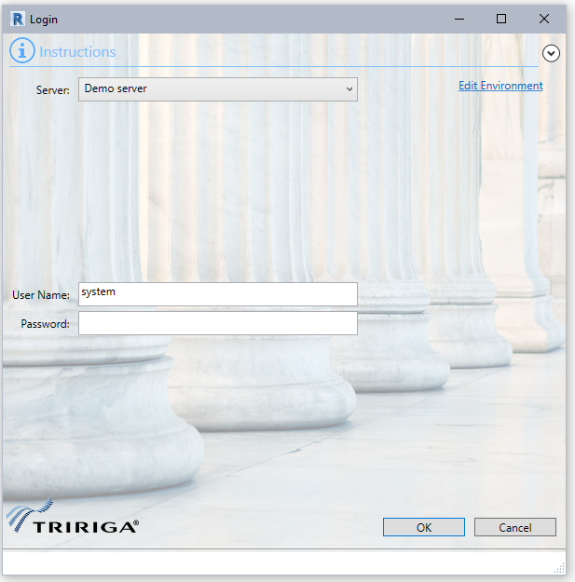

Figure 3 - Login Form

#### Basic, Digest, NTLM

Select the desired server configuration. The user is populated from the configuration but may be edited. The password is not saved and must always be provided.

If the configuration needs to be edited, it can either be edited here by selecting the edit environment link or from the Servers form.

#### Single Sign-on Login

If the TRIRIGA server is configured to use an external Single Sign-On (SSO) solution, the server definition must be configured for it. (See Single Sign-on ).

When an SSO server is selected, a Login button is displayed next to the server, and there is no User Name or Password field. Pressing the Login button displays the SSO providers login web page.

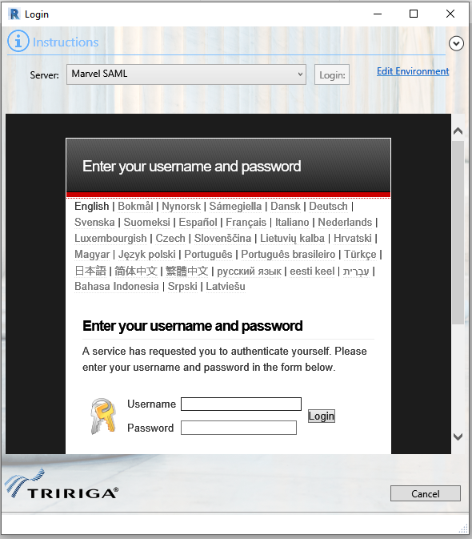

Figure 4 - Login Form with SSO Web Browser

Complete the normal web login sequence. The BIM Connector detects when a successful TRIRIGA portal login has been completed, and completes the Connector login.

#### Network Boundary Services

Many networks are divided into protected regions, and access to such a region requires authenticating to the network boundary service. When using an SSO login, the BIM Connector has a limited ability to provide authentication to boundary services. If the connector receives a challenge from a boundary service that it recognizes and can process, it displays a prompt for a user name and password, and includes any identifying information provided by the challenger.

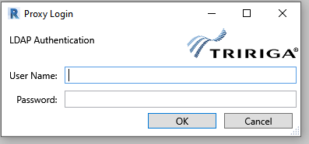

Provide credentials for the service indicate at the top of the dialog. You may be prompted again during the web-based SSO login process.

Figure 5 – Network Proxy Login

***Boundary Service – Technical Details****: Boundary services intercept the network traffic for the region of the network they protect, usually defined as a sub-net. If the connection is not properly authenticated, an authentication challenge is returned. This is expected to be an HTTP status of 401, and to include either a WWW-Authenticate or a Proxy-Authenticate response header. The header includes an authentication type and a realm. The BIM Connector can process authentication requests that require Basic Authentication. The Basic Auth header is included on all future connections made by the Connector.*

### Servers

The connector maintains a list of TRIRIGA server definitions.

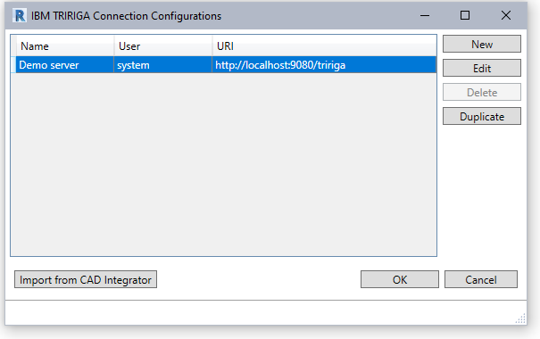

Figure 6 - Server Definition List

To create or edit a server configuration, display the Servers form.

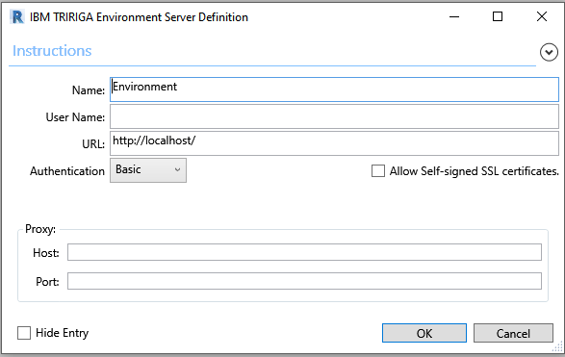

Figure 7 - Server Definition Form

**Name:** The name of this configuration. It is displayed on the login dropdown and in the Connections Configurations list. It is only visible to the current user on the current workstation.

**User Name:** The user ID to use for TRIRIGA login. This is a convenience and may be edited later.

**URL:** The URL of the TRIRIGA server. This is the base URL used to access the TRIRIGA portal. That is hostname, port, and context root.

**Authentication:** The Authentication mechanism used by the TRIRIGA server. If you are unsure how your TRIRIGA server is configured, try each method to see which one succeeds.

**Allow Self-signed certificates**: This option is not recommended for production use. It disables validation of SSL certificates allowing self-signed (or any other) certificate to be accepted.

**Proxy:** If you must pass through a proxy server to access the TRIRIGA server, specify it here. This is usually the same configuration that is required for your browser to access TRIRIGA.

**Hide Entry:** The entry is not displayed in the Servers dropdown on the login screen

The server configurations are stored in a property file on the workstation running Revit on a per user basis. The file is located at:

<Current User>AppData\Local\IBM\TRIRIGA\AR Integrator\environments.properties

**Import from CAD Integrator:** If there are CAD Integrator environments defined for the current user, this imports all them into the Revit Connector.

#### Single Sign-on Configuration

The BIM Connector can connect to TRIRIGA services that use external Single Sign-On (SSO) solutions such as a SAML provider, it can also use the native OAuth login supported by the server.

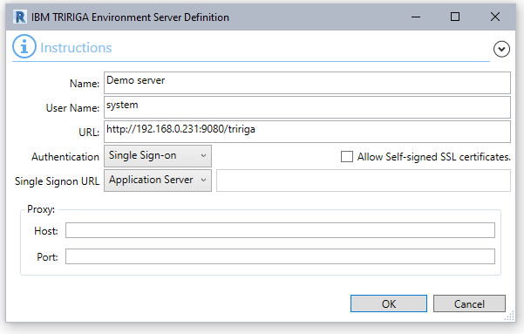

Figure 8 - Server Definition Form with SSO Enabled

All Single-Sign-on options display a browser on the login form which allows the user to log into a web-based identity provider.

There are three Single Sign-on options:

**Other:** This is generic. It opens the URL listed in the Single-sign-on URL in the browser on the login form. For the login to work correctly, the SSO process must redirect the user to the TRIRIGA main portal:

https://<host:port/context path>/html/en/default/platform/mainpage/mainpage.jsp

or for a 3.8.0 or higher server:

https://<host:port/context path>/html/en /app/tririga

with a valid login. Use this for the existing SAML SSO support or any SSO option that starts at the identity provide URL.

The main portal URLs can be configured in TRIRIGA_AR.properties

**Application Server:** This is a short cut. It opens the browser to the URL specified in the URL field. It expects to be re-directed to an identity provider login page. The login completes as above. If here is no redirect, the normal TRIRIGA login page is displayed in the browser. This can now be used to log into the BIM Connector. Use this for WebSphere SSO plug-ins.

**Platform:** This provides support for the native OAuth login added in the TRIRIGA 3.7 platform. It is configured in the TRIRIGA portal. Go to:

Tools->System Setup->OAuth Settings

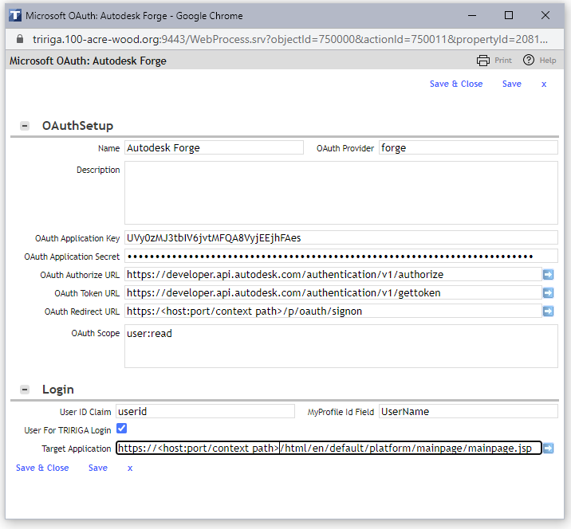

Figure - Platform OAuth Login Configuration

In the above screen:

**OAuth Provider:** Supported values are Azure and Forge.

**MyProfile Id Field:** This should be either UserName or email. The Autodesk or Microsoft email must be in the selected field of the user’s profile.

**OAuth Redirect URL:** Enter exactly as shown in the image above, but replace

<host:port/context path> with the TRIRIGA server base URL.

This must be added to the OAuth application definition in Forge or Azure as a valid redirect URL.

**Target Application:** Not used by the BIM Connector.

Other fields are taken from the Microsoft or Autodesk Oath configuration and application definition

### Log Out

Disconnect from TRIRIGA.

## Set Up

The setup section covers model configuration tasks that must be performed before the model is integrated with TRIRIGA. Most of these are independent of the TRIRIGA server.

### Project Settings

The initial values of IBM.Name, and IBM.BarCode parameters are created from other Revit parameters. As part of the connector setup, rules must be defined describing how the values for these parameters are created. Rules are defined for each Revit Element type.

Use the Project Settings form to access the rule definitions.

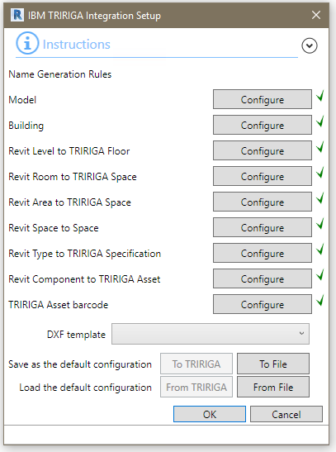

Figure 10 - Project Configuration Form

The button associated with each element type displays the dialog for creating a parameter value rule. The dialog is the same for all element types, although the values in the parameter dropdown differ. Rules must be defined in sequence from top to bottom. Each button is enabled when the preceding rule is defined.

**DFX Template:** Sets a default DFX template for use in publishing floorplans. The value becomes the default pre-selected template in the Publish Floorplan form. If the configuration is loaded from the server, and the template that is stored on the server does not exist in the model, this value is empty.

**Save To TRIRIGA:** Saves the complete configuration to the TRIRIGA server. (You must be logged in for the button to be active.)

**Save To File:** Saves the complete configuration a local file.

**Load from TRIRIGA:** Loads the configuration from the TRIRIGA server overwriting any existing configuration. (You must be logged in for the button to be active.)

**Load from File:** Loads the configuration from a file created by a Save to File action overwriting any existing configuration.

Use the Name Generation Configuration form to define parameter value generation rules.

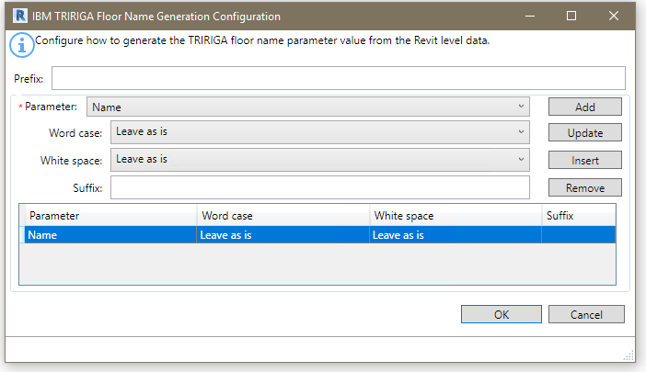

Figure 11 - Parameter value creation rule form

**Prefix:** A static text string that is applied once at the beginning of the name.

**Parameter:** The dropdown displays a list of all user visible parameters that are defined for the element type. It also exposes some non-parameter values of the element. A value generation rule requires at least one parameter and may have any number of additional parameters.

For rules that apply to components and types, only parameters that are associated with every supported category are included in the Parameters dropdown.

There are several ways the original parameter value can be manipulated before it is used:

* Word case: This provides options for case folding and capitalization of the parameter value.
* White space: This provides options for normalizing the white space contained in a parameter value.
* Suffix: This is static text that is appended to the end of the value of the referenced parameter. It is useful for adding separators between parameters.

**Add**: Adds the parameter definition at the end of the list.

**Update**: Replaces the selected parameter definition with the current definition.

**Insert:** Inserts the parameter definition before the selected definition.

**Delete:** Deletes the selected definitions.

|  |  |
| --- | --- |
| Tip | *Use the ability to save confirmation to and load it from the TRIRIGA server to ensure consistent rules are used across all models.* |

|  |  |
| --- | --- |
| Tip | *Including the element ID in Component names, Type Names, and Barcodes can help with uniqueness.* |

|  |  |
| --- | --- |
| Tip | *The parameters added by the COBie toolkit appear in the Parameters dropdown. You can effectively use the COBie rules instead of defining rules here by selecting just the COBie.name parameter for each element.* |

The project settings are stored in the model file.

#### Sample Naming Rules

The following naming rule can be used as a reasonable start to developing your origination’s naming policy:

Model: <Model file name>

Building <Building name>

Floor: <Name>

Room <Level>-<Name>-<Number>

Area <Area Scheme>-<Level>-<Name>-<Number>

Space <Level>-<Name>-Number>

Type <Category>-<Type name>

Component: <Category>-<Type name>-<Element Id>

Barcode: <Element Id>

Notes:

1. Ensure that all models in a linked set have unique model names.
2. If TRIRIGA Spaces are to be created directly from Areas, the area name must not be the same as any Room name. Since similar rules are shown above, the Area must be disambiguated from the Room. In the above example, the Area Scheme name is used. Alternatively, a simple constant prefix such a “A” can be used.
3. Element Id is only useful for barcode for prototyping. Real barcode should be entered in the model and used to match to existing assets or to create new assets.

### Populate Parameters

Before a model can be integrated with TRIRIGA, the shared parameters required by TRIRIGA must be added to the model and have values assigned according to the rules defined above. This is done with the Populate Parameter tool.

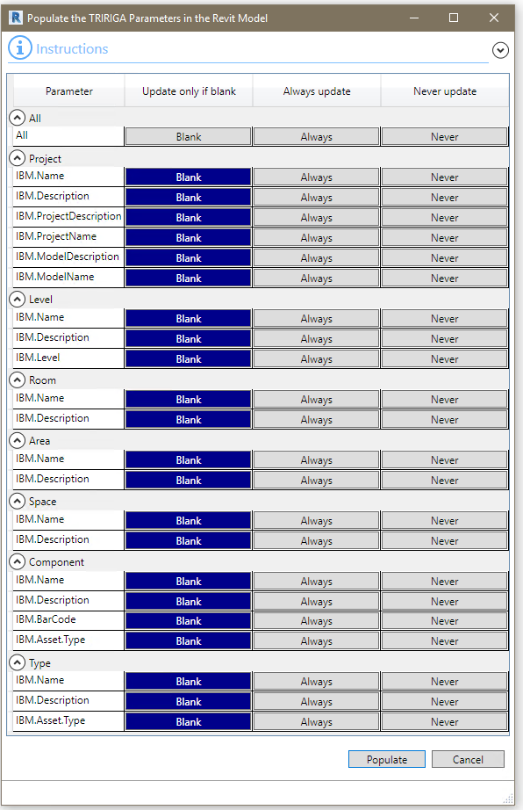

Figure 12 - Populate Parameters Form

There are 3 update options for each parameter.

* Blank: Only update the value if it is blank. This implies that either Populate Parameters has never been run, or the element has been added since the last time it was run.
* Always: Overwrite any existing value.
* Never: Do not populate.

It is usually only necessary to run populate parameters before the initial integration and before newly added elements are integrated. Blank works well for this. If one of the forms report errors, it may be necessary to use Always to overwrite the values with corrections. Once an element is linked to TRIRIGA or if it is integrated with an existing TRIRIGA record, the name value is retrieved from TRIRIGA.

#### Schedules

Populate Parameters creates schedules that show that values of the IBM parameters added to each type. It may create:

* A Levels Schedule
* A Rooms Schedule
* A Spaces Schedule
* An Areas Schedule for each Area Schema

Schedules are only created of there is at least one instance of the schedule element type in the model.

Each schedule is filtered for the IsTRIRIGA parameter having a value of true.

### , Space Use Class

Space Use Class is a split button that can display either a property sheet for setting Space Use Class on individual elements, or a bulk tool for setting Space Use Class on groups of elements. The button shows the last tools used.

TRIRIGA requires all spaces to have a Space Use Classification specified, therefore, to create TRIRIGA spaces for Revit Rooms, Spaces, or Areas, a Use Classification needs to be provided.

The Space Use Class List is retrieved from the TRIRIGA server on login and stored in the model. If a list is already stored in the model, the new list is compared to the old and a warning is issued if any entries in the old list are not in the new list. This happens whenever a model is opened and the connector is already logged into TRIRIGA, or when the connector logs into TRIRIGA with a model open.

Use Classification can be assigned individually or in bulk to Revit Rooms and Spaces. They are stored in the IBM.UseClassification parameter and the human readable label is stored in the IBM.UseClassification.Name parameter. These values are used when TRIRIGA spaces are created from the Revit objects. Once a Revit Room or Space is integrated with a TRIRIGA space, TRIRIGA is the master for Use Classification so updates here have no effect and are overwritten by a Sync operation.

The Space Use Class List may be imported and exported as an XML file. This allows the connector to be used to configure Space Use Classes without access to a TRIRIGA server.

|  |  |
| --- | --- |
| Tip | *The Integrate Room and Integrate Space tools both verify that a Use Classification is assigned and does not display the Room or Space in the list of elements to integrate if it is missing. However, the Use Classification is only used for creating new TRIRIGA spaces. Specify Use Classifications for Rooms and Spaces for which you intend to create new TRIRIGA spaces, then use the Assign Blank function to set the remainder to a default value.* |

#### Property Sheet

The Spaces Use Class property sheet is a dockable property sheet the displays and set the Space Use Class for the current selection.

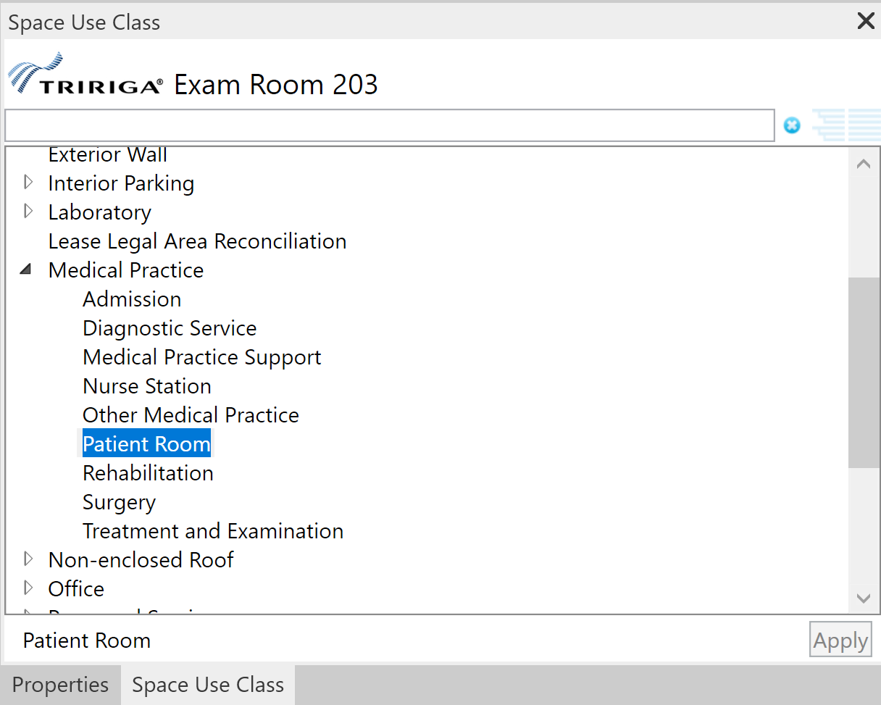

If the current selection contains at least one element that supports Space Use Class: A Room, Space, or Area, the Space Use Class tree is displayed, and the name of the element is shown in the property sheet title bar. If the selection set has exactly one element that supports Space Use Class, the currently assigned Space Use Class is selected in the tree.

**Note:** The APIs Revit provides to track the current selection do not always report when additional items of the same type are added to the selection set so the property sheet may only reflect the first Room, Space, or Area in the selection set.

**Apply:** The Space Use Class of all the elements in the selection set that supports Space Use Class can be updated by selecting a Space Use Class in the tree and pressing the Apply button.

If any of the selected elements are Areas, and the selected Space Use Class has a BOMA type specified, the Area Type of the Area is updated.

#### Bulk

The bulk Space Use Class tool assigns Space Use Classes to list of Rooms, Spaces, and Areas. The list of assignable elements can be searched and filtered and a Space Use Class assigned to the resulting element set. See Table 1 - BOMA Type to Revit Area Type Mapping

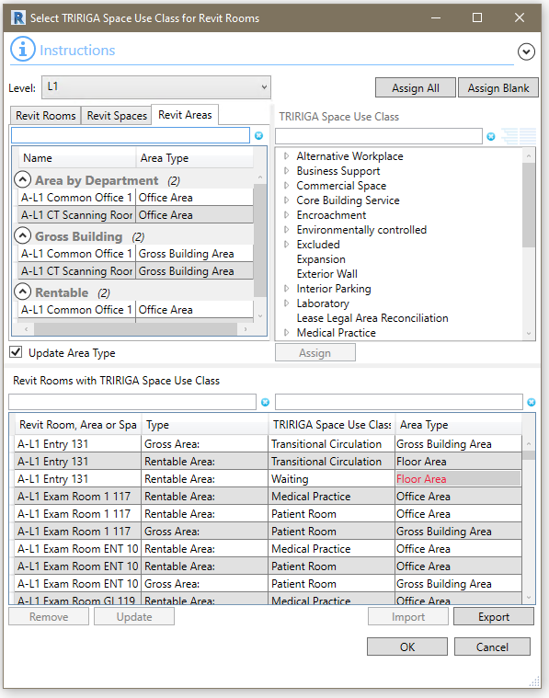

Figure 13 - Space Use Classification Form

**Level:** A list of all Revit levels. The selected level sets the context for the Revit Rooms, Revit Spaces, and Revit Areas tabs.

**Revit Rooms**: All the Rooms on the selected Level that do not have Use Classifications assigned.

**Revit Spaces**: All the Spaces on the selected Level that do not have Use Classifications assigned and are not linked to a room either by Revit, or by the Connector Spaces tool described below. If Rooms and Spaces are defined in the same model, and a Room and a Space share the same boundary, then Revit links them.

**Revit Areas**: All the Areas for any Area Schema on the selected Level that do not have Use Classifications assigned.

|  |  |
| --- | --- |
| Tip | *Use Classification is only used for Spaces if a TRIRIGA Space is directly created from the Revit Space. This is rare as Revit Spaces are typically linked to TRIRIGA Spaces created from Rooms. You can bulk assign a Use Classification to spaces, then individually edit any that will be directly integrated.* |

**Revit Rooms with TRIRIGA Space Use Class**: This shows the current list of rooms and spaces that have the have Use Classifications assigned, and their assigned value. When the form is initially opened, this displays the current state of the model.

Entries that have Space Uses Classes that are not in the list of Space Use Classes stored in the model are shown in red. This can happen if the connector logs into a server with a different set of Space Use Classes that were use used when the assignments were made.

If the Revit Area Type does not match the BOMA type of the space uses class as shown in Table 1, the Area Type is shown in red. This may happen if the Area Type is set by some method other than the BIM Connector, or for models configured with older versions of the connector.

**Update Area Type:** If this option is selected, when the form is accepted, all Areas that have Space Use Classes assigned have their Area Type updated to match the BOMA type of the Space Use Class.

**Assign**: When a Use Classification is selected, and at least one Room or Space is selected, this button is active. Pressing it assigns the Use Classification to all selected Rooms and Spaces, removes the Rooms and Spaces from their respective list and adds them to the assigned table.

**TRIRIGA Space Use Class**: The space use classification hierarchy from the server to which the connector is logged into. This is retrieved at the time of login.

**Assign All:** Assigns the selected Use Classification to all rooms and spaces on all levels. Any previously assigned values are overwritten. All Rooms and Spaces are moved to the assigned table with the new value.

**Assign Blank:** Assigns the selected Use Classification to all rooms and spaces on all levels that do not currently have a value. All Rooms and Spaces are moved to the assigned table with the new value.

**Remove**: Removes all selected rows from the assigned table, clears the Use Classification value and returns them to their respective lists.

**Update:** Values in the assigned table can be directly updated. This is useful for updating assignments when the server list has changed. To update:

* Select one or more row in the “Revit Rooms with TRIRIGA Space Use Class” table
* Select an entry in the Space Use Class tree
* Push the update buttin.

**Export:** Saves the current Use Classification list to a local file.

**Import:** This button is only active when the Connector is not logged into TRIRIGA. It imports a Use Class list previously created by export and save it in the model. This allows the Space Use Class to be used when a TRIRIGA server is not available.  
  
**Note**: The imported list is overwritten by the current list from the server when the connector logs into TRIRIGA.

Use Classifications are only used for creating new TRIRIGA spaces. When integrating with existing spaces, or when synchronizing the model with TRIRIGA, the Use Classification is updated from the linked TRIRIGA space.

### Areas from Rooms

Revit uses Area Plans to support space planning. Area plans are used to calculate space and floor area. Revit support two types of Area Plans:

* Gross Building: Only one is allowed.
* Rentable: Area is calculated according to the BOMA 98 standard. A model may define any number.

Area plans are divided into Areas. Areas are drawn onto the floorplan and need not have any relationship to Rooms or Spaces. This means that there are 4 possible relationships between an Area and a Room:

1. The area boundaries match the room boundaries.   
   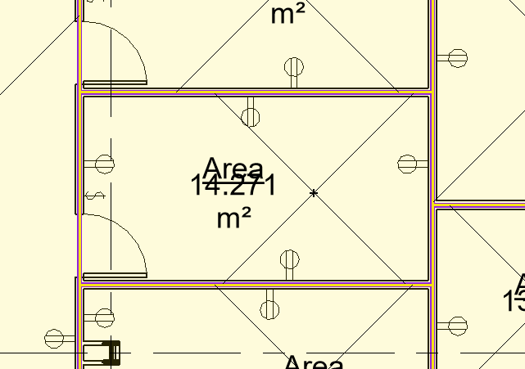
2. A room is comprised of exactly n areas. That is, none of the Area boundaries for areas within the room cross the Room boundary, and there is more than one Area within the Room.  
   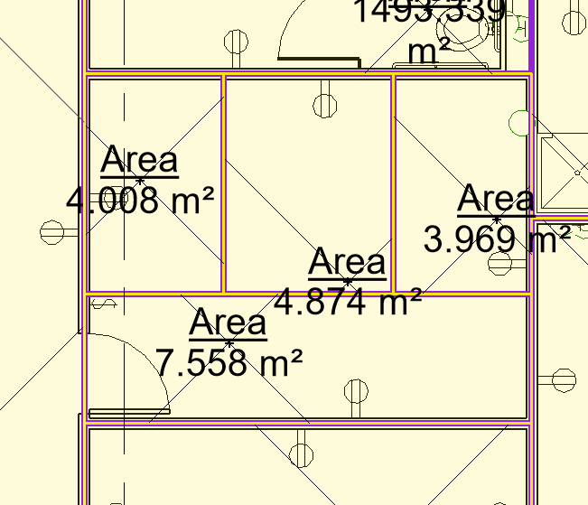
3. An Area is encompassing exactly n Rooms. That is, none of the room boundaries for Rooms within the Area cross the area boundaries, and there is more than one Room within the Area, and the Area is completely filled by Rooms.  
   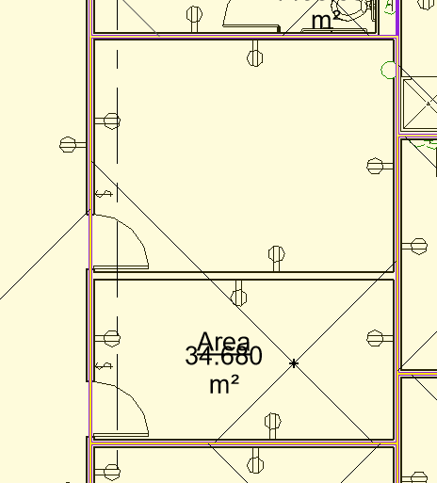
4. Areas are arbitrary: Area and room boundaries cross area boundaries.  
   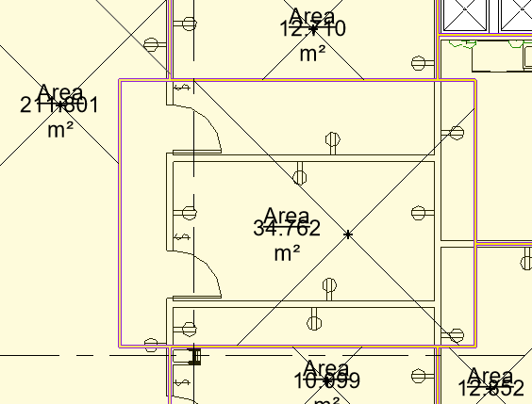

The connector can use Area Plans to calculate TRIRIGA floor area and Areas to calculate TRIRIGA Space area. Since there is only one Gross Area Plan allowed, if it exists, it is used to calculate gross floor area. The Rentable Area Plan must be specified. Areas can be linked to Rooms assuming Areas are specified as described in case 1 or 2 above. When one or more Areas are linked to a Room, the Revit Room area is replaced by the sum of the area from the linked Areas.

The Connector can aid in implementing the first case by automating the space creation process. Use the Areas from Rooms tool to automate the following steps:

1. Creating Area separator lines by cloning the Room separator lines.
2. Cloning an Area from each Room and placing it within the cloned separator lines.
3. Assigning Area name and number from the name and number of the cloned Room.
4. Creating and placing Area Tags.
5. Associating the new Area with the Room from which it was derived.
6. Setting Area Type.

**Note**: The process clones the Room boundary. It does not implement any specific area measurement standard. It may be necessary to adjust the resulting Area Separator Lines to support a specific area measurement standard.

Areas and Area Tags require an insertion point that is within the bounding lines. To determine an insertion point, the tool first tests the center of the bounding box for the Room and uses it if it is within the Room. If it is not, it tests the anchor point for the Room Tag and uses it if it is within the Room. If it is not, an error is reported and no Area is created.

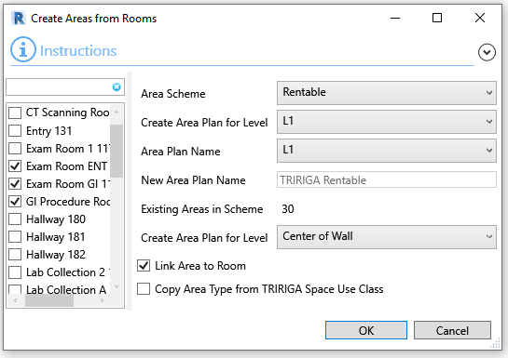

Figure Areas from Rooms form

**Area Schema:** Select an Area Schema: Gross Building Area, Rentable Area, or a custom schema. To use this tool, the Area Schema must already exist in the model. Area Schema can be created with the “Area Plan” tool found on the “Architecture” tab.

**Create Area Plan for Level:** Selected a Level.

**Area Plan Name:** Select an existing Area Plan to re-use, or select <NEW> to create a new Area Plan. If <New> is selected, the New Area Plan field is enabled.

**Link Area to Room:** When selected, the steps that are normally performed in the “Map Areas to Rooms” tool are automatically performed as part of Area creation.

**Copy Area Type from TRIRIGA Space Use Class:** If a Room has a TRIRIGA Space Use Class assigned, the Area Type parameter of the Area created from the room is initialized from the BOMA class of the Space Use Class using the following mapping:

|  |  |
| --- | --- |
| TRIRIGA BOMA Class | Revit Area Type |
| Not Applicable | Building Common Area |
| Building Common | Building Common Area |
| Building Shared | Building Common Area |
| Exterior Walls | Exterior Area |
| Floor Shared | Floor Area |
| Floor Shared | Floor Area |
| Office | Office Area |
| Other Tenant | Office Area |
| Store | Store Area |
| Vertical Penetration | Major Vertical Penetration |

Table - BOMA Type to Revit Area Type Mapping

If Areas already exist for the selected Area Schema/Level combination, you are prompted to delete the existing Areas. It is not required that existing Areas be deleted. However, if they are not, Revit issues a warning whenever an existing Area and an Area created by this tool overlap, and the new Area may not be placed properly. These warnings must be manually resolved.

If existing Areas are deleted, all information in the existing Areas is lost. New Areas are created solely from the Rooms. In addition: the new Areas have different ID from the deleted Area even if they occupy essentially the same space. Any references to the Area by ID will be broken. When existing Areas are deleted, links between Level and Area Plan and Room and Area created by the Map Areas to Rooms tool are automatically removed.

#### Room Filter

The tool is primarily intended for a one-time generation of Areas after all rooms have been added to the model. However, it can also be used to generate Areas for a selected set of Rooms, either initially or after the model has been changed. Areas are only created for Rooms that are checked in the room filter.

When the form is initially displayed, Rooms in the filter are checked if they do not have an Areas mapped to them which presumes that no Area has been created for the Room. Running the tool “fills in” the missing Area. If Rooms already have Areas occupying some or all their area, a Revit error will result.

### Map Areas to Rooms

Use the Map Areas to Rooms tool to manage the association of Areas to Rooms, and to select the desired Rentable Area Plan. When this form is first opened, it displays the current Room to Area linkage in the model, and the active Rentable Area Plan. The tool is only active if there are Area Plan(s) defined in the model.

**Note:** If a Schema has Areas that are linked to TRIRIGA Spaces, that Schema is selected and cannot be changed in this tool. To change the Schema, use the Areas tool to delete all the TRIRIGA integration records.

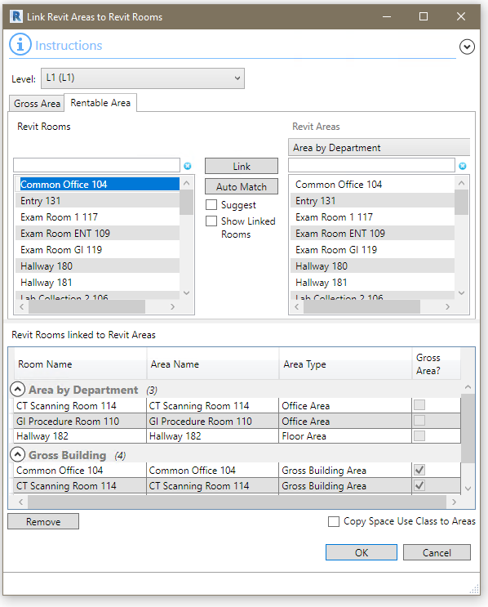

*Figure 15 - Link Areas to Rooms Form*

The form has several parts so some care should be taken to ensure you are working in the right context.

**Level:** Area Plans and Areas are associated with Revit Levels, so the level selection controls the context of the rest of the form. The Rooms, Area Plans, and Areas displayed are all for the Level selected in the Level dropdown.

**Gross Area/Rentable Area:** The form has two tabs which control the type of area plan displayed. These tabs are almost identical, except the rentable table requires selection of the Area Schema. Since only one Gross Area plan is allowed, no selection is required.

**Revit Rooms:** This displays the list of Rooms on the Level not linked to an Area in the selected Area Schema. Each Area Schema has its own set of Rooms.

**Revit Areas:** For the Gross Area Schema, this displays the list of Areas defined for the Area Schema. For Rentable Area Schemas, the Area Schema must be selected. The list of areas displayed is for the selected Area Schema. The selected Area Schema also controls the set of linked areas displayed in the linked table. Links are shown for the Gross Area Schema and the selected Rentable Area Schema.

**Link:** When an entry in the selected Rooms list and one or more entries are selected in the Areas list, pressing Link associates them, removing them from their respective lists and adding them to the Linked Rooms and Areas table in the correct section.

**Auto Match:** Auto match performs an exact name match of each room against the displayed area list. Each matching pair is linked as above.

**Suggest:** If the Suggest option is selected, the Area list is filtered by the selected room to only show Areas that have their insertion point within the bounding box of the selected room.

**Show Linked Rooms:** When this is not selected (the default), the Rooms list behaves as described above. Any Room that is linked to at least one Area is not displayed in the list. This make it easy to see which Rooms still need to be linked. However, if additional Areas need to be added to a Room, Then the Room must be displayed in the Revit Rooms list to create the new linkage. Selecting this option displays all Rooms.

**Revit Rooms linked to Revit Areas:** The table displays the Room to Area linkage that will be applied to the model if the form is accepted. Pay attention to the Rentable Area section as it changes based on the selected Rentable Area Plan.

**Remove:** Removes the highlighted row(s) from the linkage table returning the Rooms and Areas to their respective lists.

**Copy Space Use Class to Area:** If this option is selected when the form is accepted, each Area that is mapped to a Room has its Space Use Class update to match the Room’s value if the Room has a value set.

The association between Area and Rooms is stored with the Rooms in hidden parameters.

|  |  |
| --- | --- |
| Tip | *Even if you do not map rentable Areas to Rooms, select a Rentable Area Plan for use in calculating floor rentable area.* |
| Tip | *If you have worked with more than one Rentable Area Plan, be sure that the correct one is selected when you accept the form. Only the mappings for the selected Area Plan are saved and used.* |

### Validate

The validate tool tests and validates the IBM parameter values for all element types. It is the same validate performed individually by the tools in the Integrate section, but it does not require a TRIRIGA login, or any elements to be integrated.

It is a dockable property panel.

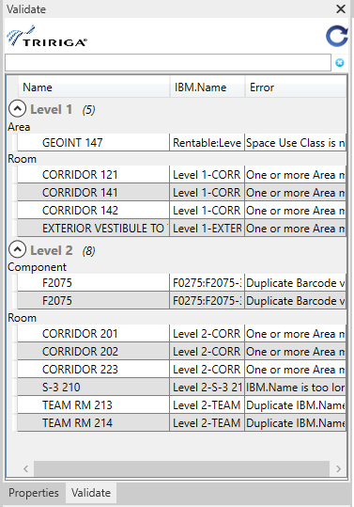

Figure – Validate Property Sheet

Validation is initiated when the tool is opened. It runs in the background. On completion, either a list of errors is displayed or a screen indicating that there are no errors.

**Refresh**: Reruns the validation.



**Double click an error entry**: Uses the standard Revit mechanism to display and select the element referenced by the error. Or for Types, selects but does not display the first component of the referenced type, then opens the Type editor.

|  |  |
| --- | --- |
| Tip | *When correcting errors for IBM parameters whose values is generated from other parameters by a naming rule, it is generally best to correct the source parameters and re-run Populate Parameters with the required parameter type(s) set to always update* |

The following validation tests are performed:

#### Project Information

* IBM.BuildingName, and the IBM.ModelName parameters have values.
* IBM.BuildingName, and the IBM.ModelName do not contain the # character.
* IBM.BuildingName, and the IBM.ModelName do not exceed 150 characters in length.

#### Levels

* All levels have a value in their IBM.Name parameter.
* There are no duplicate values for the IBM.Name parameter in the list of levels.
* The value of the IBM.Name parameter for all levels does not exceed 50 characters.
* That any Gross or Rentable Area Scheme referenced by the Level exists in the model.

#### Rooms

* The Room is placed and bounded
* All Rooms have a value in their IBM.Name parameter.
* There are no duplicate values for the IBM.Name parameter in the list of Rooms on each level.
* The value of the IBM.Name parameter for all Rooms does not exceed 100 characters.
* All Rooms have a value for IBM.UseClassification.
* The IBM.UseClassification value is in the list of Use Classifications stored in the model.
* All the Areas referenced by the area lists in the IBM.GrossAreaSource and the IBM.RentableAreaSource reference Areas that exist in the model.
* All the Areas referenced by the area lists in the IBM.GrossAreaSource and the IBM.RentableAreaSource are placed (Have an area greater than 0.0).

#### Spaces

* All Spaces have a value in their IBM.Name parameter.
* There are no duplicate values for the IBM.Name parameter in the list of Spaces on each level.
* The value of the IBM.Name parameter for all Spaces does not exceed 100 characters.
* All Spaces have a value for IBM.UseClassification.
* The IBM.UseClassification value is in the list of Use Classifications stored in the model.

#### Areas

* All Areas have a value in their IBM.Name parameter.
* There are no duplicate values for the IBM.Name parameter in the list of Areas for the combination of Area Scheme and Level.
* The value of the IBM.Name parameter for all Areas does not exceed 100 characters.
* All Areas have a value for IBM.UseClassification.
* The IBM.UseClassification value is in the list of Use Classifications stored in the model.
* The Revit Area Type is set

#### Types

* All Types have a value in their IBM.Name parameter.
* There are no duplicate values for the IBM.Name parameter in the list of Types.
* The value of the IBM.Name parameter for all Types does not exceed 100 characters.

#### Family Instance/Component

* All Components have a value in their IBM.Name parameter.
* There are no duplicate values for the IBM.Name parameter in the list of Components.
* The value of the IBM.Name parameter for all Components does not exceed 100 characters.
* All Components have a value in their IBM.BarCode parameter.
* There are no duplicate values for the IBM.BarCode parameter in the list of Components.

The Maximum field length, and restricted character list are configurable properties. They may be set in the TRIRIGA_AR.property file. These values should only be changed if the database scheme for the TRIRIGA server has been customized to change these values.

### Parameter Mapping

Parameter mapping defines relationships between parameters in Revit elements and fields in TRIRIGA records. The mapping is used by the Sync tool to transfer values between the mapped fields in Revit and the TRIRIGA server. It is essential an Extract-Transform-Load (ETL) tool. It has two components: A definitions component which is described here, and an active component which is part of the Sync process and described in the section 2.4.12 Sync.

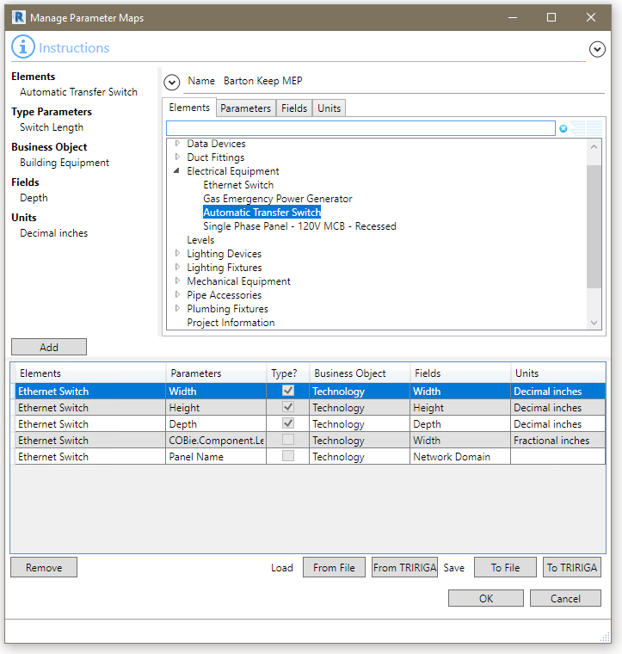

Figure 17 - Parameter Map Form

Creating a map entry is three or four steps:

1. Select the element type. This may be Project Information, Level, Room, Space, or any category or family supported by the Integrate Asset operation. The selected element type sets the content of the next two tables.
2. Select a parameter. The displayed Revit Categories fall into two groups: Project Information, Level, Room, Space. Everything else. Categories in the first group display all the parameters available for the element type. Categories in the second group work as follows: If the category is selected all the shared parameters for the category are displayed. If a Family is selected, Type or Instance parameters must be selected. All the parameters for the family of the selected type are displayed.

Parameters are marked as read-only if they are defined as read-only or the base data type is element Id, which cannot be updated from TRIRIGA. Type parameters are always read-only.

1. Select a field. The source of the fields is based on the Revit element type as follows:

|  |  |
| --- | --- |
| **Revit Element** | **TRIRIGA Record Type** |
| Project Information | triBuilding |
| Level | triFloor |
| Room | triSpace |
| Space | triSpace |

Fields for Family Instances are drawn from one of the TRIRIGA asset types. The specific business object type must be selected.  
  
The fields actually come from queries that can be user configured. See 7 Appendix: Configuring . The left-hand column has the localized query field label, and the next column the field data type.

1. If both the selected parameter and the selected field are numeric, the Units tab is displayed. Select the units used to exchange data. Revit data is converted into and out of the selected units.

Push the add button to create the mapping. This removes the parameter and field from their respective tables. A parameter or Field can only be used for one mapping for a given element type.

Each model can have a single mapping list associated with it. The mapping list may be cleared from the model with the Detach tool. Mapping lists may be saved to the TRIRIGA server or to an external file.

Mapping lists may be loaded from the TRIRIGA server of from a previously saved file. Doing so replaces the existing mapping list in the model with the newly loaded mapping list. When a new mapping list is loaded, the element type for each map entry is matched by name to element types (Families) in the current model. If one or more element types cannot be found in the model, then the “View Unmatched Map Entries” button is displayed.

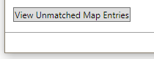

Figure 18 – View Unmatched Map Entries Button

Pushing this displays the list of map entries with Families that are not in the current model.

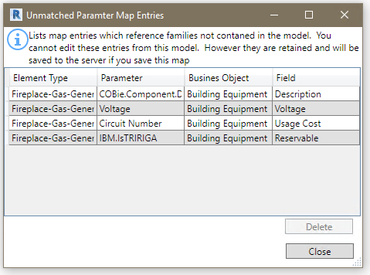

Figure 19 – Unmatched Entries Form

Entries in this list may be deleted but not otherwise altered. If the parameter map is saved to the server or an external file, these entries are included in the saved map.

## Integrate

The integrate steps generally need to be performed in the order presented here. This builds up the TRIRIGA location hierarchy. In addition, when working with federated models, the architecture model, or the model containing the majority of the room definitions should be the first model integrated. Additional models in the set are integrated as linked models.

#### Validation

Each form performs validation on the values of the parameters added by TRIRIGA to the primary object handled by the form, for example, Levels. If errors are found, the View Errors button is visible in the lower left corner of the form with an error count. This is identical to the validate dome by the Validate tool.



Figure 20 - View Errors Button

The View Errors button provides a list of error types and under each type a list of erroneous elements.

**Note**: Elements with errors are not displayed in the form and are not available for integration.

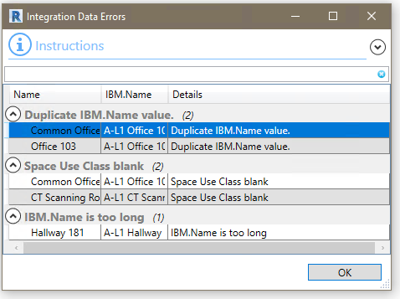

Figure 21 - Integration Error Form

Double clicking any row in the error listing initiates the normal Revit process to find a suitable view, display and highlight the element.

#### Confirmation

Each form request confirmation before initiating the integration process. The request provides a general description of the action that will be performed.

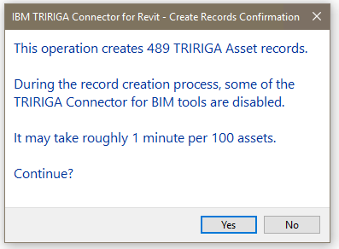

Figure 22 - Confirmation Form

#### Linked Models

Many models are composed of several federated or linked files. These are often organized by discipline. The linked files contain many assets that are of interest to TRIRIGA users. However, the asset information is much more useful if the assets are correctly placed in the TRIRIGA location hierarchy. Linked model files often echo spatial elements from the primary, usually architectural, model file: Levels are duplicated across the files set. MEP Spaces are often, from a facilities management perspective, identical to Rooms.

The primary task of integrating a linked model file is to match the congruent spatial elements to the master elements in the primary integration file. Once the match is made, the connector writes the unique ID of the matched element into a hidden parameter in the linked file. When communicating with TRIRIGA about that element, including about the locations of asset contained within it, the connector uses the ID of the master element in place of the ID in the current file.

#### TRIRIGA Staging Records

Each of the integration operation create and/or update one or more TRIRIGA BIM staging records. The description below for each operation includes details of which staging records in creates and/or updates. All staging records are in the BIM module and the Business Object names all begin with triBIM.

In normal operation, no user interaction with the staging records is needed. The information is included to provide a complete understanding of the Connector data flow, and to aid in problem resolution.

There is a set of system reports that can be used to view the staging records. To view staging records:

1. From the TRIRIGA portal, open Report Manager and select the System Reports tab.
2. Enter the staging record name in the Business Object search field. You can enter either the name, for example “triBIMModel”, or the label, for example “BIM Model”.
3. Run the report with a name ending in “- Dev”.

### Publish Status

All the integration forms use a three-step process:

1. Data is uploaded to the triBIM staging tables on the TRIRIGA server. This is synchronous and Revit cannot be used during its execution.
2. The data is published via integration workflows from the triBIM objects to the application objects. This happens asynchronously on the TRIRIGA server.
3. For Building, Level, Room, and Space publish operations, on completion of the TRIRIGA publish operation, the model is updated with the identity of the application objects created by the publish operation.

On completion of the first step, the connector form closes and control returns to the user. However, new integration operations cannot be started until the publish has run to completion on the server. Tools that initiate these operations are disabled until the publish operation is complete, When the publish operation is initiated, the Publish Status tool is displayed. The connector monitors the status of publish process. The icon for the Publish Status tool has a progress indicator and the Publish Status monitor can be opened to display slightly more detailed progress information.

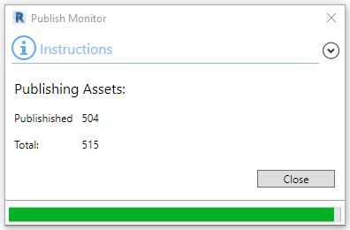

Figure Publish Status Monitor

The model tracks when a publish operation is active and what type of operation. If an operation was active when the model was closed or disconnected from TRIRIGA, when the model is reconnected to TRIRIGA, the connector checks the status of the operation. If the operation has completed, any updates required to the model are made. If it is still active, the Publish Status tool is displayed, and other interactions with the TRIRIGA server are disabled until it finishes.

A publish operation may take several hours depending on server load and amount of data published.

### Upgrade

The Upgrade button only displays on the ribbon if the currently loaded model requires upgrade.

If the model has been previously integrated with an older version of the connector, the model must be upgraded to the current connector version. If the upgrade is from the 1.x version of the connector, TRIRIGA integration data is also upgraded. Until the upgrade is run, the only tool that interacts with TRIRIGA that is available is Upgrade. Once the upgrade is complete, all the tools normally available are active.

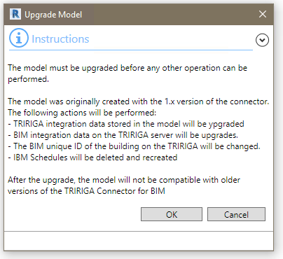

Figure 24 - Sync Upgrade Form

In addition to updating integration data, the upgrade process deletes and recreates the IBM schedules.

#### Staging Records

Upgrading from Connector version 2.6.0.0 or higher does not change any data of the TRIRIGA server.

Upgrading from the 1.x Connector updates: triBIMBuilding, triBIMFloor, and triBIMSpace. triBIMModel is deleted and a new instance is created.

The application Building, Floor, and Space records are updated to include the Revit UniqueId.

### Verify Server

When a model is integrated with TRIRIGA, the URL of the TRIRIGA server is stored in the model. Each time a model is loaded, or the connector authenticates to a TRIRIGA server, the URL store in the model is compared to the URL of the server. If they do not match, the Verify Server tool is displayed on the ribbon and all other interaction with the TRIRIGA server is disabled.

Usually this indicates that the connector is authenticated to a different server that the one the model is integrated with. The connector should be logged out and connected to the correct server.

If the TRIRIGA server is multi-homed (has more than one name), or is accessed through a proxy, then the server may be correct despite the name mismatch, and the Verify Server tool attempts to find the building integration record on the server. If it does, it updates the TRIRIGA server URL stored in the model to the current server.

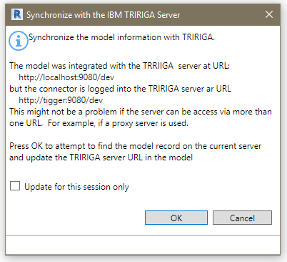

Figure 25 - Verify Server Form

**Update for this session only**: If this option is selected, then the URL in the model is not updated. Instead, the URL stored in the model is stored with the TRIRIGA session. If the stored URL of a model matches either the URL used to authenticate the session, or the verified URL from the model, it is considered correct. This continues to hold even if a new model is loaded.

### Building

There are four options for integrating a building:

* **New Building:** This creates a new TRIRIGA building record and new triBIMModel record, and a triBIMBuilding record.
* **Add Linked Model:** This adds a linked (federated) model file to a previously integrated building. This links the model file to the TRIRIGA building record, and creates a new triBIMModel record.

If the primary model was integrated on a pre-3.6.0 server and has never been synced on 3.6.0 or higher server, it does not show in the list of building. It must first be upgraded before a linked model can be added.

* **Existing Building:** This links the model to an existing TRIRIGA building, which has not previously been integrated. That is, a building that was manually created in TRIRIGA. A triBIMBuilding record and a triBIMModel record are created. The triBIMBuilding is associated with the existing TRIRIGA building.
* **Reattach:** Attach a model that does not have any integration data stored in it to a TRIRIGA building that was created from the connector. The process reestablishes all the integration links in the model from the servers. There are several different cases. Most are addressed by the Reattach option.
  + A model that was originally integrated with the 2.6.1 connector, or has been update to 2.6.1 by a previous reattach or sync using the 2.6.1 connector. This includes linked models.

The building is displayed with each model linked to the building listed under the building. To reattach the model, select the correct model record.

* + A primary model that was created by the 2.6.0 or 2.6.0.1 connector, and has not been synced or reattached using the 2.6.1 connector.

The building is displayed with each model linked to the building listed under the building. To reattach the model, select the correct model record.

Reattaching the building upgrades the TRIRIGA data in the model to the 2.6.1 level.

* + A model that was integrated as a linked model using a connector version prior to 2.6.1 and has never been synced using the 2.6.1 connector.  
      
    The building is displayed, but the model record for the linked model is not listed under the building. The model cannot be reattached. However, the model can be reintegrated as a linked model and will function, but it loses ownership or TRIRIGA records it has previously created and cannot synchronize with these records.
  + A building that was created by the 1.x connector using a 3.6.0 or higher server, or a building that was created with the 1.x connector on an older server and later synced with any connector version prior to 2.6.1 on a 3.6.0 or higher server.

The building is displayed with no models. The building can be selected and the model reattached. This upgrades both model data and TRIRIGA data to the 2.6.1 level.

* + A building that was created with the 1.x connector on a server prior to 3.6.0 and never synced after the server upgrade to 3.6.0+.

The building does not appear in the list of buildings for reattach. However, the building is displayed in the list of existing building. The model may be reattached using the existing building option. This upgrades both model data and TRIRIGA data to the 2.6.1 level.

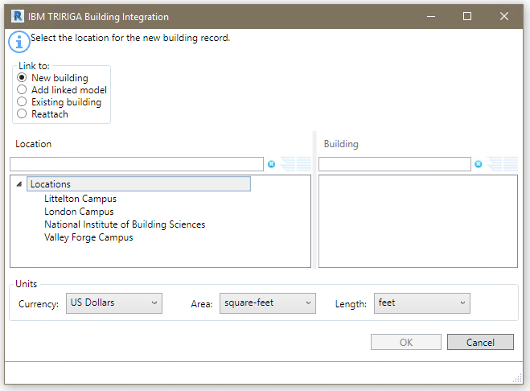

Figure 26 - Building Integration Form

To integrate the building with TRIRIGA:

1. Select how you want to integrate the building. The behavior of the rest of the form varies slightly based on the option selected.
2. Select a location. The location list can be filtered if desired.
3. If “Add Linked Model”, “Existing Building” or “Reattach” is selected, the building list is populated with buildings available for the location. The list is retrieved from the TRIRIGA server when the location is selected, so large lists may take a moment to load. For “Existing Building”, all buildings for the location that are not linked to a model are displayed. For “Add Linked Model” and “Reattach”, only buildings that were previously linked to a model through one of the other three options are displayed.
4. If “New Building” is selected, you can specify currency and units of measure.

**Validation:** When the form is opened, the following validations are performed on the model:

* Project Information: IBM.BuildingName, and the IBM.ModelName parameters have values.
* Project Information: IBM.BuildingName, and the IBM.ModelName do not contain the # character.
* Project Information: IBM.BuildingName, and the IBM.ModelName do not exceed 150 characters in length.

**Update**: If “Existing Building” or “Reattach” is selected, in the Project Information object:

* The IBM.Name is updated from the TRIRIGA building name.
* The IBM.Description is updated from the TRIRIGA building description.

If “Reattach” is selected, in the Project Information object:

* The Connector GUID for the model is updated from the TRIRIGA model record.

Once a model is integrated with TRIRIGA, the building tool is inactive. To integrate the model with a different TRIRIGA server, or to create a second instance of the building on the same server, the model must first be detached from TRIRIGA which clears data used by the connector from the model.

#### Staging Records

Integrating a Building creates a triBIMBuilding and a triBIMModel staging record. Reattaching to a previously integrated building reads these records, but makes no changes

### Levels

The Levels tool can be used to: create TRIRIGA Floors from Revit Levels, to link Revit Levels to existing TRIRIGA floors, or to link Levels from linked model files to Floors created from the same Level in the primary model file.

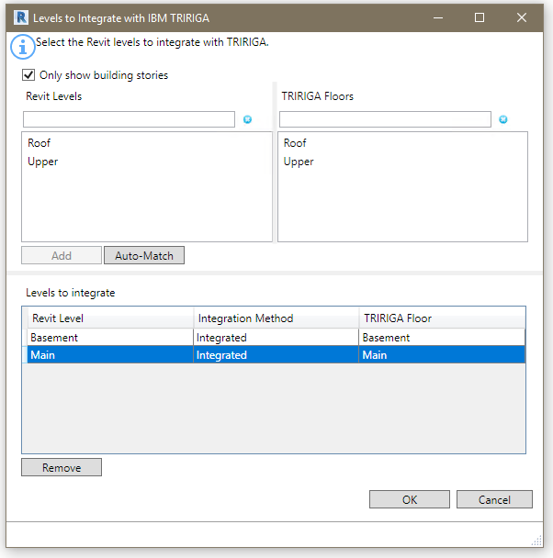

Figure 27 - Levels Integration Form

**Revit Levels:** All the levels in the model which are not yet integrated.

**TRIRIGA Floors:** If the building integration process used the “Existing Building” the “Add Linked Model” or the “Reattach” option and the TRIRIGA building has existing floors, then the list of Floors which are not integrated with a level is displayed.

**Levels to Integrate:** This shows all level that have been selected for integration or are already integrated. If they are already integrated, the associated TRIRIGA Floor is shown in the TRIRIGA Floor column. If processing this form will create a new Floor, New is shown. The Integration Method Column may have one any of:

* Blank: The level is not currently associated with a TRIRIGA Floor, and the process will create a new TRIRIGA floor and link the level to the new floor.
* Integrated: The indicated TRIRIGA Floor was previously created from this level and this model file. Or, that an existing TRIRIGA floor was selected that was not created from a model. The integration process will update the TRIRIGA floor to associate it with the Level.
* Linked: The indicated floor was previously created from a different model file that is part of the linked model set, and is either already linked to the Level in this model, or will be linked to the Level when the integration process runs.
* Locked: With Linked model files, in some cases Revit gives the Levels in the linked model file the same ID as the Level in the primary model file. The connector detects this and automatically associates the levels and marks them as “locked” because the association cannot be edited.

When the form is displayed, it attempts to match Revit Levels to TRIRIGA Floors by GUID. All matches are moved to the Levels to Integrate table. However, the form still needs to be processed to write these matches into the model. Typically, there are matches if the Floors were originally created from this model, the model has been detached, and is being reintegrated.

**Add:** If one or more level is selected, the Add button is active. Pressing Add moves all the selected levels from the Revit Levels list to the Levels to Integrate table and shows an action of New.

If a single item is selected in the Revit Levels list, and an item is then selected in the TRIRIGA Floors list, they are linked, removed from their respective list and added to the Levels to Integrate list:

* If the Floor was either not created by the Connector, or was previously created from this model file, the integration method is “Integrated”.
* If the Floor was created from a different model file in the linked set, the integration method is “Linked”.

**Auto-Match:** Auto-match attempts to match Revit Levels to TRIRIGA floors by matching the IBM.Name value to the Floor name. Each match is processed as above.

**Remove:** Removes the selected Level(s) from the integration list, When the form is processed, if it was previously integrated, the triBIM staging record is delete in TRIRIGA, if it was previously linked, the link is clear in Revit.

**Only show building stories**: If this is checked, the Revit Levels list is filtered to only show Levels that are building stories.

When the form is initially loaded, it tries to match Revit Levels to TRIRIGA Floors based on the GUID. If the model was previously detached, and is being reintegrated, all levels previously created from the model match and are moved to the Levels to Integrate table.

**Validate:** When the form is opened, the following validations are performed on the list of levels:

* All levels have a value in their IBM.Name parameter.
* There are no duplicate values for the IBM.Name parameter in the list of levels.
* The value of the IBM.Name parameter for all levels does not exceed 50 characters.
* An Area Scheme that was linked in any of the Area tools is still in the model.

**Update:** If the level is integrated with an existing TRIRIGA Floor, the following updates are made:

* Revit Level: IBM.Name is updated from the TRIRIGA floor name.
* Revit Level: IBM.Description is updated from the TRIRIGA floor description.
* Revit Level: IBM.Level is updated from the TRIRIGA Floor Level.
* TRIRIGA Floor: If a Gross Area Plan is associated with the Level, the gross area for the Floor is updated with the value calculated from the Area Plan by summing the area of all Areas in the Area Plan.

When the integration process runs, the following actions are performed:

* If a new integration is requested, a new triBIMFloor staging record is created, and a TRIRIGA floor record is created by workflow from the staging record.
* If integrate is requested, and a TRIRIGA Floor record exists, if a triBIMFloor staging record exists on the TRIRIGA server, the staging records is updated, if not, a new staging record is created and associated with the Floor. The updates described above are performed.
* If a link is requested, The GUID of the Revit Level that the TRIRIGA Floor was originally created from is retrieved from TRIRIGA and stored in a hidden parameter of the linked Level.
* If the Level was previously integrated, but now is not, the triBIMFloor staging record is deleted.
* If the Level was previously linked, but now is not, the GUID of the linked Level is removed from the Level.
* The IBM.isTRIRIGA value is updated on all Levels to reflect their new state.

### Rooms

Use the Room Tool to create TRIRIGA Spaces from Revit rooms, or to link Revit Rooms to existing TRIRIGA Spaces.

|  |  |
| --- | --- |
| Tip | *Process all the Rooms in the module you plan integrate before processing any Spaces even if you need to switch between model files. You can only link Space to Rooms, not Rooms to Spaces. So, if you create a TRIRIGA Space from a Revit Space, you will not later be able to link to a Room.* |

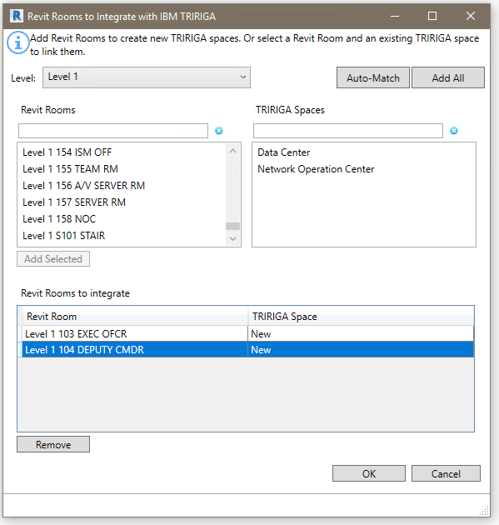

Figure 28 - Rooms Integration Form

**Levels:** The list of Levels that were integrated in the Levels step. Select the active Level. The Revit Rooms and TRIRIGA Spaces lists only contain Rooms and Spaces from the selected Level.

**Revit Rooms:** All the Rooms on the selected Level which are not yet integrated.

**TRIRIGA Spaces:** If the building integration process used the “Existing Building” the “Add Linked Model” or the “Reattach” option and the TRIRIGA building has existing Spaces, then the list of Spaces for the Floor matching the selected Level is displayed.

**Rooms to Integrate:** This shows all Rooms that have been selected for integration or are already integrated. If they are already integrated, the associated TRIRIGA Space is shown in the TRIRIGA Space column. If processing this form will create a new Space, New is shown.

When the form is displayed, it attempts to match Revit Rooms to TRIRIGA Spaces by GUID. All matches are moved to the Rooms to Integrate table. However, the form still needs to be processed to write these matches into the model. Typically, there are matches if the Spaces were originally created from this model, the model has been detached, and is being reintegrated.

**Add:** If one or more Rooms are selected, the Add button is active. Pressing Add moves all the selected Rooms from the Revit Rooms list to the Rooms to Integrate table and shows an action of New.

If a single item is selected in the Revit Rooms list, and an item is then selected in the TRIRIGA Spaces list, they are linked, removed from their respective list and added to the Rooms to Integrate.

**Auto-Match:** Auto-match first attempts to match Revit Rooms to TRIRIGA Spaces by matching the IBM.Name value to the Space name. Each match is processed as above. Next it attempts to find exactly one TRIRIGA Spaces that contains the Revit Room name. Each match is processed as above. Auto-match applies to all levels.

**Add All:** Add All is a short cut for large buildings. It adds all the rooms in the Revit Rooms list for all levels to the Rooms to Integrate table.

**Remove:** Removes the selected Room(s) from the integration list, if it was previously integrated, the triBIM staging record is deleted in TRIRIGA when the form is processed.

When the form is initially loaded, it tries to match Revit Rooms to TRIRIGA Spaces based on the GUID. If the model was previously detached, and is being reintegrated, all Rooms previously created from the model match and are moved to the Rooms to Integrate table.

**Delete Broken Links:** If there are Space integration records on the server owned by this model that do not match to any model elements (Rooms, Spaces, or Areas), then the integration records are deleted.

In previous versions of the connector, this cleanup was always performed. However, if this cleanup is performed, then the option in the Sync tool to delete TRIRIGA Spaces that are not in the model will not show any spaces as the model has relinquished ownership.

**Validate:** When the form is opened, the following validations are performed on the list of Rooms:

* All Rooms have a value in their IBM.Name parameter.
* There are no duplicate values for the IBM.Name parameter in the list of Rooms.
* The value of the IBM.Name parameter for all Rooms does not exceed 100 characters.
* All Rooms have a value for IBM.UseClassification.
* Any Area mapped to a room or used to create a sub-space is still in the model and placed.

|  |  |
| --- | --- |
| Tip | *If the room list is empty, check the error listing. You may have forgotten to assign Use Classifications.* |

**Update:** If the Rooms is integrated with an existing TRIRIGA Space, the following updates are made:

* Revit Room: IBM.Name is updated from the TRIRIGA space name.
* Revit Room: IBM.Description is updated from the TRIRIGA space description.
* Revit Room: IBM.UseClassification is updated from the TRIRIGA Use Classification.
* Revit Room: IBM.UseClassification.Name is updated from the TRIRIGA Use Classification.
* TRIRIGA Space: If an area from a Gross Area Plan is associated with the Room, the gross area for the TRIRIGA Spaces is updated with the value from the associated Area. Otherwise it is updated with the area from the Revit Room.
* TRIRIGA Space: If an area from a Rentable Area Plan is associated with the Room, the area for the TRIRIGA Space is updated with the value from the associated Area. Otherwise it is updated with the area from the Revit Room.

When the integration process runs, the following actions are performed:

* If a new integration is requested, a new triBIMSpsce staging record is created, and a TRIRIGA Space record is created by workflow from the staging record.
* If integrate is requested, and a TRIRIGA Space record exists, if a triBIMSpace staging record exists on the TRIRIGA server, the staging the record is updated, if not, a new staging record is created and associated with the Space. The updates described above are performed by workflow.
* If the Space was previously integrated, but now is not, the triBIMSpace staging record is deleted.
* The IBM.isTRIRIGA value is updated on all Rooms to reflect their new state.

### Spaces

Use the Space Tool to associate Revit Spaces with TRIRIGA Spaces. This is typically Spaces in a MEP model file with TRIRIGA Spaces that were created from Rooms in the architectural model. This allows assets contained within Revit Spaces to be associated with the correct TRIRIGA Space. You may also use this tool to create new TRIRIGA Spaces just like the Room Tool.

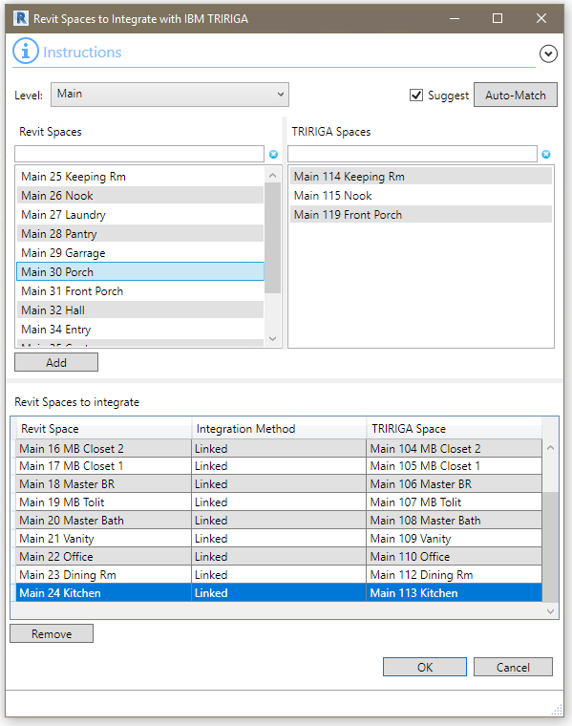

Figure 29 - Space Integration Form

When this form is displayed, it reflects the current state of the model, except where it makes automatic matches. The form must still be processed for the automatic matches to be written into the model.

**Levels:** The list of Levels that were integrated in the Levels step. Select the active Level. The Revit Spaces and TRIRIGA Spaces lists only contain Spaces from the selected Level.

**Revit Spaces:** All the Spaces on the selected Level which are not yet integrated.

**TRIRIGA Spaces:** All the TRIRIGA Spaces for the selected Level that are not yet integrated. Typically, these Spaces were created from Rooms in a linked model file that was previously integrated, and the current model file is integrated as a Linked Model.

**Revit Spaces to Integrate:** This shows all Spaces that have been selected for integration or are already integrated. If they are already integrated, the associated TRRIGA Space is shown in the TRIRIGA Space column. If processing this form will create a new Space, New is shown. The Integration Method Column may have one any of:

* Blank: The Space is not currently associated with a TRIRIGA Space, and the process will create a new TRIRIGA Space and link the Revit and TRIRIGA Spaces.
* Integrated: The indicated TRIRIGA Space was previously created from this Space and this model file. Or an existing TRIRIGA Space was selected that was not created from a model. The integration process will update the TRIRIGA Space to associate it with the Revit Space.
* Linked: The indicated Space was previously created from a different model file that is part of the linked model set, and is either already linked to the Space in this model, or will be linked to the Space when the integration process runs.
* Locked: If Rooms and Spaces exist in the same model file, and share the same boundary, Revit recognizes that they describe the same space and links them. The connector recognizes this, automatically matches them and shows the integration method as “Locked”.

**Add:** If one or more Revit Spaces are selected, the Add button is active. Pressing Add moves all the selected Spaces from the Revit Spaces list to the Spaces to Integrate table and shows an action of New.

If a single item is selected in the Revit Spaces list, and an item is then selected in the TRIRIGA Spaces list, they are linked, removed from their respective list and added to the Spaces to Integrate table.

**Auto-Match:** Auto-match first attempts to match Revit Rooms to TRIRIGA Spaces by matching the IBM.Name value to the Space name. Each match is processed as above. Next it attempts to find exactly one TRIRIGA Space the contains the Revit Room name. Each match is processed as above. Auto-match applies to all levels.

**Suggest:** If the Suggest option is selected, the TRIRIGA Space list is filtered by the selected Revit Space to only show TRIRIGA Spaces that have an area equal to the area of the selected Revit Space +/- 6” of wall thickness.

**Remove:** Removes the selected Space(s) from the integration list, if it was previously integrated, the triBIM staging record is deleted in TRIRIGA when the form is processed.

When the form is initially loaded, it tries to match Revit Rooms to TRIRIGA Spaces based on the GUID. If the model was previously detached, and is being reintegrated, all Spaces previously created from the model match and are moved to the Spaces to Integrate table.

**Delete Broken Links:** If there are Space integration records on the server owned by this model that do not match to any model elements (Rooms, Spaces, or Areas), then the integration records are deleted.

In previous versions of the connector, this cleanup was always performed. However, if this cleanup is performed, then the option in the Sync tool to delete TRIRIGA Spaces that are not in the model will not show any spaces as the model has relinquished ownership.

**Validate:** When the form is opened, the following validations are performed on the list of Revit Spaces:

* All Spaces have a value in their IBM.Name parameter.
* There are no duplicate values for the IBM.Name parameter in the list of Spaces.
* The value of the IBM.Name parameter for all Spaces does not exceed 100 characters.
* All Spaces have a value for IBM.UseClassification.

|  |  |
| --- | --- |
| Tip | *If the Space list is empty, check the error listing. You may have forgotten to assign Space Use Classifications.* |

**Update:** If the Space is integrated with an existing TRIRIGA Space, the following updates are made:

* Revit Space: IBM.Name is updated from the TRIRIGA space name.
* Revit Space: IBM.Description is updated from the TRIRIGA space description.
* Revit Space: IBM.UseClassification is updated from the TRIRIGA Use Classification.
* Revit Space: IBM.UseClassification.Name is updated from the TRIRIGA Use Classification.

When the integration process runs, the following actions are performed:

* If a new integration is requested, a new triBIMSpace staging record is created, and a TRIRIGA Space record is created by workflow from the staging record.
* If integrate is requested, and a TRIRIGA Space record exists, if a triBIMSpace staging record exists on the TRIRIGA server, the staging records is updated, if not, a new staging record is created and associated with the Space. The updates described above are performed.
* If a link is requested, the GUID of the Revit Room that the space was originally created from is retrieved from TRIRIGA and stored in a hidden parameter of the linked Space.
* If the Space was previously integrated, but now is not, the triBIMSpace staging record is deleted.
* If the Space was previously linked, but now is not, the GUID of the linked Room is removed from the Space.
* The IBM.isTRIRIGA value is updated on all Spaces to reflect their new state.

### Areas

User the Areas tool to associate Revit Areas with TRIRIGA Sub-Spaces. A Sub-Space is a Space that has another space as its parent instead of a floor. For this tool, the parent Space must be integrated with a Revit Room.

|  |  |
| --- | --- |
| Tip | *Use Rooms to represent physical walled space. When a room such as a large open work area is sub-divided for space management purposes such as in to cubes, work areas, and circulation: Represent the various space management divisions of the room as areas, then use this tool to create sub-spaces for each area. TRIRIGA sets the parent space (room) area to zero and uses the sub-spaces for area proration and calculation.* |

The tool can also be used to create TRIRIGA spaces thar are not sub-spaces from Revit Areas that are not contained within a Revit Room. This handles special cases such as Shafts and services spaces that need to be included in the floor area, but are not rooms.

There are three basic operations that can be performed with this tool:

* Create new sub-spaces for a room that is already linked to a TRIRIGA Space. This is done from the Rooms tab and create sub-spaces for all Areas contained within the Room
* Create top level Spaces from Areas that are not contained within any Room. This is done from the Area tab by selecting Areas in the – Not in Room – section
* When integrating with existing TRIRIGA data such as a floor that was created through CAD Integrator and is migrating to BIM, Match existing sub-spaces to Areas. This is done on the Area tab. When an Area is selected, all the valid sub-spaces are displayed in the space list and a match can be made.

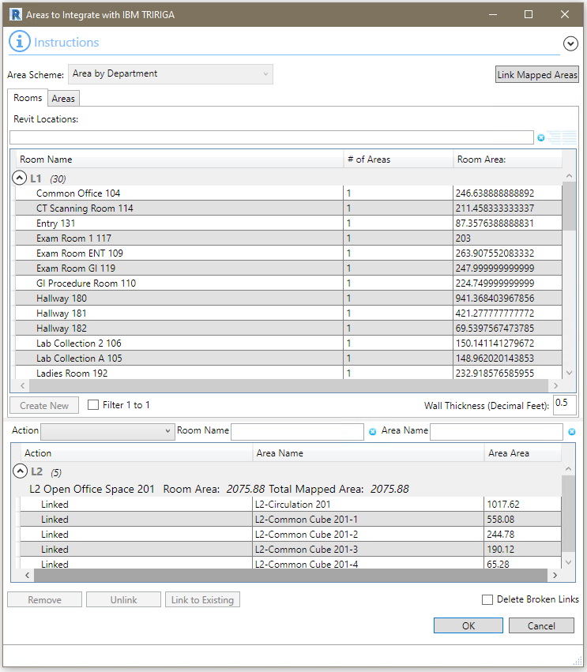

Figure - Areas Integration From – Rooms Tab

**Area Schema**: The list of all rentable Area Schema defined in the model. Select the Schema from which to draw Areas to create new or link to existing TRIRIGA Spaces. Areas can only be selected from a single Area Scheme for integration with TRIRIGA.

**Note**: Once an Area Schema has any Areas linked to TRIRIGA Spaces, no other Schema can be selected. To use a different Schema, all links must be deleted.

**Rooms Tab:** Use the Rooms Tab to create new TRIRIGA Sub-spaces from Revit Areas.

**Revit Locations (Room Tab):** This table has the Revit Levels, and Rooms. The # of Areas column indicates the number of Areas contained within each room. Only Areas that are fully contained within a Room are included.

**Create New:** To create new TRIRIGA Sub-spaces from Revit Areas.

1. Select a Room.
2. Press Create New.
3. All the Areas for the Room are added to the Linked Areas table with an action of “New”.

**Areas Tab:** Use the Areas Tab to link existing TRIRIGA Spaces to Revit Areas, and to create Spaces for Areas that are not contained within a Room.

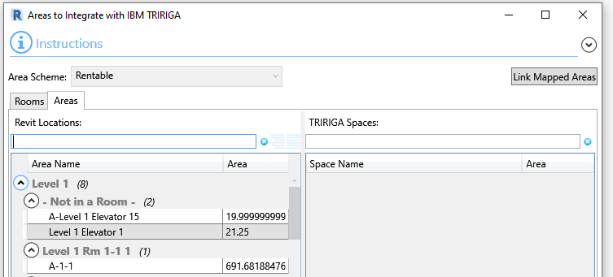

Figure - Areas Integration From – Area Tab

**Revit Locations (Area Tab):** This tree has the Revit Levels, Rooms and Areas. Areas are shown under the Room that contains the Area insertion point. Only Areas that are fully contained within the Room with adjustment for wall thickness (see below) are shown. There is a special “– Not In Room –“ section that contains Areas whose insertion point is not within any *integrated* rooms. This is intended to allow Spaces to be created from Areas in Shafts voids and similar so all the are on a level can be described.

**TRIRIGA Spaces:** This table lists existing TRIRIGA Spaces that are children of Spaces that are integrated with Revit Rooms. The list is filtered when an Area is selected in the Revit Locations tree to only show valid Spaces for the selection.

**Create New:** To create a new TRIRIGA Space from a Revit Areas.

1. Select an Area in the “– Not in a Room –“ section
2. Click Create New.
3. The Area is added to the Linked Areas table with an action of “New”.

**Link To Existing:** Use this action when integrating with an existing building to integrate existing TRIRIGA Spaces with Revit Areas.

1. Select an Area from the Revit Location Tree. The Spaces list is filtered to show Spaces that are children of the Room that is the selected Area’s parent.
2. Select a Space.
3. Press Link to Existing to add the Area Space link to the Linked Areas table with an Action of “To Be Linked”.
4. Repeat until all valid spaces have been mapped to Areas.
5. If the room has any remaining Areas, use Create New to create Spaces for them.

**Wall Thickness:** Areas are matched to rooms by comparing the Area geometry to the Room geometry to determine if an Area is contained within a Room. Rooms are defined by inner face of wall, but Areas may be determined by center of wall or outer face. To accommodate this, the calculation adds wall thickness to the Room geometry. By default, it is 0.5 ft. Changes to this are stored in the model with the Project Settings.

**Linked Areas Table**: This table show all of the Area to Space links and the action that will be taken when the form is accepted.

Actions:

* New: Create a new TRIRIGA Sub-Space with the TRIRIGA Space associated with the indicated Revit Room as its parent. Or to Create a new TRIRIGA Space directly from a Revit Area
* To Be Linked: Create a TRIRIGA BIM integration record linking the indicated Revit Area with the selected existing TRIRIGA Space.
* To Be Unlinked: Delete the existing TRIRIGA BIM integration record linking the indicated Revit Area to the selected TRIRIGA Space. The TRIRIGA Space record is not deleted.
* Linked: No action taken. Indicated that the indicated Revit Room is already linked to the selected TRIRIGA Space.

When any row with an Action of new is selected, all rows with the same Room and an Action of new are also selected.

**Remove:** Removes all selected rows with an action of “New” or “To Be Linked”. Areas and Spaces are returned to their respective tree and list.

**Unlink:** For every selected item with an Action of “Link”, the Action is changed to “To Be Unlinked”. When the form is accepted, the integration record for the selected Area is deleted.

**Link:** For every selected row that has an Action of “To Be Unlinked”, the Action is changed to “Linked”.

**Delete Broken Links:** If there are Space integration records on the server owned by this model that do not match to any model elements (Rooms, Spaces, or Areas), then the integration records are deleted.

In previous versions of the connector, this cleanup was always performed. However, if this cleanup is performed, then the option in the Sync tool to delete TRIRIGA Spaces that are not in the model will not show any spaces as the model has relinquished ownership.

**Link Mapped Areas:** Uses the Area to Room mapping defined by the Map Areas to Room tools to convert the mapping into Sub-Spaces. Each mapping is added to the Linked Area table with an Action of “New”.

**Auto Match:** Performs a name matching between Areas and Spaces that are valid to link to the Area and if there is exactly 1 match, add to match to the Linked Areas table with an Action of “Link”.

**Validate:** When the form is opened, the following validations are performed on the list of Revit Areas:

* All Areas have a value in their IBM.Name parameter.
* There are no duplicate values for the IBM.Name parameter in the list of Areas.
* The value of the IBM.Name parameter for all Areas does not exceed 100 characters.
* All Areas have a value for IBM.UseClassification.

|  |  |
| --- | --- |
| Tip | *If Areas are missing from the Revit Location tree, check the error listing. You may have forgotten to assign Space Use Classifications.* |

**Update:** If the Room is integrated with an existing TRIRIGA Space, the following updates are made:

* Revit Area: IBM.Name is updated from the TRIRIGA Space name.
* Revit Area: IBM.Description is updated from the TRIRIGA Space description.
* Revit Area: IBM.UseClassification is updated from the TRIRIGA Use Classification.
* Revit Area: IBM.UseClassification.Name is updated from the TRIRIGA Use Classification.
* TRIRIGA Space: TRIRIGA Space is updated with the value from the associated Area.
* TRIRIGA Space: If one or more children are associated with a TRIRIGA Space, the Area value for the parent Space is set to 0.

When the integration process runs, the following actions are performed:

* If the action is New, a new triBIMSpace staging record is created, and a TRIRIGA Space record is created by workflow from the staging record.
* If the action is To Be Linked, A new triBIMSpace staging record is created and linked to the existing Space record. The updates described above are performed.
* If the action is Unlinked, the triBIMSpace staging record is deleted
* If integrate is requested, and a TRIRIGA Space record exists, if a triBIMSpace staging record exists on the TRIRIGA server, the staging records is updated, if not, a new staging record is created and associated with the Space. The updates described above are performed.
* The IBM.isTRIRIGA value is updated on all Spaces to reflect their new state.

### Families

Use the Families tool to integrate Revit Families and types with TRIRIGA Specifications. The tool can either link a Family or Type to an existing Specification, or it can create a new Specification.

**Link to Existing:** To link a Revit Family or Type to an existing TRIRIGA Specification:

1. Select the Family or Type.
2. On the “Link Existing” tab, select the target Specification.
3. Press the “Add” button.

**Create New:** To create a new Specification:

1. Select the Family or Type that is the source for the new Specification, and will be linked to it after it is created.
2. On the “Create New” tab, select a Specification Type. The Specification Class tree is filtered to show values valid for the selected type.
3. Select a Specification Class.
4. Press the “Add” button.

Requests to link and create Specifications are displayed in the Families to Integrate table. They are processed when the form is accepted.

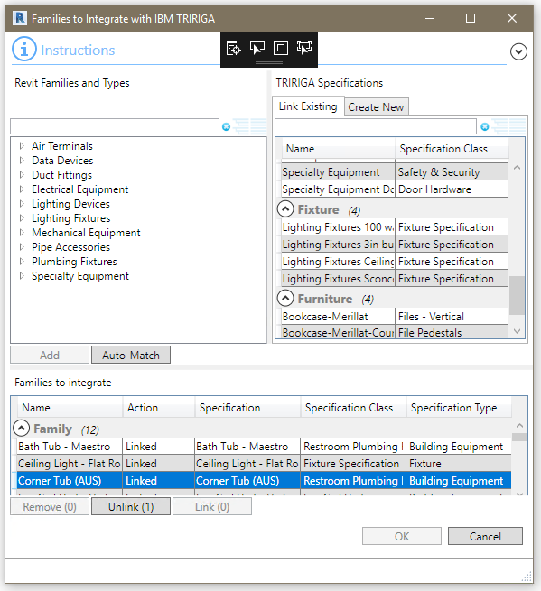

Figure 32 - Families Integration Form

**Revit Families and Type:** This tree shows all the Revit Categories supported by the Connector, and all the Families and Types in the model belonging to those categories. Select either a Family or a Type. Categories cannot be integrated. When types are used, they are removed from this tree. When Families are used, they remain in the tree, but are grayed out and cannot be used again.

**TRIRIGA Specification –** **Link Existing:** This table lists all the Specifications on the TRIRIGA server organized by specification type. Only Building Equipment Specifications are pre-loaded. To load other specification types, either expand the header in this table, or select the specification type on the “Create New” tab.

**TRIRIGA Specification –** **Create New:** A new specification requires a specification type and class to be specified.

* **Specification Type**: The combo box has a list of all speciation types supported by the Connector. Selecting a specification type filters the Specification Class tree for classifications valid for the selected type. If the list of Specifications of the selected type has not yet been retrieved from the TRIRIGA server, it triggers loading of the list.
* **Specification Class**: TRIRIGA Specification Classes valid for the selected specification type.

**Add:** Moves the selected element from the “Revit Families and Types” tree and either the selected Specification, or the selected Specification Type/Class combo to the “Families to Integrate table. The new entry has an Action of either “To Be Linked” or “New”. Types are removed from the tree; Families are grayed out. Specifications are removed from the table.

**Families to Integrate:** This table shows both existing integrations and integrations that will be created when the form is processed.

* **Name**: Name of the Revit Family or Type.
* **Action:** Describes either the action that will be performed when the form is accepted or the current state of the link.
* **New:** A new Specification of the indicated type will be created from the indicated category.
* **To Be Linked:** An Integration record will be created to link the model and the indicated Family or Type to the indicated specification.
* **Linked:** An integration record owned by this model exist that links the indicated Family or Type to the Indicated Specification.
* **To Be Unlinked:** An integration record owned by this model exist that links the indicated Family or Type to the Indicated Specification. The integration record will be deleted and the family or type will be marked as not linked.
* **Matched:** An integration record owned by some other model exist that links the indicated Family or Type to the Indicated Specification.
* **Not Matched:** The Indicated Family or Type is marked as integrated, but no integration record was found on the server. The Family or Type will be marked as not integrated.
* **Not Loaded:** The indicated Family or Type is marked as integrated with a specification of the indicated type, but specifications of that type have not yet been loaded so the Family or Types has not been matched to an integration record. When the indicated type of specifications is loaded, the record will become Linked, Matched, or Not Matched. If the form is processed without loading the specifications, then no action is taken on the item.
* **Specification***:* The name of the TRIRIGA Specification, New if the row is a request to create a new Specification, or blank if the list of Specifications for the Specification type associated with the row is not yet loaded.
* **Specification Class:** The TRIRIGA Specification class for the associated Specifications, or if New, that will be used when the Specification is created.
* **Specification Type:** The Type of Specificationused in the link, for example, Building Equipment. The Specification type is stored with the Family or Type when the integration is created.

**Remove:** Active if a selected row has the New, or To Be Linked action. Removes the row from the table and cancels the action.

**Unlink:** Active if a selected row has the Link action. Changes the Link action to the To Be Unlinked action.

**Link:** Active if a selected row has the To Be Unlinked action. Changes the action to Linked and cancels the request to unlink the specification.

Unlike other model elements, integrated specifications are not associated with a TRIRIGA building, and can be shared across many models. This can happen in either of two ways:

* The same family or type exists in two or more models. Because the model file was copied, or because the same Family is loaded into each file. In this case there is a single triBIMType link record.
* Multiple models link to the same Specification. In this case there are many triBIMType link records all associated to the same Specification.

**Validate:** When the form is opened, the following validations are performed on the list of Revit Components:

* All Types have a value in their IBM.Name parameter.
* There are no duplicate values for the IBM.Name parameter in the list of Types.
* The value of the IBM.Name parameter for all Types does not exceed 100 characters.

### Assets

Use the Asset Tool to create TRIRIGA Asset records from Revit Components. The following categories of components can be integrated:

* Air Terminals
* Data Devices
* Doors
* Duct Fittings
* Electrical Equipment
* Furniture
* Lighting Devices
* Lighting Fixtures
* Mechanical Equipment
* Pipe Accessories
* Plumbing Fixtures
* Specialty Equipment
* Telephone Devices

#### Match to Existing Asset

Before creating a new asset, the connector attempts to match each asset to an existing TRIRIGA Asset record. First, it attempts to match the Revit Component ID to an ID in a triBIM staging record. This is useful If the building is being re-attached. Second, it tries to match the IBM.Barcode parameter value to the barcode of existing Asset records. If a match is found, the asset is linked to the existing record.

**Note: The barcode match is not restricted to the building being linked. If an asset is matched by barcode, the integration workflows move the asset in TRIRIGA from wherever it is, including a different building to its location in the Revit model.**

#### Match to Specification

All TRIRIGA Asset records must be associated with a TRIRIGA Specification. The type of the asset is determined by the type of the matched Specification. In the case of an existing Asset, the Specification is updated based on the match. If the Specification is not of a type supported by the Connector, an error is reported. For an existing Asset, if the Specification is a different type that the asset, an error is reported.

The following Specification type are supported by the Connector:

* Building Equipment
* Fixtures
* Food Services
* Furniture
* Point of Sale Equipment
* Security
* Technology
* Telephones
* Work Area Outlets

See 7 Appendix: Configuring for details on how to add additional asset types.

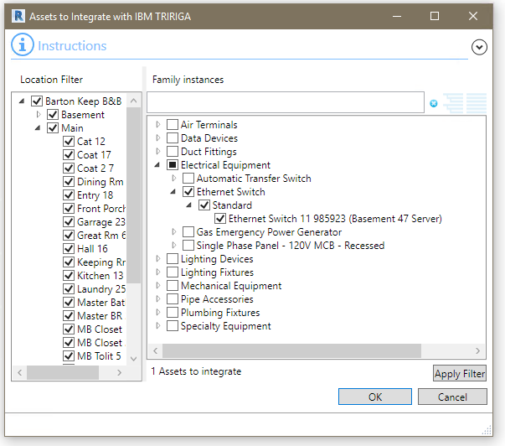

Figure 33 - Asset Integration Form

The Assets tool displays all Revit Family Instances available for integration with TRIRIGA. The Asset listing is filtered by previous integration choices. If an asset is on a level, it is only shown if the level is integrated, if the asset is contained in a Room or a Space, it is only shown if the containing Room or Space is integrated.

When the form is initially displayed, the currently integrated items are checked and any selected assets are checked.

Checked items are to be integrated when the form is processed.

**Filtering:** The Family Instance tree can be filtered by location and by text match similar to other lists. To filter by location, check or uncheck items in the location tree on the left. A Family instance must have its immediate containing location checked to be displayed in the tree. For example: An asset contained in a room is only displayed if the room is checked. Selecting or unselecting the level of building has no effect on the instance’s visibility.

When filtering by text, the filter text is only applied to the Family Instance. Types, Families, and Categories are shown if they have at least one visible child.

**Note: What is integrated is the set of Family instances that are checked whether they are visible or currently hidden by a filter.**

The number of checked assets is indicated beneath the tree.

**Only show assets linked to Families or Types:** If this option is selected, the visible assets are filtered to only show asset whose Family or Type is integrated with TRIRIGA.

**Apply Filter:** This checks every asset that is visible and unchecks every asset that is not visible.

**Selection:** If one or more items are selected when the form is open, the selection is applied to the filter and to the list of Family Instances. Only items in the selection are checked in the location filter. If there are no previously integrated Family Instances, then all the Family instance in the selection set from supported categories are selected.

**Validate:** When the form is opened, the following validations are performed on the list of Revit Components:

* All Components have a value in their IBM.Name parameter.
* There are no duplicate values for the IBM.Name parameter in the list of Components.
* The value of the IBM.Name parameter for all Components does not exceed 100 characters.
* All Components have a value in their IBM.BarCode parameter.
* There are no duplicate values for the IBM.BarCode parameter in the list of Components.

For assets with errors, the check box to select the asset for integration is not checked, and is disabled so it cannot be checked.

**Update:** If the Component is integrated with an existing TRIRIGA Asset, the following updates are made:

* Revit Component: IBM.Name is updated from the TRIRIGA asset name.
* Revit Component: IBM.Description is updated from the TRIRIGA asset description.

When the integration process runs, the following actions are performed:

* If a new integration is requested, and no triBIMAsset staging record exists, a new one is created. Otherwise, it is updated.
* If no TRIRIGA Asset record is associated with the staging record, the publish workflow attempts to find a match by searching for a record with the same barcode. If it finds exactly one, it is associated with the staging record.
* If no match is found, the workflow then attempts to find a specification.
  + The unique ID of the Revit Type matches the ID of a triBIMType records. The associated Specification is used.
  + The unique ID of the Revit Family matches the ID of a triBIMType records. The associated Specification is used.
  + The Revit Type IBM.Name matches the Specification name. This is the value that was generated during the populate parameters process from the Specification Name generation rule configured in Project Settings.
  + The Revit Family name matches the Specification name.
  + If it is an existing asset, the current Specification is used.
  + The Revit Category name matches the Specification name.
  + If no match is found, an error message is recorded and no asset record is created.
  + If a match is found, a new Asset record of the same type as the matched Specification is created and associated with the triBIMAsset staging record. The Specification is associated with the new Asset. The location is set to the space, floor, or building as provided in the location path.
* If the Component was previously integrated, but now is not, the triBIMAsset staging record is deleted.
* The IBM.isTRIRIGA value is updated on all Components to reflect their new state.

Creation of assets may trigger additional asynchronous workflow. For an out-of-the-box application, 4 per asset. These are processed after the publication workflow has completed and the connector has indicated that the publish action is complete.

### Detach

Use the Detach tool to selectively remove data added to the model by the connector.

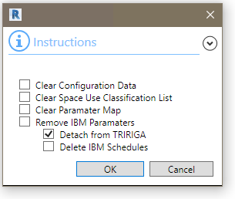

Figure 34- Detach Form

It has four options:

* **Clear Configuration Data**: This clears the parameter value rules created in Project Settings as well as the default DFX template.
* **Clear Space Use Classification List:** Clears the Space Use Classes cached in the model that were either loaded from the TRIRIGA server, or from a local file.
* **Clear Parameter Map:** This removes any parameter map from the model.
* **Remove IBM Parameters.** This removes all the shared parameters added to the model by the connector. Since much of the integration information is stored in these parameters, it also detaches the model from TRIRIGA.
* **Detach from TRIRIGA**: This clears all data that associates a model with TRIRIGA. This includes:
  + Setting the value of IBM.IsTRIRIGA parameter to false for all elements as well as values of hidden parameters used to track TRIRIGA integration.
  + Clearing the internal integration data store.
  + Deleting the unique ID used to identify the model in TRIRIGA. This can be reestablished by integrating the model again to the same server using the reattach building option.
* **Delete IBM Schedules**: Delete the schedules created by the Connector.

### Sync

Use the Sync tool to synchronize a limited number of Building, Floor Space, and Asset properties between Revit and TRIRIGA, and to make Revit and TRIRIGA updates defined by the parameter map associated with the model.

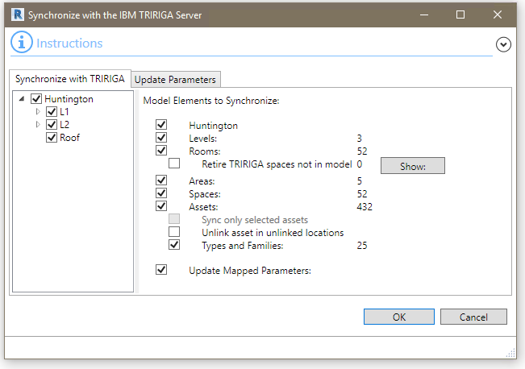

Figure 35 - Synchronize with TRIRIGA Form

**Filtering:** There are three mechanisms to control what is synced:

* By element type
* By location
* By selected items

Entire groups of a given type of element may be excluded from sync by unselecting the check box on the count line for the element type.

Elements may be selected or excluded by location using the filter tree on the left side of the form. For Levels, Rooms, and Spaces, uncheck the element to exclude it from the sync. For assets, a Family instance must have its immediate containing location checked to be synced. For example: An asset contained in a Room is only synced if the Room is checked. Selecting or unselecting the Level or Building has no effect on the instance’s visibility. Areas are included if the parent or linked Room is checked.

Families and Types are only included in the sync operation if at least one asset referencing them is included.

**Selection:** If elements are selected in the model when the Sync form is opened, the selection set can be used to filter what is synced. For Levels, Rooms, and Spaces, the selected items are the only items checked in the filter tree. For Areas, if the Area is linked to a Room, then the linked Room is selected. If there are any Family Instances in the selection that are integrated with TRIRIGA, then the “Sync only selected assets” check box is enabled and checked.

The count for each element type reflects the current state of the filters

Linked Spaces indicate the count of Spaces that are not directly integrated, but are available for parameter mapping. These are spaces that are in the same model as their corresponding Room. They show in the Space Tool with an Integration Method of “Locked”

|  |  |
| --- | --- |
| Tip | *For large models, the sync form loads and syncs faster when a selection set is used than when the entire asset set is used and filtered.* |

**Deleting TRIRIGA Spaces:** The Sync tool can find and retire or delete from the TRIRIGA server spaces that are integrated with the model, but no longer exist in the model. All the Space integration records on the TRIRIGA server that belong to the model are compared against Rooms Spaces, and Areas in the model. A count of the number of integration records that cannot be matched to model elements is displayed.

The Show button displays the list and allows items to be removed from the list. The count is updated to reflect deletions.

If the “Retire TRIRIGA Spaces not in Model” option is selected, when the form is processed:

* The integration records for each item in the list is deleted.
* If the TRIRIGA Space is in “Draft” state, it is deleted. Otherwise it is retired.

**Update:** For Levels that are integrated with TRIRIGA Floors, the following updates are made:

* Revit Level: IBM.Name is updated from the TRIRIGA Floor name.
* Revit Level: IBM.Description is updated from the TRIRIGA Floor description.
* Revit Level: IBM.Level is updated from the TRIRIGA Floor Level.
* TRIRIGA Floor: If a gross area plan is associated with the Level, the gross area for the Floor is updated with the value calculated from the area plan by summing the area of all Areas in the Area Plan.

For Rooms, Areas and Spaces that are integrated with existing TRIRIGA Spaces, the following updates are made:

* Revit Room, Space or Area: IBM.Name is updated from the TRIRIGA Space name.
* Revit Room, Space or Area: IBM.Description is updated from the TRIRIGA Space description.
* Revit Room, Space or Area: IBM.UseClassification is updated from the TRIRIGA Use Classification.
* TRIRIGA Space: If an Area from a gross area plan is associated with the Space, the gross area for the Space is updated with the value from the associated Area. Otherwise it is not updated. This is a change introduced in the 3.6.0.5 Platform. Previously, the gross area was set to the Room area. This logic is controlled by workflow.
* TRIRIGA Space: If an area from a rentable area plan is associated with the Space, the area for the Spaces is updated with the value from the associated Area. Otherwise it is updated with the area from the Revit Room.

Spaces that are in the same model as a Room and have the same bounding box are not synced. These are spaces that are marked as locked in the Space Tool.

For Family Instances that are integrated with existing TRIRIGA Assets, the following updates are made:

* Revit Family Instance: IBM.Name is updated from the TRIRIGA asset name.
* Revit Family Instance: IBM.Description is updated from the TRIRIGA asset description.
* Revit Family Instance: IBM.BarCode is updated from the TRIRIGA barcode if it has a value.
* If the Family Instance has been moved within the model, TRIRIGA location of the asset is updated.
* If the type or family and type of the Family Instance has been changed and a new specification record of the same type as the asset can be found on the TRIRIGA server, then the specification is updated.

For Types that are integrated with existing TRIRIGA Specifications, the following updates are made:

* Revit Type: IBM.Name is updated from the TRIRIGA Specification name
* Revit Type: IBM.Description is updated from the TRIRIGA Specification description.
* TRIRIGA Specification: If the type has the Classification.UniFormat.II.Number set, the TRIRIGA Building System Class is updated.

For Families that are integrated with existing TRIRIGA Specifications, the following updates are made:

* Revit Type: IBM.Name is updated from the TRIRIGA Specification name.
* Revit Type: IBM.Description is updated from the TRIRIGA Specification description.

#### Parameter Sync

If the model has a parameter map defined, the map entries are listed on the “Update Parameters” tab and data may be synchronized between Revit Parameters and TRIRIGA record fields.

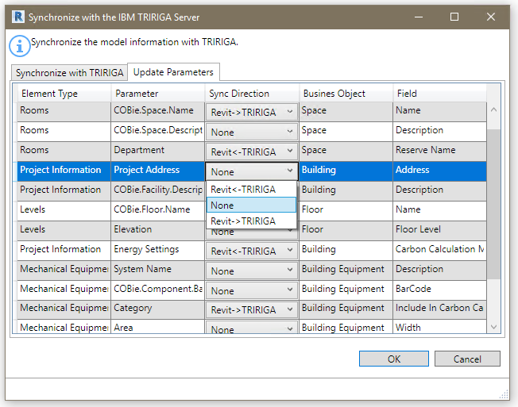

Figure 36 - Synchronizing mapped parameters

Each map entry requires the sync direction to be set to one of the following:

* Revit->TRIRIGA: Revit is the master. Data is copied from the Revit Parameter and written to the TRIRIGA record.
* TRIRIGA->Revit. TRIRIGA is the master. Data is copied from the TRIRIGA record and written to the Revit parameter.
* None: No sync is performed.

If a sync target is read-only, the None option is shown to sync that direction.

In a successful sync, the sync direction selection is saved to the parameter map. It remains with the map including if the map is saved to TRIRIGA or an external file.

|  |  |
| --- | --- |
| Tip | *To just save the sync direction settings, unselect all the element type check boxes on the “Synchronize with TRIRIGA” tab so the sync count is showing zero for everything, then accept the form.* |

Revit->TRIRIGA:

Update of TRIRIGA data is performed at the record level. All fields to be updated are sent as a single transaction. Some data validation is performed in the Connector before updates are attempted.

* If the Revit parameter is a value parameter, and the target TRIRIGA type is not a number or a check box, then the parameter value is retrieved as a value string. This is a fully formatted string with the value converted to the selected display units for the model. For example: 12’-6”.
* If the Revit parameter is a value parameter, and the target TRIRIGA type is a number, then the parameter value is retrieved as a decimal using the raw units Revit uses for its internal calculations.
* If the Revit parameter is a value parameter, and the target TRIRIGA type is a check box, then the value cannot be converted and an error is logged.

Only Revit Spaces that are associated with TRIRIGA Spaces owned by the model can be used with a Parameter Map. Spaces in linked models cannot be mapped to TRIRIGA Spaces created from a different model.

### Publish Floor Plans

Use the Publish Floor Plan Tool to publish one or more floor plans for use in the TRIRIGA graphics section, and the Floor Plan tab in the UX Locate and UX Work Task applications.

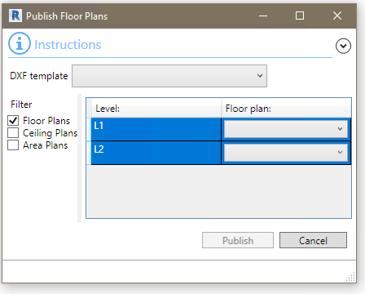

Figure 37 - Publish Floorplan Form

When this form is first displayed, it shows the options used in the last publish operation.

The Publish Floor Plan tool uses the Revit DXF export feature to export the selected floor plans in DFX format. Each DXF file is then imported into TRIRIGA and Rooms on the floor plan are automatically associated with TRIRIGA Spaces created by the connector.

The DFX files are saved in:

<UsrProfile>\AppData\Local\IBM\TRIRIGA\AR Integrator\Drawings.

**DXF Template**: Revit uses DXF templates to control many visual aspects of a floor plan exported in DXF format. The dropdown shows all the DXF templates included in the model. If one is selected, it is applied to all the selected floor plans. If a template is used, it is stored in the IBM. DXF.Template parameter in Project Information, and is automatically selected the next time the Publish Floor Plans tool is opened.

Select the table rows for the Levels for which you want to publish floor plans.

The Floor Plan dropdown on each row has a list of floor plans in the model for that level. Select the desired plan.

**Filter:** The filter controls the type of plans that are displayed in the combo box for each level.

If the floor plan was previous publish, the published plan is displayed in the list and selected even if the filter check box for its type is not selected.

**Note:** The TRIRIGA floor plan viewer may draw Rooms and Spaces on top of Areas. It is recommended that in the Visibility/Graphics override settings for an Area Plan that Rooms and Spaces not be selected.



### Publish Model

Publish the current Revit file to the Forge service, submit it for translation, and associate it with the building record created from the connector.

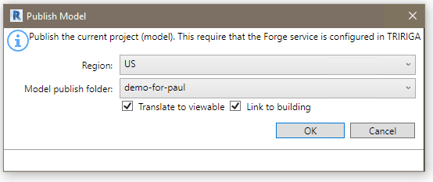

Figure 38 - Publish Model Form

**Region.** Selects the geographic region where the uploaded model and resulting translated viewable will be physical stored. This filters the bucket list for buckets within the region.

**Translate to viewable:** If checked, a translation job is submitted to the Autodesk Forge service to translate the model to viewable format.

**Link to Building:** Requires “Translate to viewable” to be selected. Associates the translated model with the building as the model to use with the Forge viewer for the building. This replaces any previously associated building.

**Forge service access is proxied through TRIRIGA.** It uses the Forge application credentials configured in TRIRIGA and TRIRIGA security is applied.

## TRIRIGA Data

Each tool in this section launches the TRIRIGA application in the default browser using the credentials and server definition used for the connector login.

### Property Panel

The TRIRIGA property panel is a property sheet style display of TRIRIGA data for model elements that are integrated with TRIRIGA. It can be displayed or hidden by using the TRIRIGA Properties button on the TRIRIGA ribbon.

It functions similar to the Revit element property pane; in that it is dockable, and that the data displayed in the panel tracks the Revit selection. When initially displayed, the TRIRIGA property panel is displayed with the Revit Element property panel. If it is subsequently moved, its location is stored with the model and its position is restored when the model is reopened.

It has four models:

* **Property display:** If a single element is selected and that element is integrated with TRIRIGA, the TRIRIGA data for the element is displayed in a property sheet style interface.
* **A blank screen:** If no element or more than one element is selected, the screen is blank with only the banner with the element name.
* **Not integrate:** If a single element is selected, and the element is not integrated with TRIRIGA, an image and message are displayed indicating so.
* **Error:** If there is an error loading either the report definition required by the element type, or the TRIRIGA record data for the selected element, an error screen with the error is displayed.

Property sheets are available for all elements that can be integrated with TRIRIGA. This includes Levels, Rooms, Spaces, and Components of supported categories. It also includes Levels and Spaces in a linked model that are linked to TRIRIGA records created from a primary model. TRIRIGA data is drawn from user configurable queries. (See 7 Appendix: Configuring ).

Property data is displayed in three columns:

* The localized column name from the supporting query.
* The field value for the selected record.
* If the field has an associated unit of measure, the units for the field.

Fields that have a value of null or 0 are not displayed. Displayed fields are sorted by query section and localized section headers are displayed.

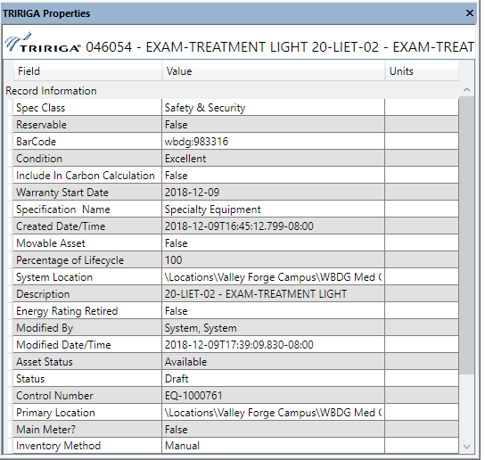

Figure 39 - Property Panel

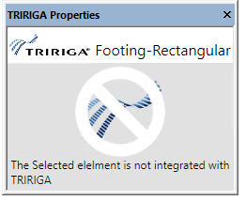

*Figure 40 - Element Not Integrated*

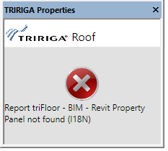

Figure 41 - Property Panel Error

### Open Building

The tool opens the building record associated with the model.

### Open Selection

The opens a single Floor or Space in TRIRIGA based on the Revit selection. The tool is only active if there are items selected and only functions if the selection is either a single Level or a single Room, Area, or Space.

### Launch Portal

This tool launches the main TRIRIGA portal.

## Help

### Info

This tool displays connector version and build information.

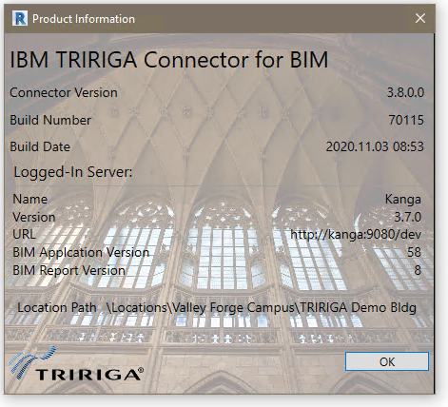

# Autodesk Forge Model Administration

Model administration is performed from the BIM Administration Tool which is found in the TRIRIGA portal under Tools. Typically, the model must be prepared using Autodesk Revit® and Navisworks®. To utilize the Autodesk Forge viewer, models must be uploaded to the Forge service, and translated to the format used by the viewer. The viewable format must then be associated with the TRIRIGA building record that corresponds with the model.

Figure 42 depicts the process for configuring the Forge viewer for use in TRIRIGA and for managing models.



Figure 42 - Model Integration Process

## Setting up the Forge Service

These steps are performed once when the Autodesk Forge service is first registered with TRIRIGA, and may be revisited if there are changes in your Autodesk Forge account.

### Register with Autodesk Forge and Create an application

The Forge Viewer and Forge Service are Autodesk® products integrated with TRIRIGA. Use of the Forge service requires a subscription from Autodesk. A new subscription or a free trial may be secured here:

<https://developer.autodesk.com/>

Or an existing Autodesk account may be used.



Figure 43 – Create an Autodesk® Forge application

Once you have registered for the service, Select Create Application to Create a Forge application for use with TRIRIGA. A single application can be shared between multiple instances of TRIRIGA or between TRIRIGA and Maximo. However, TRIRIGA does not support BIM360 logins.

The Data Management API and Model Derivative APIs are required

None of the values entered in this screen are visible from within TRIRIGA. Select values that will help you identify this application should you need to return to this screen. TRIRIGA does not support 3 leg authentication, so the callback URL is not used. Enter any value that is a valid URL format.



Figure 44 – Forge application definitions

Once the application is created, the application credentials are displayed (the yellow highlighted fields). **Keep these secure**, as they allow access to all date and functions of the application. This will include all the models that you use in TRIRIGA. If they are compromised, you can return to this page to generate a new secret which must then be updated in TRIRIGA.



Figure 45 – Forge application credentials

### Entering Forge Credentials into TRIRIGA

To utilize Forge services from within TRIRIGA, the credentials created in the previous step must be registered with TRIRIGA. All administration of the Forge service from within TRIRIGA, as well as model management is done with the BIM Model Management Tool found under Tools on the TRIRIGA portal.

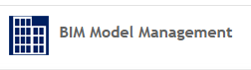

1. From the BIM Model Management Tool menu, select “Set Key System Wide”. This displays a dialog to enter the Forge Credentials.
2. Enter the credentials from the application you created in the previous step.
3. When the dialog is accepted, a warning message is displayed. If this is the first time you are entering credentials, or you are only updating the client secret, this can be ignored.

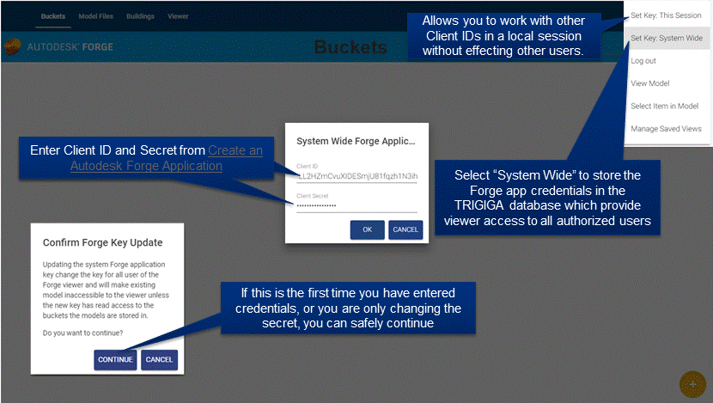

Figure 46 – Configure Forge Credentials in TRIRIGA

If you need to work with other Forge applications, credentials can be set for your login without affecting other users by selecting “Set Key: This Session”. Be sure to explicitly logout when you are done to clear your credentials. When switching credentials, the first access to the viewer fails. This forces a credential reset and subsequent access succeeds.

### Configure TRIRIGA for access to Forge Management tool

When the Forge service is accessed through TRIRIGA, normal TRIRIGA security controls which users can access Forge service operations. The BIM User security group is pre-configured for full access to the Forge Service.

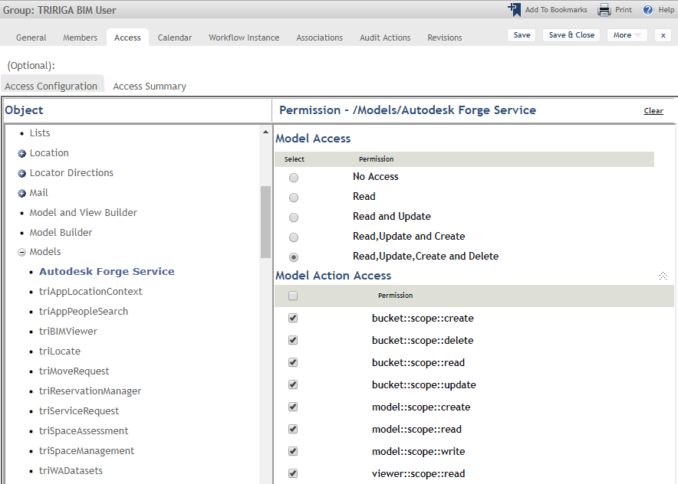

Figure 47 – TRIRIGA BIM User Security Group.

Fined-grained access is controlled through the Autodesk Forge Service model. Model actions are mapped directly to the scope parameter of the Forge Authenticate endpoint defined here:

<https://developer.autodesk.com/en/docs/oauth/v2/overview/scopes/>

Viewer::scope::read is required for any user that access the Forge viewer. It may be desirable to add this access to other security groups.

### Autodesk SSL Certificate

For TRIRIGA to access the Autodesk Forge service, the app server must make an SSL connection to the Autodesk cloud services. This requires the app server to trust the Forge SSL Certificate. Typically, Java Virtual Machines (JVMs) browsers and app servers include the signer certificate from most major certificate authorities so they trust any certificated signed by these certificate authorities including those used by the Forge service. However, high security app server deployments do not include any certificate authority certificates in the app server trust store as part of the base install. This means that the app server does not trust the Autodesk certificates and connections to the Forge service fail with an SSL Handshake exception. To resolve this, the certificate authority public root certificate use for by the Forge service must be imported into the app server trust store.

There has been some variance seen in the certificate presented by the Forge service both over time and by region, so these steps may need to be periodically repeated.

The procedure varies by app server.

#### WebSphere®

The certificate can be imported from the WebSphere administration console.

* Select Security->SSL certificate and key management
* From “Related Items”, select: Key stores and certificates
* Select NodeDefaultTrustStore if available. Otherwise select CellDefaultTrustStore
* From “Additional Properties” Select Signer certificates
* Select “Retrieve from port”
* Provide the following values:

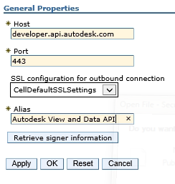

Select “Retrieve signer information”

WebSphere should respond with:

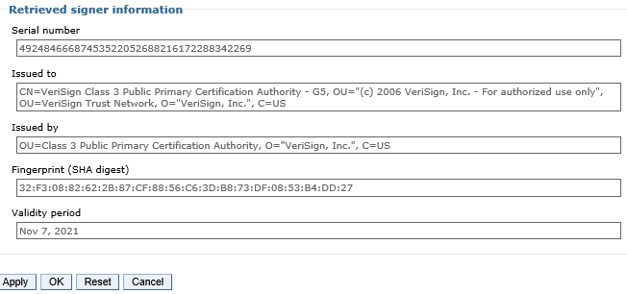

* Click OK, and the save the changes on the following screens.

**Note**: The certificate may not match what is shown above.

#### WebSphere Liberty ®

WebSphere Liberty relies on the underling JVM trust store. The following is one of many ways the Forge signer certificate can be retrieved and imported into the JVM trust store.

**To retrieve the certificate:**

Open the link <https://developer.api.autodesk.com> in FireFox

Click on the certificate (next to the site name)

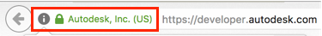

* Click the “>” button

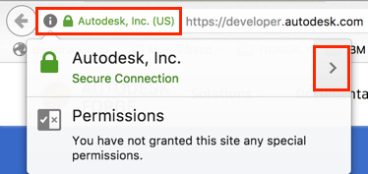

* Click on “More Information”
* Click on "View certificate"
* Click on "Details"
* Click on "Export..."  
  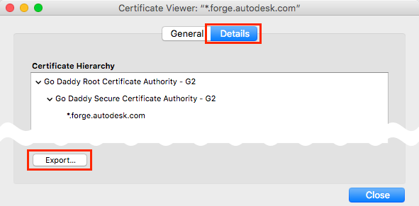
* Choose "X.509 Certificate **with chain** (PEM)", select the folder and specify a name (e.g., *forgeautodeskcom.crt*) and click "Save",

#### To Import into the JVM trust store

* Identify which Java is being used by your TRIRIGA installation. If you have previously started TRIRIGA, the fourth line in the messages.log from the TRIRIGA server (e.g., C:\Tririga\wlp\usr\servers\tririgaServer\logs\messages.log) will show the java home. Make note of the path, e.g., C:\Program Files\IBM\Java80\jre.
* Search for cmd in start menu when it appears right-click on the icon and select 'Run as Administrator'
* Navigate to the bin directory within the java install folder via command line  
  For Java JDK the install the command would be something like: cd C:\Program Files\Java\jdk1.8.0_181\bin

Once within the bin directory run the following command (make sure you have adjusted the paths to match what exists on your machine):

* Open a command prompt.
* Navigate to the bin directory of the JVM used by WebSphere Liberty. Liberty locates JVM by testing the following:
  + JAVA_HOME environment variable
  + JRE_HOME environment variable
  + Looking for a JVM in the path
* Use the keytool to import the certificate.   
    
  The following is a sample command line for Windows:

keytool -importcert -alias developerautodeskcom -keystore "C:\Program Files\Java\jdk1.8.0_162\jre\lib\security\cacerts" -file C:\temp\developerapiautodeskcom.crt

The following is a sample command line for Mac OS:

sudo keytool -import -alias developerautodeskcom -keystore /Library/Java/JavaVirtualMachines/jdk1.8.0_161.jdk/Contents/Home/jre/lib/security/cacerts -file ~/Desktop/developerautodeskcom.crt

sudo password: <your log in password>

keystore password: changeit

* When prompted, the default password is changeit, or whatever you have set you keystore password to.

The above command lines are for the Oracle® JVM. They differ slightly for the IBM JVM.

If SSL configured on TRIRIGA server, you need to do the same thing but using the path to your local server’s key.jks keystore.

New Forge cert:

keytool -importcert -alias developerautodeskcom -keystore "C:\tririga\wlp\usr\servers\tririgaServer\resources\security\key.jks" -file C:\temp\forge_autodesk_com.crt

The password is the one used to set up SSL on the TRIRIGA Liberty server (e.g., MyTRIPassword)

You also have to add the following to the C:\tririga\wlp\usr\servers\tririgaServer\server.xml file:

<ssl id="defaultSSLConfig" trustStoreRef="defaultTrustStore"/>

<keyStore id="defaultTrustStore" location="${java.home}/lib/security/cacerts"/>

#### Removing a certificate from the trust store

If you need to delete the certs and reimport them (e.g., if you are updating the server with new certificates or you did not download the cert correctly, etc.), use the following commands prior to running the import commands above:

keytool -delete -alias developerautodeskcom -keystore "C:\Program Files\Java\jdk1.8.0_181\jre\lib\security\cacerts"

{password is changeit}

keytool -delete -alias developerautodeskcom -keystore "C:\tririga\wlp\usr\servers\tririgaServer\resources\security\key.jks"

{Password is password used to set up SSL on Liberty server (e.g., MyTRIPassword)}

Note: If you receive a message after importing the certificates into the TRIRIGA server key store that indicates the key store is in a proprietary format, you can upgrade the keystore with the following command (again, modify any paths, keystore aliases, etc., with those from your environment):

keytool -importkeystore -srckeystore C:\tririga\wlp\usr\servers\tririgaServer\resources\security\key.jks -destkeystore C:\tririga\wlp\usr\servers\tririgaServer\resources\security\key.jks -deststoretype pkcs12

As of Liberty 19.0.0.3 (i.e., used by Platform 3.6.1) the default keystore type was changed from JKS to PKCS12. If your keystores are in JKS format (even if they have the new .p12 file extension – which is what Liberty creates by default!) then you have to add the type="JKS" attribute to the keyStore element, like this:

<keyStore id="samplePKCS12KeyStore"

location="MyKeyStoreFile.p12"

type="PKCS12" password="myPassword" />

## Exporting Navisworks Models

Forge viewer viewable objects created directly from Revit models have no visual representation for Revit Rooms and Spaces. This means they cannot be used to visualize TRIRIGA spaces, severally limiting their usefulness. This can be resolved by using Navisworks models. To do that, the Revit model needs to be converted to Navisworks. There are two ways to do that:

* Directly open the Revit file in Navisworks.
* Use the Navisworks exporter plug-in for Revit.

### Exporting the model

The plug-in appears to produce better files, and can be used without a Navisworks license, so it is what is covered here. The exporter can be downloaded [here](https://www.autodesk.com/products/navisworks/3d-viewers)

The exporter is found on the Revit add-in ribbon.



There are several export options that may be useful. These are accessed from the file selection dialog after export is selected.



If you do not have a Navisworks license, you should select “Convert Linked Files” as this is the only way to get a single Navisworks file that contains all the model. If you do have a Navisworks license, you can gain more control by exporting each file separately and merging them in Navisworks.



### Enhancing the model

If you have a Navisworks license, there are several things you can do to improve the usefulness of the model in TRIRIGA:

**Merging Files:** You can add linked files to the Navisworks model by selecting:

**Home-**>Append

**Setting the Default View:**  The Forge translation service uses the default view. This is what is displayed when you initially open the file, and is set by what is displayed when you save the view.

**Changing element visualization:** There are several ways the visual aspect of elements can be customized all which require locating and selecting all instance of the item. One way of doing this is with the Selection Tree. Navigate to the desired item set, and right click to see a list of options. One useful approach is to use Revit Categories. These can be found at:

**Element-**>Category->Name

**Suggested enhancements including**

* Decreasing the transparency and changing the color of rooms
* Hiding all spaces except those explicitly integrated with TRIRIGA, for those that are integrated, setting the transparency and color to match Rooms
* Color coding key assets or color-coding asset by category

## Importing models into the Forge Service

There are 4 steps required to view a model with the Forge Viewer from within TRIRIGA:

1. Create one or more storage containers called Buckets in the Forge service to hold the model files. For the purpose of a demo, only one storage container is required. If you manage models for multiple projects or companies, you should create additional container to organize you models.
2. Uploaded the model files(s) to the Forge service.
3. Request that the Forge service translate the model into a viewable format.
4. Associate the viewable model with the TRIRIGA Building record for the facility that is represented by the model. The Building and its contained Floor, Space, and BuildingEquipment records are typically created from Autodesk Revit with the TRIRIGA Connector for BIM.

Some of the above steps may have been performed outside the current TRIRIGA instance. If so, Buckets, Model Files and translated models may already be shown in the BIM Model Administration tool.

### Managing Model Storage

The Forge service uses storage containers (called buckets by Forge) to store any model files that are uploaded to the service. A storage container is similar to a directory in a file system. Buckets are managed from the Bucket tab of the BIM Model Administration tool.

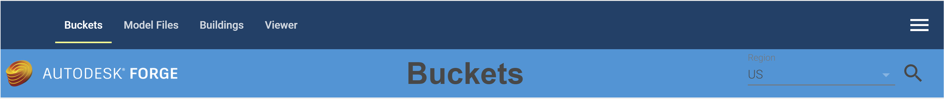

When the Bucket tab is displayed, existing buckets are automatically displayed. Buckets are filtered by region. US is the default region. To view Buckets for a different region, select the region from the Region drop down and click the Search icon.

#### Creating a storage container:

To use the Forge service, you must create at least one storage container. To create a storage container,

1. Select the  icon to display the Create Bucket dialog

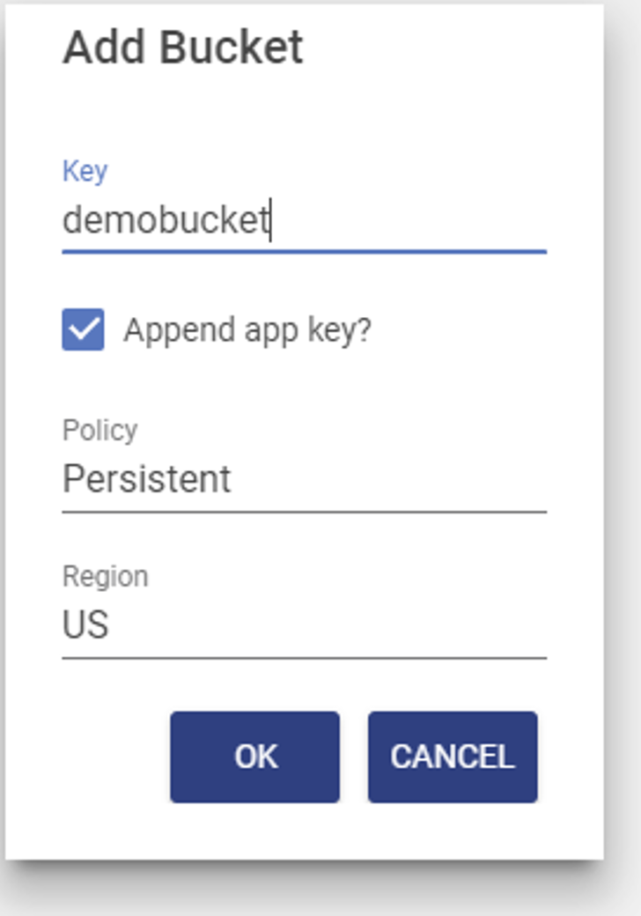

1. Specify a storage container name and description**.** Names must be unique across the Autodesk Forge service including all Autodesk Forge users. To facilitate this, TRIRIGA can append your Autodesk Forge service key to your storage container name. If you select this option, only the base name is displayed on the UI. If you do not select this option, it is highly recommended that you include in your storage container names some unique string that is associated with your company or organization, such as a registered domain name,

Unless you design your own strategy to ensure your storage names are unique across the entire Forge Service, you should leave the Append Service key checkbox checked.

The name may contain -_.a-z0-9 and must be between 3-128 characters in length including the appended key.

1. Select the desired retention policy. There are three types of buckets:

**Transient:** Model files are retained only for 24 hours

**Temporary:** Model files are retained only for 30 days

**Permanent:** Model files are retained until they are deleted.

**Note:** If a model has been translated to a viewable format and is then removed, including through its storage period expiring, the viewable format is not removed.

1. The region displayed here is read only. It is set by the dropdown on the toolbar**.** That is, buckets are always created from the actively displayed region. Buckets may be created in the US or the EMEA region of the Forge service. The region controls the physical location of the Forge service servers that host the Bucket.

#### Deleting a Storage Container:

A storage container can be deleted. Deleting a storage container also deletes everything that is stored in it**. This process CANNOT be undone**. All models and translated viewable bubbles stored in the container are also deleted. To delete a Bucket:

1. From the Bucket tile, click the “Delete Permanently” icon.



1. This displays the delete confirmation dialog. **Heed this warning.** You can delete a very large amount of data with a few mouse clicks!

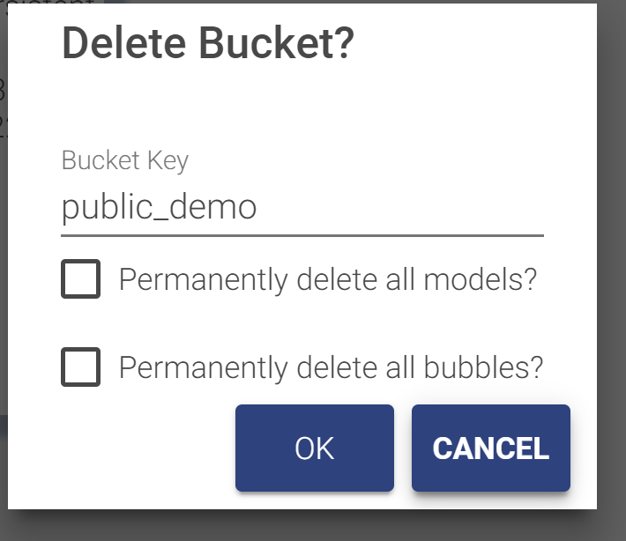

1. Check both the “Permanently delete all models” and the “Permanently delete all bubbles” check boxes. You cannot accept this dialog until you have acknowledged that all the data in the bucket will also be deleted.

#### Rights

Rights to a storage container may be granted to other service keys. The actions Autodesk currently allows through granted rights is extremely limited so it is currently of little use.

To grant rights:

1. On the tile for the bucket: select the lock icon, this displays the rights dialog.

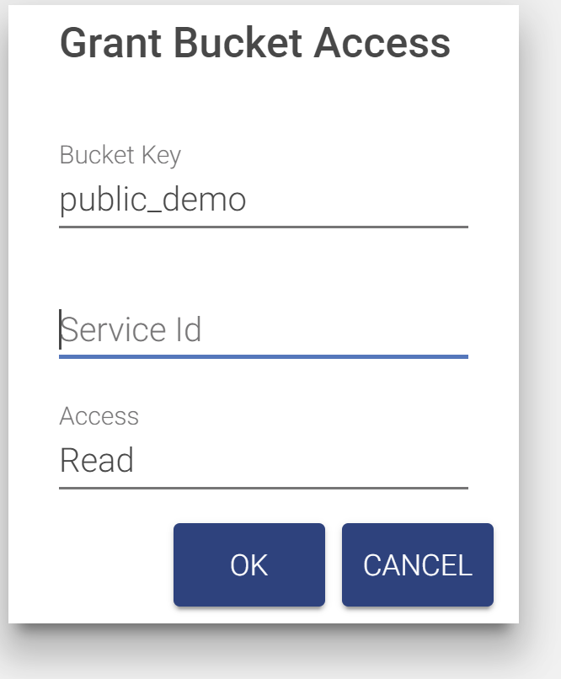

1. Enter the Service ID for any other Forge application.
2. Select the rights to grant.
3. The bucket tile displays a list of all service ids that have access to the bucket.

There is no validation that the service id is valid.

To remove access, click the trash can to delete the row. The row is deleted immediately.

### Managing Model Files

Model files are managed from the Model tab of the BIM Model Management tool.

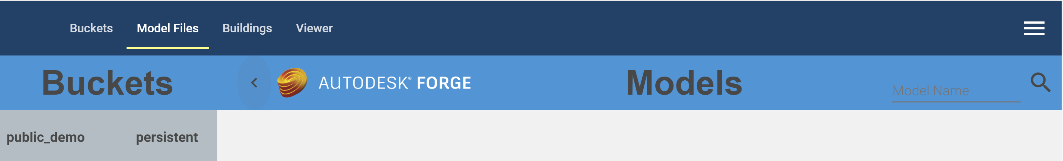

The tab has a fly-out on the left that displays the list of buckets from the Bucket tab, and a list of models contained in the selected bucket.

* When the tab is first displayed, the first bucket in the list is selected, and the first 50 models in the bucket are displayed. Autodesk does not guarantee any sort order so it is effectively 50 random models.
* Additional models may be displayed by scrolling to the bottom of the model list.
* The model list may be filtered by entering a value in the model name field on the tool bar and clicking the search icon. Models whose name begin with the search string are listed. The search is case sensitive.
* Selecting a new bucket updates the model list using the current search criteria.

Any type of file can be uploaded to a bucket. However, only those file types that can be translated into viewable format are of interest here. Each model file is displayed as a tile. The content of the tile varies during the model upload and translation process (see below). A fully translated model ready for use displays a thumbnail image of the model and a link to drill into details of the model.

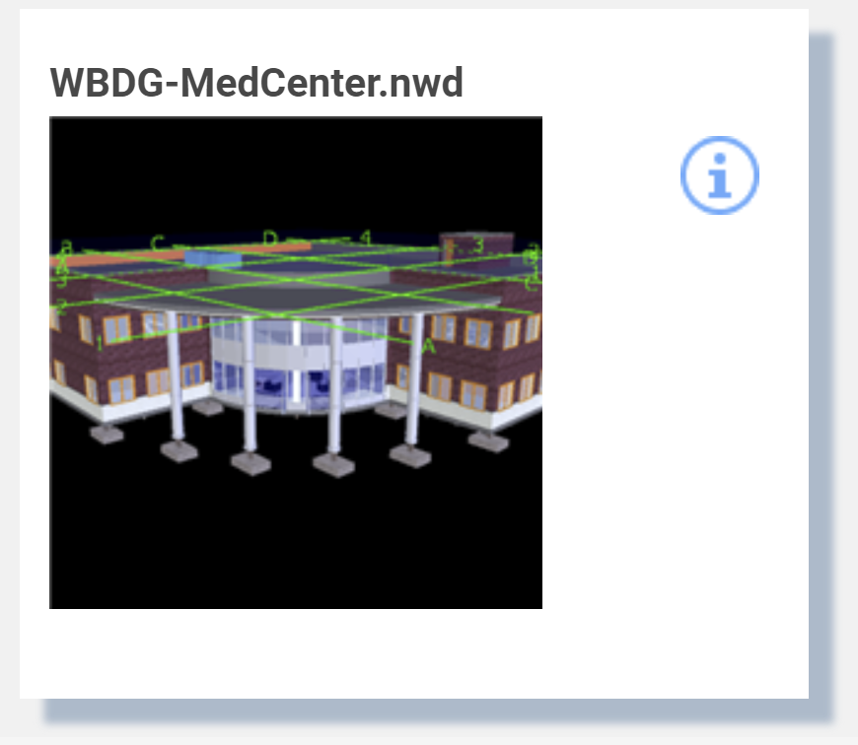

Selecting the thumbnail switches to the viewer tab and displays the model in the viewer. Selecting the info icon drills into details of the model (see below).

### Upload Model

1. To upload a model file, click the Upload Model button 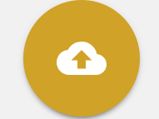. This displays the Upload Model dialog. The model is uploaded into the currently active bucket.

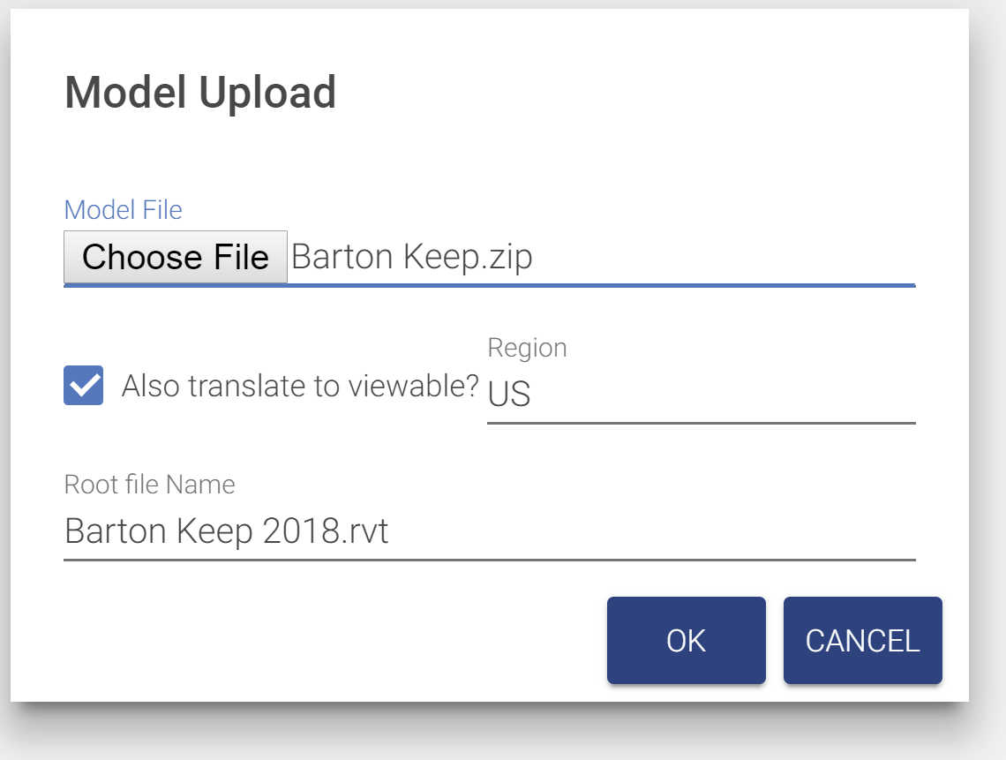

Figure 48 - Model Upload

1. Select a model file to upload.
2. Checking the Also Register Viewable checkbox causes the model to be automatically submitted to the Forge Service for translation and eliminates the need to manually perform the viewable translation process.
   1. Select a region. This is where the translated viewable “bubble” will reside. This may be different from the bucket containing the model.
   2. If the model file is a zip archive containing a set of linked files (see below), specify the base file name with extension of the root file. This is the file that you would normally open to view the model set.
3. Click OK and you are returned to the Models tab. A tile is added for the new model as the first tab in the model list. If the model list is refreshed while an upload is in progress, the monitoring tile is lost, but if the upload is successful, a normal model tile is available for display when it is complete.

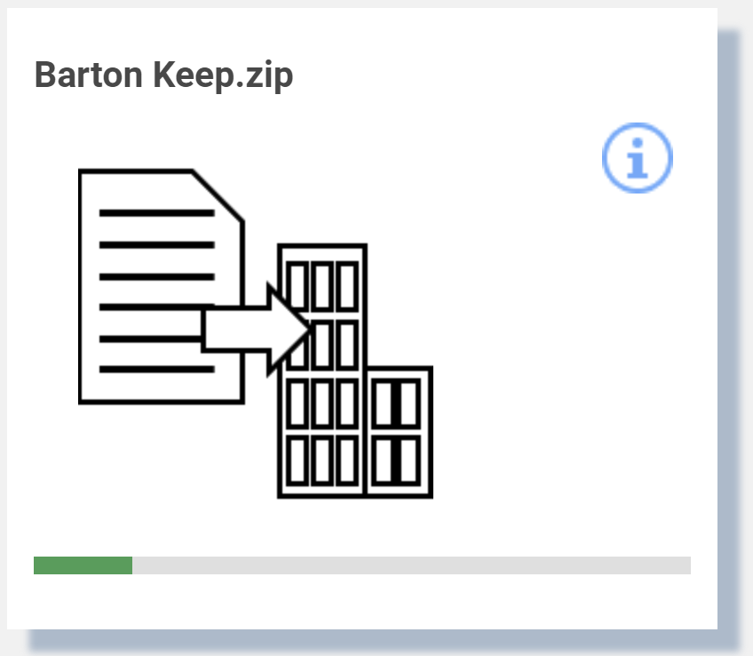

1. If “Also translate to viewable” is selected, when the upload is complete, the translation process is started. This may take a few seconds to several hours. The tile displays the progress of the translation process. Initially, the translation progress is updated every 30 seconds. After a few minutes, the update is less frequent. The translation process may be manually displayed and updated from the Bubble tab of the model details dialog (see below). If the model list is refreshed during the translation process, the tile is displayed in its normal position in the list instead of first and the progress monitoring is halted. Progress can still be manually displayed.

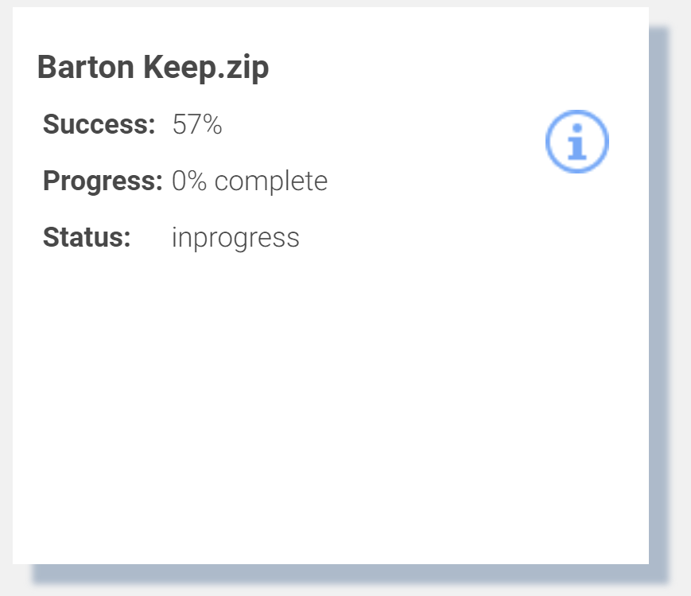

#### Translating models

The model translation process may be run separately from the model upload. A model that has been uploaded but not translated has the following tile:

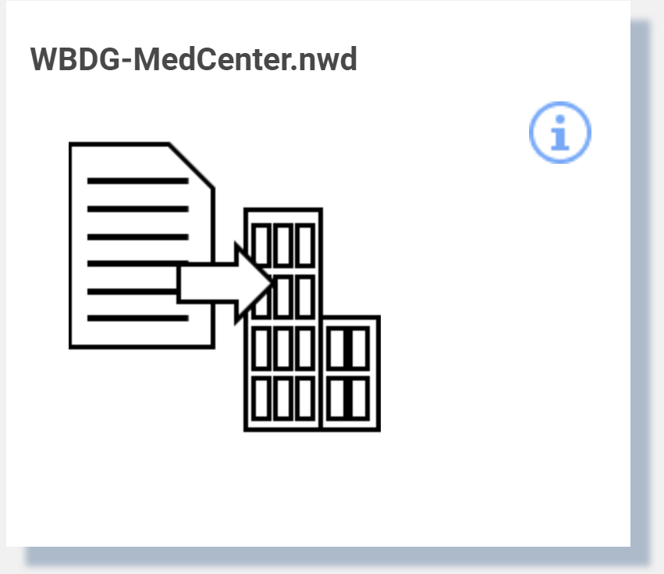

Clicking the image displays the Model Translation dialog.

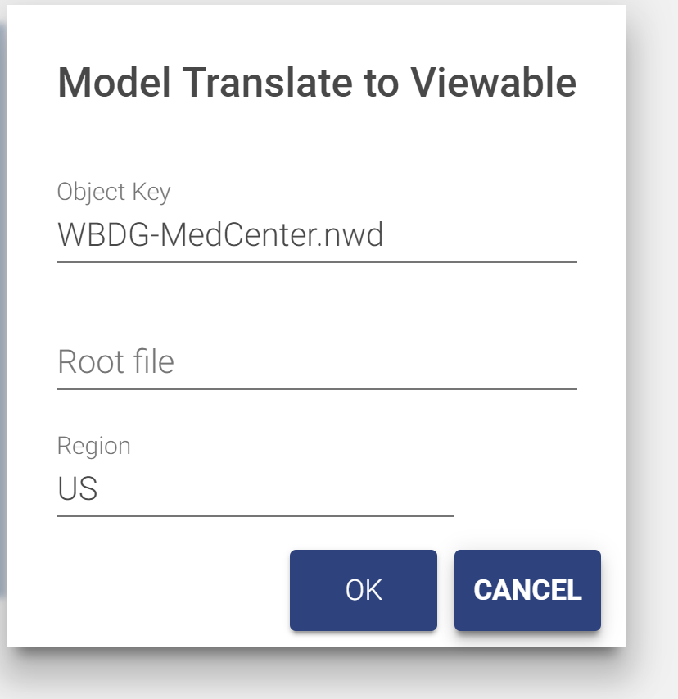

1. Select a region. This is where the translated viewable “bubble” will reside. This may be different from the bucket containing the model.
2. If the model file is a zip archive containing a set of linked files (see below), specify the base file name with extension as the root file. This is the file that you would normally open to view the model set.

The translation process may take a few seconds to several hours. The tile displays the progress of the translation process. Initially, the translation progress is updated every 30 seconds. After a few minutes, the update is less frequent. The translation process may be manually displayed and updated from the Bubble tab of the model details dialog (see below). If the model list is refreshed during the translation process, progress monitoring is halted. Progress can still be manually displayed.

#### Working with multi-file models

Some modeling tools, such as Revit, have workflows that distribute a model across many files that are then linked to form the complete model. For example, a model may be divided into an architectural, a MEP, and a structure component each in different Revit files. The Forge service can integrate these parts into a single model for display in the Forge viewer. To do so, perform the following steps:

1. Gather the files composing the model into a directory tree that can easily be converted into a .zip file. Ideally you should remove extraneous files such as auto-save files.
2. Select the file that will be the master file for the linked model. Ensure that all linked parts or sub-model files load correctly when this file is opened.
3. Convert the directory containing the model files into a .zip archive.
4. Upload the .zip archive as described above.

#### Model Details

The provides a drill down into additional information about the model file and about any translated viewable data which Autodesk refers to as the “Bubble”. The information varies by type of file.

If the model is in the process of translation, or translation has been attempted whether or not it succeeded, the dialog has a Bubble tab that includes the status of the translation process.



Figure 49 - Translated Viewable (bubble) Details

**Has Thumbnail:** Indicates if the bubble included a thumbnail image of the model. Revit, Navisworks, and AutoCAD file all have a thumbnail.

**Started At:** Timestamp of when the model was submitted for translation

**Progress:** Percent of the translation process that has completed.

**Success:** Percent of the model that has been successfully translated

**Status:** Status of the translation process. Typically, In Progress, Success, or Failed

**Fetch Time:** When the information in the dialog was last refreshed

Use the Refresh button to update the dialog with the current values directly from the Forge Service.

Other information on the bubble tab, and the information on the mode tab is only useful to administrators that have other interactions with the Forge service.

The bubble for Revit files includes information from the Revit Project Information screen. Translated Revit files have a Project Information tab with this information

#### Delete Model

A translated model consists of several Forge objects: the model files and a set of objects that constitute the bubble. The model files and the bubble can be deleted independently of each other.

* To delete the model with an option to also delete the bubble:
  + Open the Model detail dialog as above
  + From the Model tab, click the trash can (Permanent Delete) icon
  + A confirmation dialog is displayed with an option to also delete the bubble

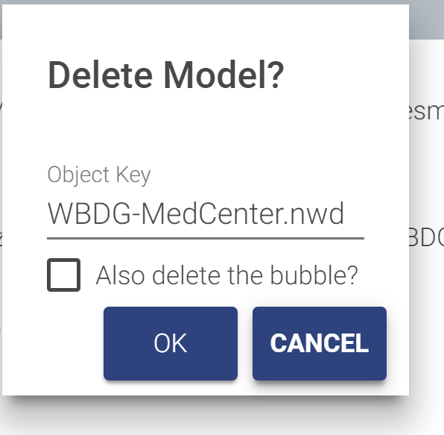

* To delete just the bubble:
  + Open the Model detail dialog as above
  + From the bubble tab, click the trash can (Permanent Delete) icon
  + A confirmation dialog is displayed

Autodesk provide no mechanism to list or search for bubbles, and TRIRIGA maintains no record of model or bubbles outside of the Forge service. Therefore, if you delete the model but not the bubble, you will not be able to later view or delete the bubble, however existing references to the bubble continue to work. So, if a model has been associated with a building and then just the model is deleted, you can continue use the viewer to display the model for that building. If the model file is later re-loaded, it will automatically be associated with the existing bubble.

### Associating Translated Models with Buildings

To view a model from a TRIRIGA application, it must be associated with a building. For TRIRIGA to be able to automatically select and focus on a space or asset, the space or asset must be keyed to the model. If the Building, Space, and Asset records were created by the BIM Connector for Revit, and the model is the Revit file used with the connector, or a Navisworks file derived from the Revit file, this process is automatic.

There are two means of associating a model with a building:

* A single file Revit model may be published directly from Revit using the BIM Connector for Revit (See section 2.4.14). The publish process handles the model upload, translation and linking to building. It is not necessary to use the BIM Model Management tool.
* For federated Revit models, Navisworks models, and other types of models, the model is linked to the building using the BIM Model Management tool.

Building to Model associations are managed from the Building tab of the BIM Model Management Tool.

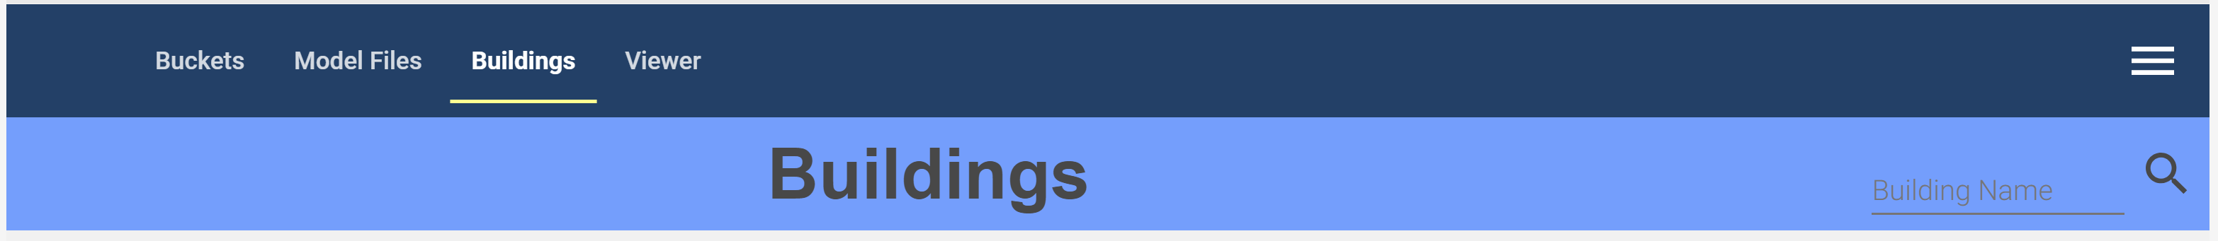

The tab displays all buildings that are accessible to the current user sorted by building name.

* When the tab is first displayed, the first 50 buildings are displayed.
* Additional buildings may be displayed by scrolling to the bottom of the building list.
* The buildings list may be filtered by entering a value in the Building Name field on the toolbar and clicking the search icon. Buildings whose name or address contains the search string are listed.

Each building is displayed as a tile.



Figure 50 - Building to Model Link

* The search button displays a model selection list with the same list of models that is displayed on the Model Files tab. To display models from a different bucket, return to the Model Files tab and select the desired bucket.

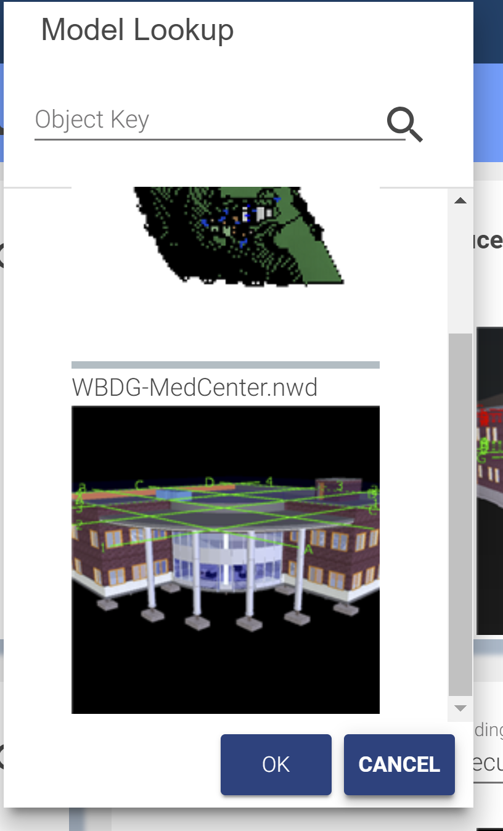

Use the search box to filter the list. This also filters the list on the Model Files tab.  
Select a model to link it to the building. Scroll to the bottom to fetch additional records.

* Click the info icon to display additional details about the link

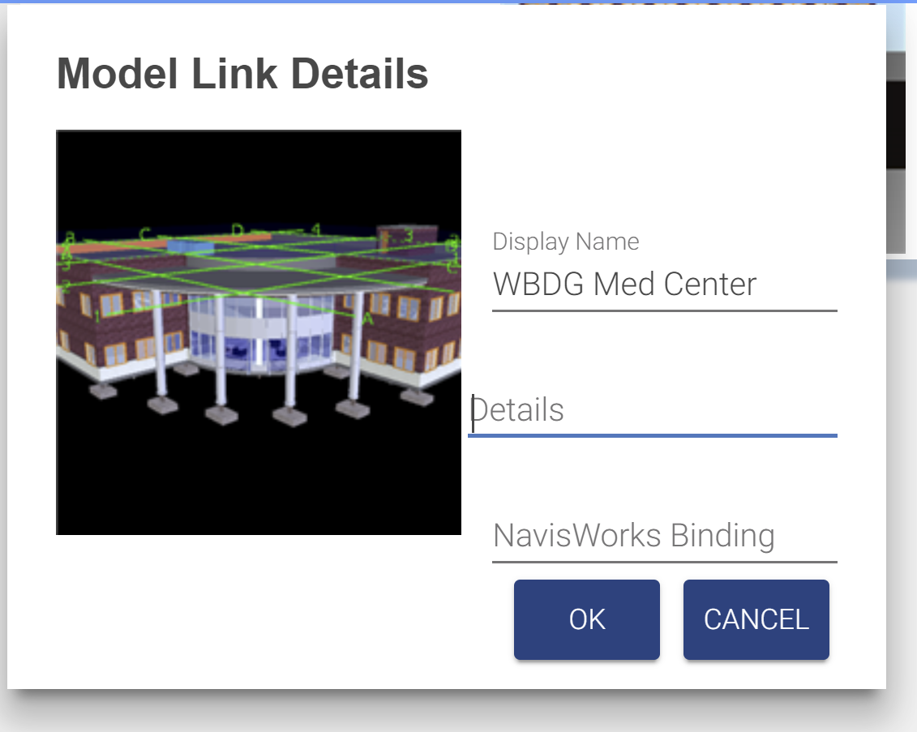

Figure 51 - Building to Model Link Details

* Details: Additional descriptive information not processed by TRIRIGA.
* Navisworks Binding: This is the name of the viewer property which is used to match a viewer element with a TRIRIGA record. If it is not set, it defaults to “GUID”. Some older Navisworks files require “Guid”. It can also be used to create custom binding for other model file types or if the TRIRIGA records were not created by the BIM Connector for Revit.
* Selecting the thumbnail switches to the viewer tab and displays the model in the viewer.

### Previewing Models in the Viewer

Any translated model may be previewed in the viewer included in the BIM Model Management tool. To view a model, select the Viewer tab

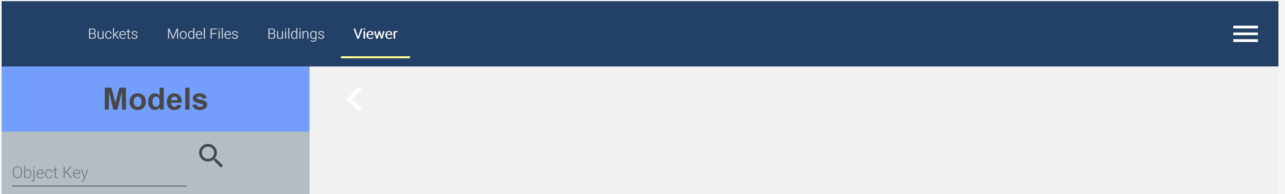

There is a fly-out with a model list. This is the same model list that is displayed on the Model Files tab, except only translated models are shown.

* To view models from a different bucket, return to the Model Files tab, select the desired bucket and refresh the model list.
* Scrolling to the bottom of the list fetches the next 50 models
* The search field filters the existing list. It does not re-fetch the list from the Forge service. The filter match is a substring match.

Select a model in the list to display it in the viewer.

Use the viewer to create saved views (see section 4.4) for use in the Work Tasks application

#### Advanced Viewer Options

There are two advanced options on the BIM Model Management tool menu:

**View Model:** This takes the base 64 encoded model URN and displays the model. The base 64 URN is displayed on the bubble tab of the model details dialog, or it can be obtained from other applications that utilize the Forge viewer.

**Select item in Model:** With the target model displayed, the allows selection of an item in the model based on its raw ID. For Revit models, and Navisworks models derived from Revit, this is the Revit export GUID.

# Using the Autodesk Forge Viewer

The Autodesk® Forge Viewer is integrated into the TRIRIGA UI to support 3D viewing and performing actions from building models. The Viewer is available from three places in the TRIRIGA UI. They are:

* As an additional BIM tab in the Locate application
* As an additional BIM tab for locations and assets in Work Task application
* In the BIM Model Administration Tool

## TRIRIGA context

When the viewer is used with the Locate or Work Task application it displays the current context of the application. The model displayed is for the building containing the active location or asset. If the active space or asset is keyed to the model, it is also selected in the model and the camera is placed in the model to display that item. For a space, that is near the center of the space. This works well for reasonably regular shaped rooms but for some rooms such as an L- shaped hall, the geometric center is not in the space.

For an asset that is a view that centers the asset in the view and zooms such that the asset fills most of the view. On occasion, an asset can be obscured, and it may be necessary to rotate the view to see the asset.

## Viewer Navigation

Basic and extended viewer navigation and view manipulation is provided by Autodesk as part of the Forge Viewers. These functions are accessed from the bottom toolbar. Various TRIRIGA applications expose more or less of the toolbar, and the toolbar adjusts for screen size so on a small screen some tools are hidden.

### Viewer Toolbar

The left hand three sections of the bottom toolbar are part of the basic viewer package as provided by Autodesk. This provided access to standard viewer navigation features, viewer configuration, and model properties. Several of these features are highlighted below:



Figure 52 - Forge Viewer Toolbar

The right most section of the toolbar contains IBM extensions and access to TRIRIGA specific features.



Figure 53 - TRIRIGA Extension to the Forge Viewer Toolbar

**Search**: The Viewer provides a quick search for items in the model. It searches all model properties for all items for any property value that contains the search string. Any item that has a match is part of the search result and is selected.

**Toggle Zoom to Context:** / 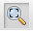 The Toggle Zoom to Context button enables or disables the auto zoom to context when an item is selected in the viewer.

**Zoom to Selection:**  The Zoom to Selection button centers the model on the current selection and zooms the view into the current selection. If multiple items are selected, the view includes all selected items.

**Zoom to Model:**  The Zoom to Model button zooms the view so that the entire model is displayed.

**Apply View ** This button displays a list of all the saved views that are associated with this model. A saved view may be displayed in the viewer by double-clicking the saved view description or by selecting the saved view description then pressing the Apply button.

**Save View**  This button displays the save view dialog to allow the current view to be saved to the TRIRIGA database.

**Show Markup ** This button displays a list of all the Markup that are associated with this model and Work Task. A markup may be displayed in the viewer by double-clicking the markup description or by selecting the markup description then pressing the Apply button (See below).

**Create Markup** 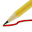 This button switches the viewer to Markup Mode and displays the Markup Toolbar (See below).

### Model Tree

The model tree displays a hierarchical representation of the internal structure of the model. Different types of models have different structures. So, the model tree for a Revit model and a Navisworks model derived from the Revit model are not the same. The model tree can be used to navigate through the model by using its structure. To select individual items or groups of items, and through the context menu, to control how the currently selected item(s) are shown in the model.

If the model tree is open, selecting an item in the model also selects and displays it in the model tree.

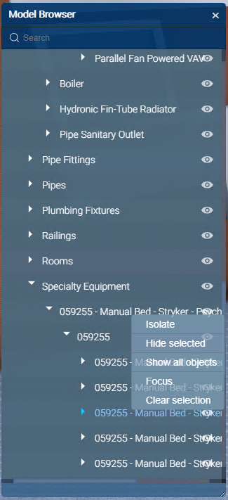

Figure 54- Forge Viewer Model Tree

## Sections

A model can be cut by a section plane in the X, Y, or Z axis, or cut by a box in all three axes at once.

Display the desired section tool and drag the arrow to move the cut plane through the model. The cut plan can be rotated so almost any cut is possible

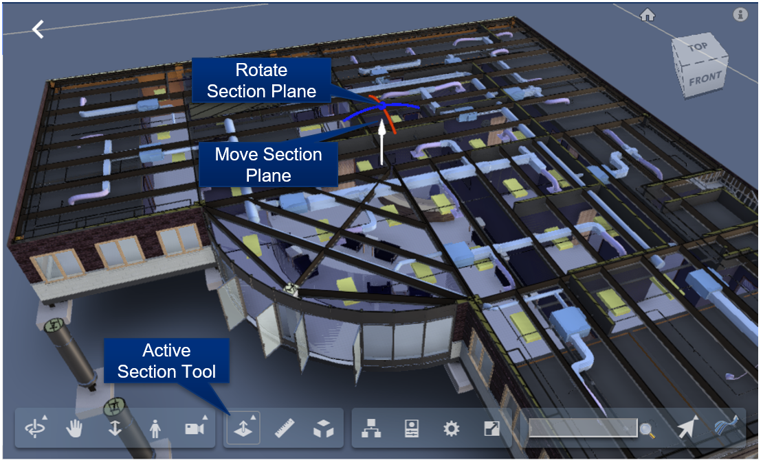

Figure 55 - Forge Viewer Section Tool

|  |  |
| --- | --- |
| Tip | *Use the Z section plane and the top down Orth view to create 2D floor or ceiling plans which can then be store as saved views for later use. A view down the Z axis can be created by clicking on the Top of the view cube* |

## Saved views

Saved Views are available in the viewer embedded in the BIM Administration Tool, and in the Work Task application.

Much of the Viewer state can be captured in a Saved View, stored in the TRIRIGA database and later restored. This includes: The camera position and zoom, the current selection, and section cuts and the selection. Saved views are created from within the viewer. They can be found on the TRIRIGA submenu on the bottom toolbar.



**To create a Saved View:** Setup the desired viewer image, then select the Save View button on the Viewer toolbar. This displays the Save View dialog.

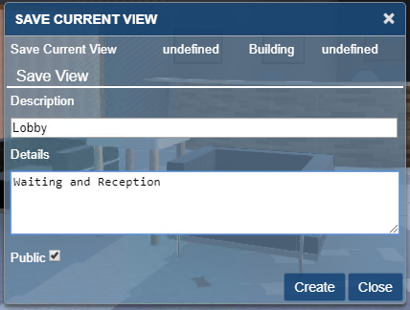

Figure 56 - Saved View Dialog

**Description:** The description is required and identifies the view for later use.

**Details:** Optional addition description

**Public:** Private views are only visible to the user who creates them. Public views are visible to all users with access to the building.

**To restore a view:** Select the Apply Saved View button from the Viewer toolbar. Highlight the desired view and click the Apply button or double-click the desired view.

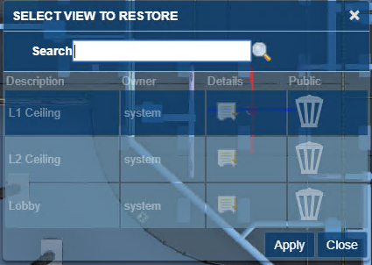

Figure 57 - Apply View Dialog

The dialog only displays the first 20 views for the model. If the view you are looking for is not displayed, use the search field to filter the dialog. The search is a substring match against the description.

**Managing Saved views**: From the BIM Model Management Tool menus select Manage Saved Views. This displays the first 50 saved views. Scroll to the bottom to display additional views. Views may be filtered by description. This is a substring match.

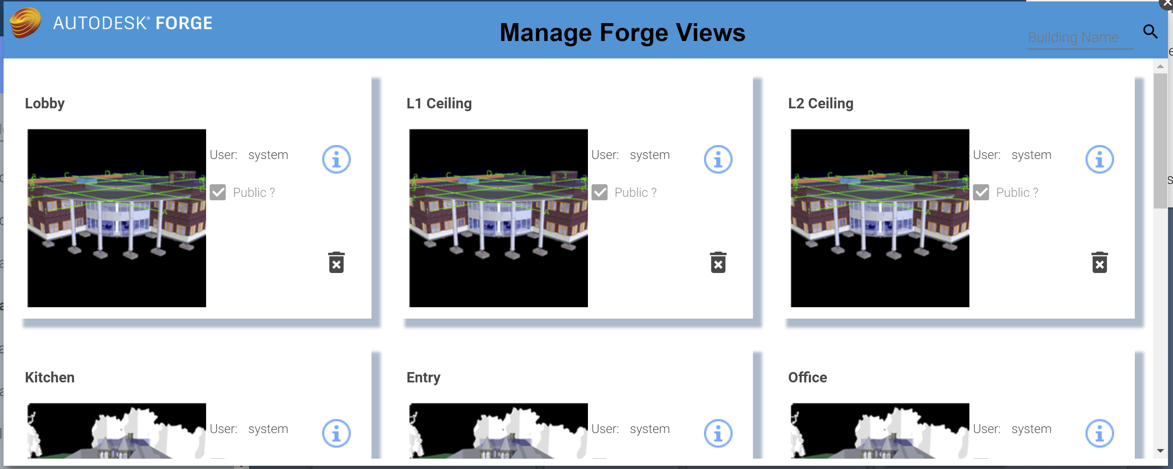

Figure 58 - Manage Forge Views Popup

Views can be deleted from the Manage Saved Views dialog. However, views can only be created from within the Viewer.

Each view is displayed as a tile. The tile has a thumbnail image of the model with which the view is associated.

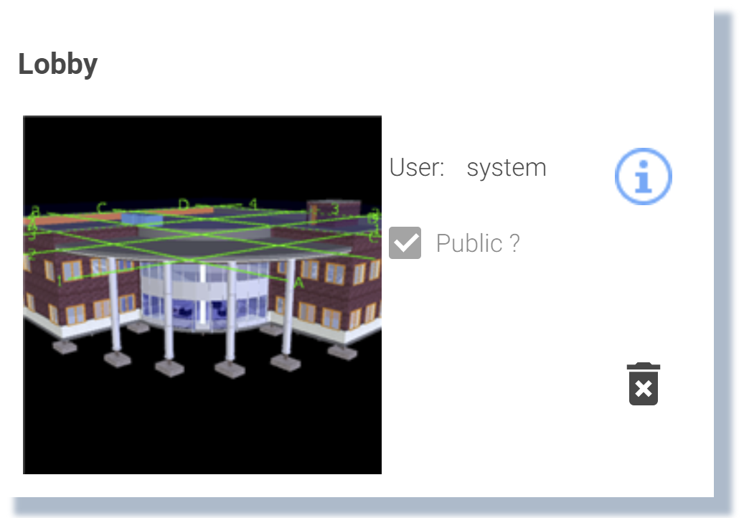

**User:** The login id of the user who created the view (read-only).

**Public?:** Is the view restricted to its creator?

**Info icon:** Displays and allows you to update the details information for the saved view

**Trash can icon:** Deletes the saved view.

**Thumbnail image:** Loads the model into the viewer, switches to the viewer tab, and applies the save view to the model.

## Markup

Markup mode provides a set of drawing tools that can be used to draw on top of the view that is displayed at the time the markup mode is entered. Once in markup mode, the view cannot be changed except to zoom and pan. Once complete, the markup can be saved with the work task and displayed later. A work task can have any number of markups associated with it.

When markup mode is entered, the Markup toolbar is displayed:



Figure 59 - Forge Viewer Markup Toolbar

#### Drawing markup

The first section of the Markup tool bar provides a set of drawing tools. The active drawing tool is highlighted. The drawing mechanism differs slightly by tool type:

**Arrow:** Click and drag.

**Cloud:** Click to place each segment. Clicking on the start closes the cloud and allows it to be filled.

**Freehand:** Hold the mouse down and drag.

**Line:** Click to place each segment. Clicking on the start closes the figure and allows it to be filled.

**Oval:** Click and drag to form the bounding box.

**Rectangle:** Click and drag to create diagonally opposite corners.

**Text:** Click to place the top left corner of the text box, then type the text. When complete, click on the background outside the text box to exit edit mode.

#### Markup Properties

The appearance of markup elements can be changed. Selecting the 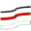 button displays the Markup Properties dialog:



The dialog has two slightly different forms depending on whether the active drawing tools is the Text tool or any of the other tools.

The property setting remains in effect until it is changed. When a new tool is selected, it uses the current markup properties.

Selecting a previously drawn markup sets the current drawing properties to those used to draw the newly selected markup.

#### Editing Markup

Any previously drawn markup can be selected and edited. Click on the markup to select it. Editing options vary by markup. Generally, markups can be moved, resized, deleted, and in some cases rotated. And they may have their properties edited.

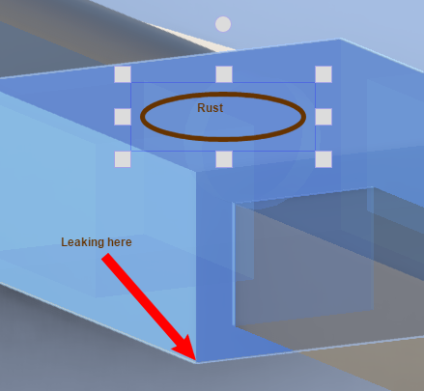

Selecting a markup also makes that markup type the currently selected drawing tool on the Markup toolbar and updates the drawing properties.

#### Save Markup

Select the  Save button to complete the markup session and to save the markup.

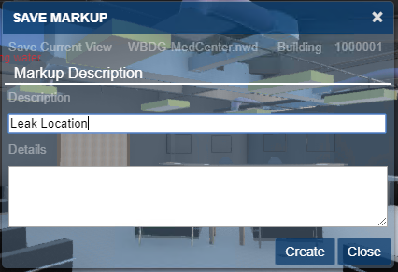

Figure 60 - Save Markup Dialog

When you click the Create button, TRIRIGA saves the just completed markup, the current view, the markup name, and any description with the Work Task.

#### Display Markup

Select the  Display Markup button to display a list of markups that are associated with the work task.

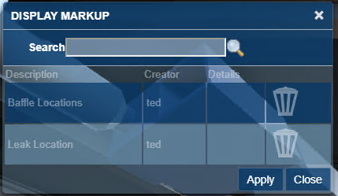

Figure 61- Display Markup Dialog

The dialog only displays the first 20 markups for the model and work task combination If the markup you are looking for is not displayed, use the search field to filter the dialog. The search is a substring match against the description.

Applying a markup restores the view that was used to create the markup and displays the drawing elements of the markup. The Viewer is locked except for zoom and pan until the markup display is closed.

The **Delete** button can be used to delete the associated markup.

# Best Practices

The following are recommended best practices:

* Integrate all Rooms you plan to integrate for all model files before you link spaces to rooms or directly integrate Revit Spaces with TRIRIGA.
* For federated models, the IBM.ModelName value should be unique for each file in the set, and ideally be descriptive of the role the file is playing in the model. For the primary file, IBM.ModelName and IBM.BuildingName can be the same.
* A gross area plan should be created for any level that will be integrated with Revit. Allow Revit to outline the exterior walls. If you subdivide the area plan into additional areas, ensure that the entire level is filled with areas.
* If area names are the same as room names, the auto-match can be used to link rooms to areas. If you expect to detach and reintegrate the model with any frequency, this will save work.
* If space names are the same as room names, the auto-match can be used to link rooms to spaces. If you expect to detach and reintegrate the model with any frequency, this will save work.
* Use a Navisworks model in the TRIRIGA viewer to be able to display and select rooms.

**Spaces:** When assets are contained within a TRIRIGA space, it is highly desirable that the relationship is established when the asset is created by the connector. This is problematic for two reasons:

* The model for most large projects is divided into several linked files. Both Rooms and Spaces can map to TRIRIGA spaces. Rooms typically appear in the architectural model, and Spaces in the primary MEP model. Sub-discipline models may not have spaces. Coordinating Rooms and Spaces across models requires a well thought out strategy.
* Room definitions are often not created for service spaces such as plenums, elevator shafts and the like. Many components exist in these areas and may not have a logical association to a defined space although they are access and serviced from a space.

There are several strategies that can be used to address this. These include:

* Rigorously define all spaces such that there is a space definition for every volume in the model including external service areas
* Copy space definitions into linked models. This makes the spaces available in those models. The connector can link the spaces in each model to the Rooms used to create the TRIRIGA space. Even though the copied space has a different internal identifier in each model, Assets in linked paces are Integrated into TRIRIGA using the identity of the original room.
* Allow components to default to floor or facility references.

It is expected that most models will use a combination of these approaches.

# Troubleshooting

## Forge Viewer

**Symptom:** SSL Error

**Resolution:** The signer certificate that is used by the Autodesk Forge service is not in the application server trust store. For WebSphere, this typically is the CellDefaultTrustStore, but it can vary based on the deployment type.

**Symptom:** When using Safari on iOS, the viewer returns a 401 – Unauthorized error and the model load spinner spins forever.

**Resolution:** enable cookies.

**Symptom:** When you use a Navisworks file, the viewer does not zoom to context and when you select an item that should match the imported data it does not

**Resolution:** The Navisworks Binding attribute that is displayed on the Model Link Info dialog in the BIM Model Management Tool may be incorrect. Typically, it is either Guid or GUID, but it may be necessary to examine the model properties in the viewer to identify the ID Property/GUID.

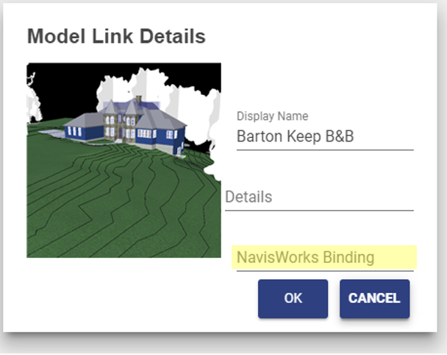

## BIM Model Management Tool

**Symptom:** When attempting to enter credentials the BIM Model Management tool displays and error with a Java stack trace that includes a connection timeout error.

**Resolution** Ensure the TRIRIGA server can communicate with the internet. From the server console, you must be able to connect to https://developer.api.autodesk.com.

## BIM Connector for Revit

The BIM Connector has a log file that contains additional error information. The log files are located at:

<System drive>\ProgramData\IBM\TRIRIGA\AR Integrator\log

Additional logging can be enabled by editing the file

log4net.xml

in the connector config directory. Set the value of:

<level value="INFO" />

To “ERROR” or “DEBUG”

**Symptom:** Login into TRIRIGA from the connector fails typically with a message indicating a problem accessing UOM (Units of Measure).

**Resolution:** The value for the property OSLC_BASE_URI in the TririgaWeb.properties file is incorrect. Correct the URL. To test the URL:

* Launch the TRIRIGA portal from a browser and log in.
* Open a new tab in the same browser windows
* Past the OSLC URL into the address bar of the new tab. If you have copied it directly from the properties file, be sure and remove the \ escape characters first

The browser should respond with something similar to:

{"prefixes":{"rdf":"http:\/\/www.w3.org\/1999\/02\/22-rdf-syntax-ns#","spi":"http:\/\/jazz.net\/ns\/ism\/smarter_physical_infrastructure#","oslc":"http:\/\/open-services.net\/ns\/core#"},"spi:calendar":"gregorian","spi:language":"en","rdf:type":[{"rdf:resource":"http:\/\/jazz.net\/ns\/ism\/smarter_physical_infrastructure#System"}],"spi:currentDate":"2020-01-15T06:27:04.985-08:00","spi:serviceProviders":{"rdf:resource":"http:\/\/tigger:9080\/dev\/oslc\/sp"},"rdf:about":"http:\/\/tigger:9080\/dev\/oslc"}

**Symptom:** When opening a new or second model in Revit whether or not the first one is closed; the following error is displayed.

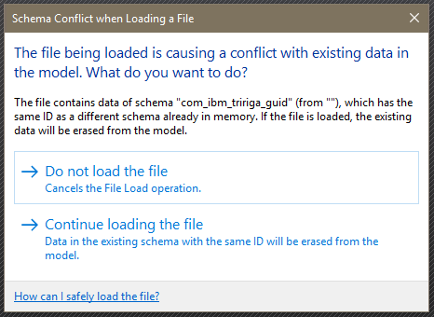

**Resolution:** Continuing to open the model will clear the model GUID which effectively detaches it from TRIRIGA although it does not appear to be detached. If this has happened, the model can be detached and reintegrated.

Closing Revit and re-opening it with the new model bypasses this issue.

**Symptom:** Cannot log into TRIRIGA from the connector as an admin user.

**Resolution:** The number of allowed active admin users has been exceeded. Use the TRIRIGA admin console to close some or all the active admin users.

**Note**: Logging out of the connector or just closing Revit may not close the session in TRIRIGA.

**Symptom:** After an install, on a workstation where the old version of the connector is run or Revit reports that in cannot start the addin because a DLL is missing

**Resolution:** If the previous version of the connector was installed for the current user and the current version is installed for all users, the .addin file from the previous version is found first. Go to the directory <current user> \AppData\Roaming\Autodesk\Revit\Addins\<year> and delete the RevitIntegrator.addin file.

**Symptom:** When using Launch Portal, Open Building, and Open Selection, the browser prompts for a login.

**Resolution:** The hostname in the OSLC_BASE_URI in the TririgaWeb.properties files is different from the hostname used with the connector login. This can happen with multi-homed servers, or if localhost is used for the connector login. Single sign-on to the portal only works when the hostnames match.

## Known Limitations

* In the Forge Viewer, large models can generate “out of memory” errors especially in browsers on low memory devices, such as tablets. This can manifest as a console error message or a browser crash.
* For the Forge Storage Management, rights granted on storage to other IDs do not in fact grant them rights.
* If the Revit application is open and the BIM Integrator is being updated from a previous build of version 2.6.0 to a later build of the same version, the existing revitintegrator.dll file will not be overwritten. As a result, version 2.6.0 will not reflect the later build of the BIM Integration in the Revit application. To upgrade to the later build, user should close the Revit application, delete the AR integrator folder inside C>ProgramData > IBM >Tririga and install the later build. (Tri-53540)
* Internet Explorer 11 is not supported for BIM Model Management. This prevents the loading of Tools > BIM Model Management. (Tri-54131)
* Within the BIM tab of the perceptive Work Task Service app running on tablets or phones, if one wants to change the font size or the color after entering Markup mode, if the font size is increased beyond 25pt, Bold & Italic options are hidden. Try selecting the Bold & Italic option before changing the font size (Tri-53780).
* In iPhones running either Safari or Chrome, the BIM Viewer is not supported via the "Request Desktop Site" or "Desktop Site" option of the browser menu. The BIM Viewer is only available when those options are not used or you may encounter a black screen in the BIM tab in the perceptive Locate app or the perceptive Work Task Services app. (Tri-53902)
* When a room or Area has one or more holes in the middle, the graphics section does not function properly. The outer room boundary and each hole are poly-lines. The TRIRIGA space is bound to the first poly-line encountered which may be one of the holes. In addition, when the space is displayed int the graphics section, the hole(s) may not be excluded from the room.

# Appendix: Configuring to BIM Connector

## Configuring Property Panel and Parameter Map Display

The property Panel, and Parameter mapping communicates with the TRIRIGA server via the OSLC interface. The OSLC endpoints are defined by standard TRIRIGA queries which are intended to be customer configurable.

The property panels rely on 3 queries:

* triFloor - BIM - Revit Property Panel
* triSpace - BIM - Revit Property Panel
* triBuildingEquipment - BIM - Revit Property Panel

Parameter Mapping uses 4 queries:

* triBuilding - BIM – Sync
* triFloor - BIM – Sync
* triSpace - BIM – Sync
* triBuildingEquipment - BIM - Sync

These queries and the accompanying OSLC definitions are installed by the platform from the file:

IBM TRIRIGA BIM Customizable Reports v2.6.1.zip

Found in:

Userfiles/upgrades/BIM

Platform upgrade may install a new version of this OM package. However, unlike the base BIM OM, there is no validation that the objects loaded from the package have not been modified so configuration are not removed on a platform restart.

The following fields are required and are not displayed to the user:

* triRevitUniqueIdTX
* triBIMModelGUIDTX

And for triBuilding records:

* triBIMGUIDTX

The property panel queries are read-only and can utilize any query where the combination of triBIMModelGUIDTX field from the triBIMFlloor, triBIMSpace or triBIMAsset record and the triRevitUniqueIdTX from the triFloor, triSpace or triAsset (triBuildingEquipment) record returns a unique row.

To support sync to TRIRIGA, parameter mapping queries must be updatable.

When one of the query definitions is altered, the OSLC endpoint definition must be updated. There are several paths to navigate to this. The easiest is: from the query definition screen, select the “Where Used” tab. Locate the line that looks like:

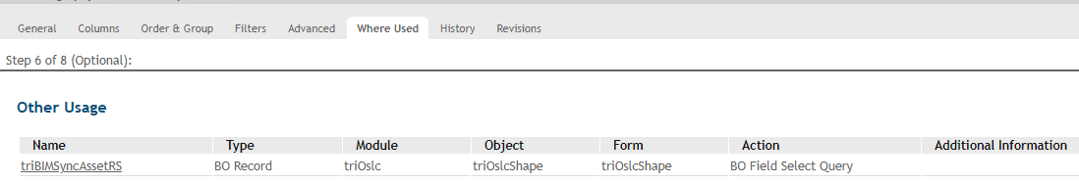

And open the record and select the “Import All Fields” action:



Save the OSLC record and the report definition.

## Changing Supported Asset Types

Out of the box, the BIM Connector supports 9 asset and specification types. These are the types that can reasonably be expected to appear in a model. The definition of these types is table driven so types can be added or removed, including adding support for new customer or business partner defined types.

Each supported type has a triBIMSupportedTypes record. To add or remove supported types, add or remove records from this table.

At startup, the connector queries the server for all instance of this BO. The result populates:

* The dropdown on the Fields tab of the Parameter Mapping tool.
* The list of loadable groups on the Link Existing tab of the Families tool.
* The dropdown on the Create New tab of the Families tool.

It defines reports and OSLC Query Contexts that are used by:

* The “Fields” tab in the Parameter Mapping tool.
* The TRIRIGA Property Panel.
* The Specifications popup of the TRIRIGA Property Panel.

It is used by workflows to select dynamic workflow to:

* Create a specific asset type.
* Synchronize a specific asset type.
* Create a specific specification type.

#### Adding a new Specification and Asset type

1. Asset Create Workflow:
   * Copy the workflow: triBIMAsset - Synchronous - Create Asset - Building Equipment Spec.
   * Rename for the new asset type.
   * Update the Create Asset step to create the correct asset type.
   * Update the Create Asset step to use the correct form.
   * Update the Map Location to Asset step to reference the new Create Asset step (Change of BO type).
2. Asset Sync Workflow:
   * Copy the workflow triBIMAsset - Synchronous - Sync Asset - Building Equipment Spec.
   * Rename for the new asset type.
   * Update the expression in the switch to test for the correct business object type and form name.
3. Specification Create Workflow:
   * Copy the workflow triBIMType - Synchronous - Create Specification - Building Equipment Spec.
   * Rename for the new asset type.
   * Update Create Specifications to use the correct business object type and form name.
   * Update each of the remaining steps to reference the new business object type.
4. Ensure that the fields triBIMGUIDTX and triRevitUniqueIdTX are part of the asset business object definition. Add them if necessary.
5. Parameter Mapping/Sync Report: If this is a new BO type, create a report for the new Asset type for the Property Panel. The columns in this report are what can be displayed in the Fields tab of the Parameter Mapping tools. If it is a new form for an existing supported BO type, the base report can be reused or a new report can be created to expose a different set of fields:
   * The base object is the base asset business object. The report is either all or the specific report.
   * tryBIMAsset must be associated with associations of All.
   * The base BO must have the column triRevitUniqueIdTX selected.
   * For the base BO, select all the fields that are to be displayed in the TRIRIGA Properties Panel in Revit.
6. Property Panel Asset Report: If this is a new BO type, create a report for the new Asset type for the Property Panel. The columns in this report are what can be displayed in the TRIRIGA Property Panel in Revit. If it is a new form for an existing supported BO type, the base report can be reused or a new report can be created to expose a different set of fields:
   * The base object is the base asset business object. The report is either all or the specific report.
   * tryBIMAsset must be associated with associations of All.
   * The base BO must have the column triRevitUniqueIdTX selected.
   * For the base BO, select all the fields that are to be displayed in the TRIRIGA Properties Panel in Revit.
7. Property Panel Specification Report: If this is a new BO type, create a report for the new Specification can be displayed in the TRIRIGA Property Panel in Revit. If it is a new form for an existing supported BO type, the base report can be reused or a new report can be created to expose a different set of fields:
   * The base object is the base specification business object. The report is either all or the specific report.
   * tryBIMType must be associated with associations of All.
   * triBIMType must have the columns BIM Model GUID and External ID selected.
   * For the base BO, select all the fields that are to be displayed in the TRIRIGA Properties Panel in Revit.
8. For each new report created above, create an OSLC resource description:
   * Use spi for the name space.
   * Import all fields.
   * Either select the form used with the report or the form with the same name as the business object.
9. For each OSLC resource description created above, create an OSLC query capability:
   * Use triBIMSP as the service provider.
   * Use triBIMSV as the service.
   * Select the resource created above.
   * Select the query used by the resource.
10. Create and populate a new BIM Supported types record:
    * Use the system report triBIMSupportedSpecTypes – Dev to create a new record.
    * Populate the record with values from each of the above steps.
11. 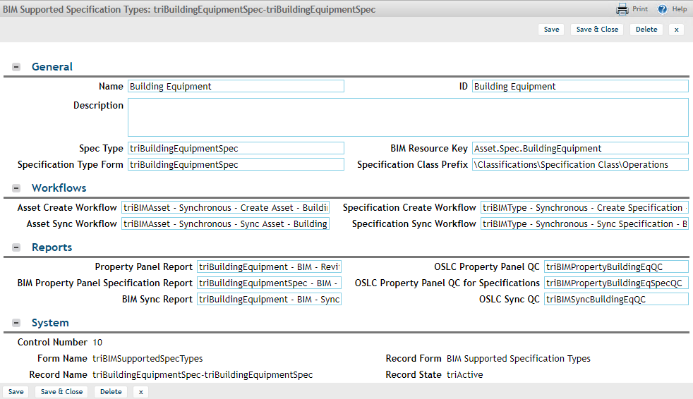

|  |  |
| --- | --- |
| Field Name | Usage |
| Name | Human readable name and record key. Displayed of the resource key is missing or not found |
| ID |  |
| Description | A description of this record – For documentation purpose only |
| Spec Type | The business object name for this specification |
| Specification Type Form | The form name for this specification |
| BIM Resource Key | A key in the connector resource file used to get the name of the object in the Revit user’s language. If this is not specified, or the key is not in the resource file, the Name of the records is used |
| Specification Class Prefix | Specification classes displayed in the “Add New” tab of the family tool are filtered to only show records that start with this prefix. It can be found on the SpecClass field of the form in Form Builder |
| Asset Create Workflow | Name of workflow from step 1 |
| Asset Sync Workflow | Name of workflow from step 2 |
| Specification Create Workflow | Name of workflow from step 3 |
| Specification Sync Workflow | Not currently used |
| Property Panel Report | Name of report from step 6 |
| BIM Property Panel Specification Report | Name of report from step 7 |
| BIM Sync Report | Name of report from step 5 |
| OSLC Property Panel QC | Query Context for report in step 6 |
| OSLC Property Panel QC for Specifications | Query Context for report in step 7 |
| OSLC Sync QC | Query Context for report in step 5 |

## Adding additional Revit Categories to Family and Asset integration

The connector Family and Component integration has selected a set of Revit categories to support that is expected to work for most uses, however, the list can be configured. The default list of supported categories is:

|  |  |  |
| --- | --- | --- |
| * OST_DataDevices | * OST_Furniture | * OST_PlumbingFixtures |
| * OST_Doors | * OST_LightingFixtures | * OST_SpecialityEquipment |
| * OST_DuctFitting | * OST_LightingDevices | * OST_TelephoneDevices |
| * OST_DuctTerminal | * OST_MechanicalEquipment |  |
| * OST_ElectricalEquipment | * OST_PipeAccessory |  |

This list controls:

* To which Components and Types IBM Parameters are added.
* The Categories displayed in the Families tool.
* The list of Categories displayed in the Integrate Asset tool.
* The Categories displayed in the Elements tab of the Parameter Mapping tool.
* The Categories supported by the Property Panel.
* The Categories used by the Sync tool to build its asset list.

This list can be configured. It is stored with the model as part of the configuration data managed by the setting tool. To configure the list of Categories:

1. From the setting tool, export the configuration data. This creates an XML file.
2. Open the file with an XML or text editor.
3. Look for elements tagged <SupportedCategories>
4. Add or remove elements as desired. Elements added must be from the list of Revit built-in categories found here: [BuiltinCategory](http://www.revitapidocs.com/2017/ba1c5b30-242f-5fdc-8ea9-ec3b61e6e722.htm), and be a category that can be assigned to a family instance (component).
5. Import the edited file. This is best done before any elements are integrated.
6. Close and reopen the model. If categories have been added, the Populate Parameters tool must be run again.
7. Once the changes have been imported and verified, the configuration can be saved to the TRIRIGA server and shared with other models.

Changing the category list for a model that is already integrated may have undesirable effects including making integration data for removed categories unavailable and leaving TRIRIGA data in the model when detach is run.

# Appendix: REST API support

The TRIRIGA server provides a proxy for the portion of the Autodesk® Forge REST service use by the viewer and the BIM Model Management Tool. This resolves browse Cross Object Resource Scripting (CORS) restrictions, and allows TRIRIGA security to be applied to Forge access.

The proxy endpoints closely follow the original Forge endpoints. In most cases the body, the result, and any error information are passed directly from the original Forge endpoint, See the referenced Forge documentation for details.

The Forge application key and secret are stored in the server HTTP session. The session must be initiated by either calling Authenticate which initializes the session with the credentials provided in the call. Or by calling GetAuthToken. This initializes the session using the credentials stored in the TRIRIGA database in the triBIMConfig business object.

#### Authenticate

Return a Forge auth token with scope viewables:read which is suitable for use by the Forge viewer. If successful, this also initializes the HTTP session with the provide key and secret. These credentials are used for subsequent Forge service calls.

[Forge Endpoint reference](https://developer.autodesk.com/en/docs/oauth/v2/reference/http/authenticate-POST/)

**Path**: /api/p/v1/forge/token

**Method**: GET

**Request Parameters**:

* key: Client ID of the app
* secret: Client secret of the app

#### Get Auth Token

[Forge Endpoint reference](https://developer.autodesk.com/en/docs/oauth/v2/reference/http/authenticate-POST/)

Return a Forge auth token with scope viewables:read which is suitable for use by the Forge viewer. The application key and secret stored in the TRIRIGA database is used to request the token. On success, the credentials are copied into the current HTTP session.

**Path**: /api/p/v1/forge/auth/token

**Method**: GET

**Body**: The result from the Forge service Authenticate Endpoint or:

{

"key": "",

"authenticated": "false";

"error": <TRIRIGA Error message>

}

#### Get Application Key

Gets the application key currently associated with the HTTP session, if there is one, and whether or not the session has successfully authenticated with the Forge service.

**Path**: /api/p/v1/forge/auth/key

**Method**: GET

**Body**: JSON

{

"key”: <Client ID>

"authenticated”: <true/false>

}

#### Logout

Clears the Forge credentials for the HTTML session which disconnects the session from the Forge service. This is only needed or useful if the session was created by Authenticate so session specific credentials were provided.

**Path**: /api/p/v1/forge/auth/logout

**Method**: POST

**Return**: None

#### Get Bucket List

Returns all the buckets associated with the application

[Forge Endpoint reference](https://developer.autodesk.com/en/docs/data/v2/reference/http/buckets-GET/)

**Path**: /api/p/v1/forge/bucket

**Method**: GET

**Request Parameters**:

* region: The region where the bucket resides. Acceptable values: US, EMEA Default: US

#### Query Bucket Details

Returns detailed information about the specified bucket.

[Forge Endpoint reference](https://developer.autodesk.com/en/docs/data/v2/reference/http/buckets-:bucketKey-details-GET/)

**Path**: /api/p/v1/forge/bucket/<bucketkey>

**Method**: GET

**Path Parameters**:

* bucketkey: URL-encoded bucket key for which to get details

#### Create Bucket

Creates a new bucket

[Forge Endpoint reference](https://developer.autodesk.com/en/docs/data/v2/reference/http/buckets-POST/)

**Path**: /api/p/v1/forge/bucket/<bucketkey>

**Method**: POST

**Path Parameters**:

* bucketkey: URL-encoded bucket key for which to get details

**Request Parameters**:

* policy:
* region: The region where the bucket resides. Acceptable values: US, EMEA Default: US

#### Delete Bucket

Deletes the specified bucket which also deletes all models and bubbles associated with the bucket.

Undocumented Forge Endpoint

**Path**: /api/p/v1/forge/bucket/<bucketkey>

**Method**: DELETE

**Path Parameters**:

* bucketkey:

#### Grand Rights to a Bucket

Grants rights to a different application key to access the bucket. Currently of limited functions.

Undocumented Forge Endpoint

**Path**: /api/p/v1/forge/bucket/<bucketkey>/rights/<serviceId>

**Method**: PUT

**Path Parameters**:

* bucketkey: URL-encoded bucket key for which to get details
* serviced: Client ID of the app

**Request Parameters**:

* access:

#### Revoke Rights to a Bucket.

Revokes rights granted by Grant.

Undocumented Forge Endpoint

**Path**: /api/p/v1/forge/bucket/<bucketkey>/rights/<serviced>

**Method**: DELETE

**Path Parameters**:

* bucketkey: URL-encoded bucket key for which to get details
* serviced: Client ID of the app

#### Get Model List

Gets a filtered and paged list of models for the specified bucket.

[Forge Endpoint Reference](https://developer.autodesk.com/en/docs/data/v2/reference/http/buckets-:bucketKey-objects-GET/)

**Path**: /api/p/v1/forge/model/< bucketkey>

**Method**: GET

**Path Parameters**:

bucketkey **Request Parameters**:

* name: String to filter the result set by. The result set is restricted to items whose objectKey begins with the provided string.
* start: The position to start listing the result set. This parameter is used to request the next set of items, when the response is paginated. The fetch the next page of data, this should be the last item returned on the current page.
* pagesize: The number of objects to return in the result set. Acceptable values = 1 - 100. Default = 10.

#### Query Model Details

Returns detailed information about a single model file.

[Forge Endpoint Reference](https://developer.autodesk.com/en/docs/data/v2/reference/http/buckets-:bucketKey-objects-:objectName-details-GET/)

**Path**: /api/p/v1/forge/model/<bucketkey>/object

**Method**: GET

**Path Parameters**:

* bucketkey: URL-encoded bucket key for which to get details

**Request Parameters**:

* objectKey: URL-encoded object name to get details for

#### Upload Model

Uploads a model file to the selected bucket

[Forge Endpoint Reference](https://developer.autodesk.com/en/docs/data/v2/reference/http/buckets-:bucketKey-objects-:objectName-resumable-PUT/)

**Path**: /api/p/v1/forge/model/<bucketkey>/object

**Method**: PUT

**Path Parameters**:

* bucketkey: URL-encoded bucket key for which to get details

**Request Parameters**:

* objectKey: URL-encoded object name to get details for

#### Delete Model

Deletes a model. If the model has been translated to a viewable bubble, the bubble is not deleted.

[Forge Endpoint Reference](https://developer.autodesk.com/en/docs/data/v2/reference/http/buckets-:bucketKey-objects-:objectName-DELETE/)

**Path**: /api/p/v1/forge/model/<bucketkey>/object

**Method**: DELETE

**Path Parameters**:

* bucketkey: URL-encoded bucket key for which to get details

**Request Parameters**:

* objectKey: URL-encoded object name to get details for

#### Query Bubble Details

Query details about a translated model, or a model in the process of being translated. This can be used to get status and progress on the translation process.

[Forge Endpoint Reference](https://developer.autodesk.com/en/docs/model-derivative/v2/reference/http/urn-manifest-GET/)

**Path**: /api/p/v1/forge/bubble

**Method**: POST

**Request Parameters**:

* objectKey: URL-encoded object name to get details for

#### Delete Bubble

Delete the viewable bubble resulting from model translation

[Forge Endpoint Reference](https://developer.autodesk.com/en/docs/model-derivative/v2/reference/http/urn-manifest-DELETE/)

**Path**: /api/p/v1/forge/bubble

**Method**: DELETE

#### Translate Model to Bubble

Translate a model file into a viewable bubble. The translated format is required for use with the Forge viewer

[Forge Endpoint Reference](https://developer.autodesk.com/en/docs/model-derivative/v2/reference/http/job-POST/)

**Path**: /api/p/v1/forge/bubble/translate

**Method**: POST

**Request Parameters**:

* rootFileName: The root filename of the compressed file. Mandatory if the upload file is a .zip file.
* region: The region where the bucket resides. Acceptable values: US, EMEA Default: US

#### Get Thumbnail

Retrieves the thumbnail image for the translated bubble. This url is suitable for as a src url attribute of a html img element.

[Forge Endpoint Reference](https://developer.autodesk.com/en/docs/model-derivative/v2/reference/http/urn-thumbnail-GET/)

**Path**: /api/p/v1/forge/bubble/<urn>/thumbnail

**Method**: GET

**Path Parameters**:

* urn: The Base64-encoded (URL-safe) design URN

Return: octet steam with thumbnail image.

 ®

© Copyright IBM Corporation 2018

IBM United States of America

Produced in the United States of America

US Government Users Restricted Rights - Use, duplication or disclosure restricted by GSA ADP Schedule Contract with IBM Corp.

IBM may not offer the products, services, or features discussed in this document in other countries. Consult your local IBM representative for information on the products and services currently available in your area. Any reference to an IBM product, program, or service is not intended to state or imply that only that IBM product, program, or service may be used. Any functionally equivalent product, program, or service that does not infringe any IBM intellectual property right may be used instead. However, it is the user's responsibility to evaluate and verify the operation of any non-IBM product, program, or service.

IBM may have patents or pending patent applications covering subject matter described in this document. The furnishing of this document does not grant you any license to these patents. You can send license inquiries, in writing, to:

IBM Director of Licensing  
IBM Corporation  
North Castle Drive  
Armonk, NY 10504-1785   
U.S.A.

**The following paragraph does not apply to the United Kingdom or any other country where such provisions are inconsistent with local law:**

INTERNATIONAL BUSINESS MACHINES CORPORATION PROVIDES THIS PAPER “AS IS” WITHOUT WARRANTY OF ANY KIND, EITHER EXPRESS OR IMPLIED, INCLUDING, BUT NOT LIMITED TO, THE IMPLIED WARRANTIES OF NON-INFRINGEMENT, MERCHANTABILITY OR FITNESS FOR A PARTICULAR PURPOSE. Some states do not allow disclaimer of express or implied warranties in certain transactions, therefore, this statement may not apply to you.

This information could include technical inaccuracies or typographical errors. Changes may be made periodically to the information herein; these changes may be incorporated in subsequent versions of the paper. IBM may make improvements and/or changes in the product(s) and/or the program(s) described in this paper at any time without notice.

Any references in this document to non-IBM Web sites are provided for convenience only and do not in any manner serve as an endorsement of those Web sites. The materials at those Web sites are not part of the materials for this IBM product and use of those Web sites is at your own risk.

IBM may have patents or pending patent applications covering subject matter described in this document. The furnishing of this document does not give you any license to these patents. You can send license inquiries, in writing, to:

IBM Director of Licensing

IBM Corporation

4205 South Miami Boulevard

Research Triangle Park, NC 27709 U.S.A.

All statements regarding IBM's future direction or intent are subject to change or withdrawal without notice, and represent goals and objectives only.

This information is for planning purposes only. The information herein is subject to change before the products described become available.

If you are viewing this information softcopy, the photographs and color illustrations may not appear.

**Trademarks**

IBM, the IBM logo, and ibm.com are trademarks or registered trademarks of International Business Machines Corporation in the United States, other countries, or both. If these and other IBM trademarked terms are marked on their first occurrence in this information with a trademark symbol (® or ™), these symbols indicate U.S. registered or common law trademarks owned by IBM at the time this information was published. Such trademarks may also be registered or common law trademarks in other countries. A current list of IBM trademarks is available on the web at "Copyright and trademark information" at <http://www.ibm.com/legal/copytrade.shtml>.

Autodesk, the Autodesk logo, BIM360, Navisworks, Revit, Forge are registered trademarks or trademarks of Autodesk, Inc., and/or its subsidiaries and/or affiliates in the USA and/or other countries. All other brand names, product names, or trademarks belong to their respective holders. Autodesk reserves the right to alter product and services offerings, and specifications and pricing at any time without notice, and is not responsible for typographical or graphical errors that may appear in this document. © [2018] Autodesk, Inc. All rights reserved.

Microsoft, Windows, Windows NT, and the Windows logo are trademarks of Microsoft Corporation in the United States, other countries, or both.

Other company, product, or service names may be trademarks or service marks of others.